EMBARGOED UNTIL TUESDAY, JAN 25TH @ 12PM ET/9AM PT
SCOTTISH ALT-ROCK GIANTS BIFFY CLYRO ANNOUNCE 2022 NORTH AMERICAN TOUR

Tickets On Sale Starting Friday, January 28th at 10AM Local Time on www.biffyclyro.com/live

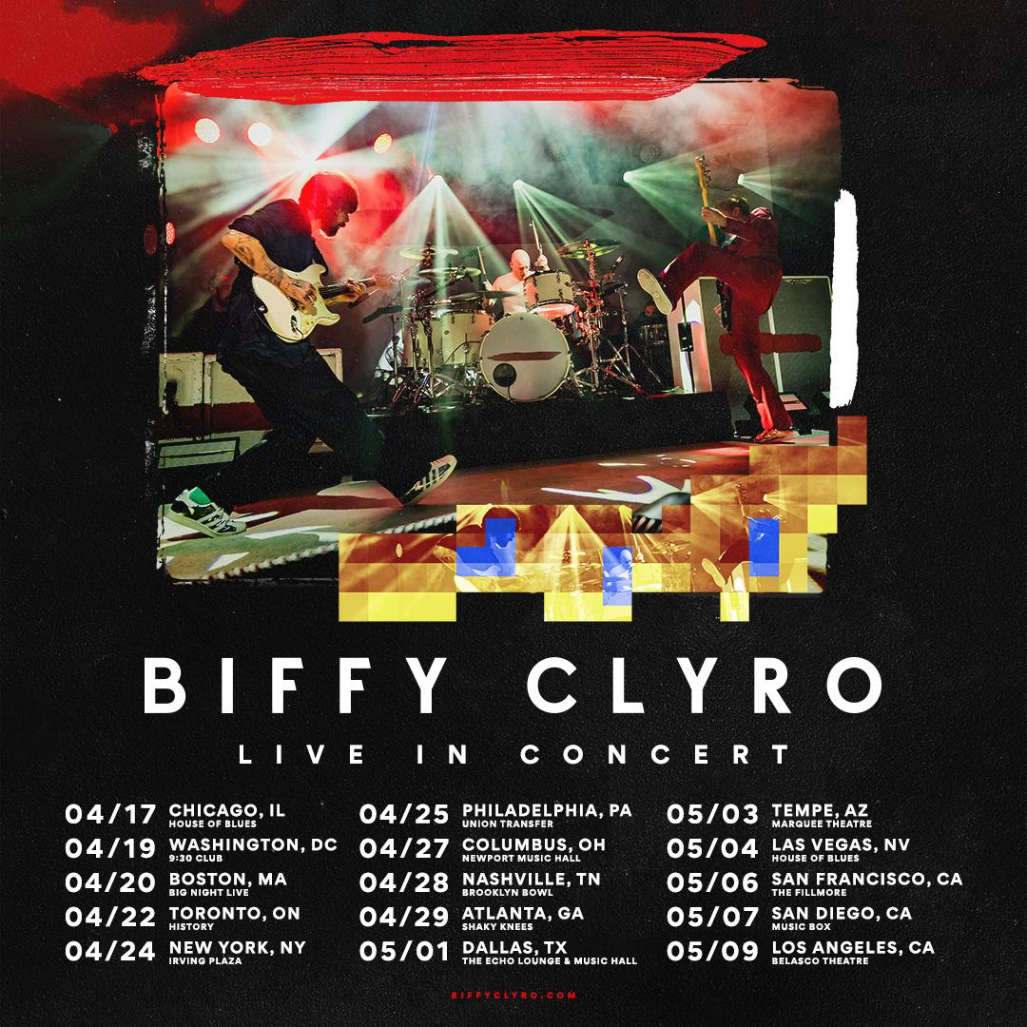

For approved artist images and hi-res tour art, please download HERE.

WHO: Biffy Clyro
WHAT: Marking the group’s first North American tour since 2017, the highly-anticipated 15-city run kicks off on April 17th at House of Blues in Chicago, IL making stops across North America in Boston, Philadelphia, Nashville, New York, and Los Angeles, plus a stop at this year’s Shaky Knees Festival in Atlanta, GA.

Said Biffy Clyro of their upcoming tour, "America - we've missed you, it's been way too long! We can't wait to come and play for you all again, it's going to be special..."

TICKETS: Tickets on sale starting Friday, January 28th at 10AM local time on www.biffyclyro.com/live

PRESALE: Citi is the official card of the Biffy Clyro tour. Citi cardmembers will have access to presale tickets beginning Tuesday, January 25th at 2pm ET until Thursday, January 27th at 10PM local time through the Citi Entertainment program. For complete presale details visit www.citientertainment.com.

BIFFY CLYRO TOUR AND FESTIVAL DATES:
Sun Apr 17 – Chicago, IL – House of Blues
Tue Apr 19 – Washington, DC – 930 Club
Wed Apr 20 – Boston, MA – Big Night Live
Fri Apr 22 – Toronto, ON – History
Sun Apr 24 – New York, NY – Irving Plaza
Mon Apr 25 – Philadelphia, PA – Union Transfer
Fri Apr 27 – Columbus, OH – Newport Music Hall
Thu Apr 28 – Nashville, TN – Brooklyn Bowl
Fri Apr 29 – Atlanta, GA – Shaky Knees Festival
Sun May 01 – Dallas, TX – The Echo Lounge & Music Hall
Tue May 03 – Phoenix, AZ – Marquee
Wed May 04 – Las Vegas, NV – House of Blues
Fri May 06 – San Francisco, CA – The Fillmore
Sat May 07 – San Diego, CA – Music Box
Mon May 09 – Los Angeles, CA – Belasco

MORE:
Biffy Clyro have emerged from their independent beginnings to become Britain’s premier rock band. They most recently unveiled their latest project The Myth of the Happily Ever After, the follow-up to their internationally acclaimed albums A Celebration of Endings (2020), Ellipsis (2016) and Opposites (2013) , which shot straight to #1 in the U.K. charts with millions of copies sold, and the band boasts more than 950 million streams worldwide to date. In the U.S. they’ve toured arenas with the likes of Foo Fighters and Muse, in addition to sold-out headline runs, while overseas they’ve headlined leading festivals including Reading and Leeds, Download, TRNSMT, and Radio 1’s Big Weekend. Continually supported by the press, Biffy Clyro have also won a wide range of major awards. These include four NME Awards (2 x Best British Band, Best Live Band and Best Music Video); four Kerrang! Awards (Best British Band, Classic Songwriter, Best Album and Best Music Video); and three Q Awards (Best Live Band, Best Album and the Fender Play Award). They’ve also been nominated three times for Best British Group at the BRIT Awards and a Mercury Prize.

MEDIA CONTACTS:

Biffy Clyro
Ceri Roberts | Ceri.Roberts@warnerrecords.com
Patrice Compere | Patrice.Compere@warnerrecords.com

