

**SCOTTISH ALT-ROCK GIANTS BIFFY CLYRO SHARE LATEST SONG**

**“TINY INDOOR FIREWORKS”**

**NEW ALBUM *A CELEBRATION OF ENDINGS* ARRIVES AUGUST 14**

**SINGLE “INSTANT HISTORY” CLIMBING ALTERNATIVE & ROCK RADIO CHARTS**

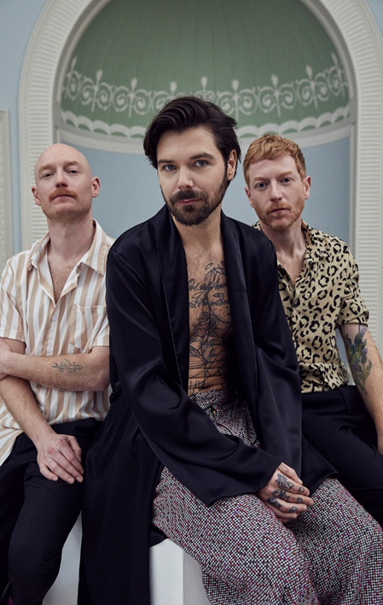

**May 14, 2020 (Los Angeles, CA) –** The U.K.’s alt-rock giants Biffy Clyro have shared new song “Tiny Indoor Fireworks,” the latest from their forthcoming 8th studio album *A Celebration of Endings*, now set for a new release date of August 14. Though “Tiny Indoor Fireworks” is snappy, melodic and joyous in feel, key lyric “*Pray for better days*” has taken on a new sense of poignancy in these times. “Tiny Indoor Fireworks” follows previous releases “End Of” and Biffy Clyro’s single “Instant History,” which is climbing the charts at both Alternative and Rock radio formats.

**Listen to “Tiny Indoor Fireworks”** [**HERE**](https://biffyclyro.co/tinyindoorfireworks) **– Listen to “Instant History”** [**HERE**](https://biffyclyro.co/instanthistory)

**Pre-Order/Pre-Save *A Celebration of Endings*** [**HERE**](https://nam04.safelinks.protection.outlook.com/?url=https%3A%2F%2Fbiffyclyro.co%2Facelebrationofendings&data=02%7C01%7Cfreelancewriter%40warnermusic.com%7C03c681b633c14877411708d7c052b908%7C8367939002ec4ba1ad3d69da3fdd637e%7C0%7C0%7C637189333825842222&sdata=N7QjNiGLFbdJ1R89JUh%2FkgXkwTlJD4aLhZ84Yto230c%3D&reserved=0)

Biffy Clyro have been keeping busy during quarantine, preparing to play Radio 1’s virtual Big Weekend UK 2020, on May 22-24 alongside acts such as Jonas Brothers, Sam Smith, Niall Horan, and Rita Ora. The band also joined the BBC Radio 1 Live Lounge Allstars (featuring Dua Lipa, Coldplay, and more) for their take on Foo Fighters’ “[Times Like These](https://www.youtube.com/watch?v=7GElP4YdrBE),” and frontman Simon Neil has been hosting Friday night acoustic shows live from his home on the band’s social media.

*A Celebration of Endings* finds Biffy Clyro pushing everything they do to the next level, with the help of GRAMMY-winning producer Rich Costey (Foo Fighters, Muse, The Killers). It’s a forward-thinking set which embraces the joy of things changing and progressing. On a personal level that might be a relationship which has reached a point where it’s in both parties’ interest to separate. And on a wider scale, it’s about standing up for what you believe in.

Biffy Clyro have emerged from their independent beginnings to become Britain’s premier rock band. Their two most recent albums both shot straight to #1 in the U.K. charts with 2 million+ copies sold, and the band boasts more than 750 million streams worldwide to date. The success of their huge-selling, critically-acclaimed albums is matched by the scale of their live show. In the U.S. they’ve toured arenas with the likes of Foo Fighters and Muse, in addition to sold-out headline runs, while overseas they’ve headlined leading festivals including Reading and Leeds, Download and TRNSMT, and are set to launch their UK and Ireland headline tour in September.

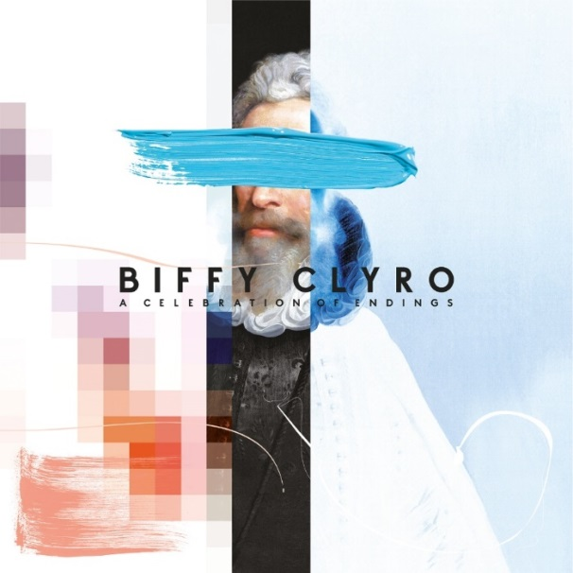

***A Celebration of Endings*** **tracklist:**

1. North Of No South
2. The Champ
3. Weird Leisure
4. Tiny Indoor Fireworks
5. Worst Type Of Best Possible
6. Space
7. End Of
8. Instant History
9. The Pink Limit
10. Opaque
11. Cop Syrup

***A Celebration of Endings*** will be released on vinyl, colored vinyl (exclusive to select indie stores), CD, and digital formats, with additional packages available at [**https://store.biffyclyro.com/**](https://nam04.safelinks.protection.outlook.com/?url=https%3A%2F%2Fstore.biffyclyro.com%2F&data=02%7C01%7CCeri.Roberts%40warnerrecords.com%7Cfbb185055e4241a51f5508d7c08697a9%7C8367939002ec4ba1ad3d69da3fdd637e%7C0%7C0%7C637189556604439559&sdata=1SP8CjSNH2sY81dw2%2BqRJcvigfmDbbLpN30fuFtODYQ%3D&reserved=0). “Tiny Indoor Fireworks,” “End Of” and “Instant History” will be provided as instant downloads for fans who pre-order the album.

###

**For further information please contact Warner Records Publicity:**

Ceri Roberts / [Ceri.Roberts@warnerrecords.com](mailto:Ceri.Roberts@warnerrecords.com)

**Follow Biffy Clyro:**

[**Official website**](http://www.biffyclyro.com/)**|** [**Facebook**](https://www.facebook.com/biffyclyro) **|** [**Twitter**](https://twitter.com/biffyclyro) **|** [**Instagram**](https://www.instagram.com/biffy_clyro/) **|** [**YouTube**](https://www.youtube.com/user/biffyclyro)

**cid:image004.jpg@01D5E66A.9F2C7370**