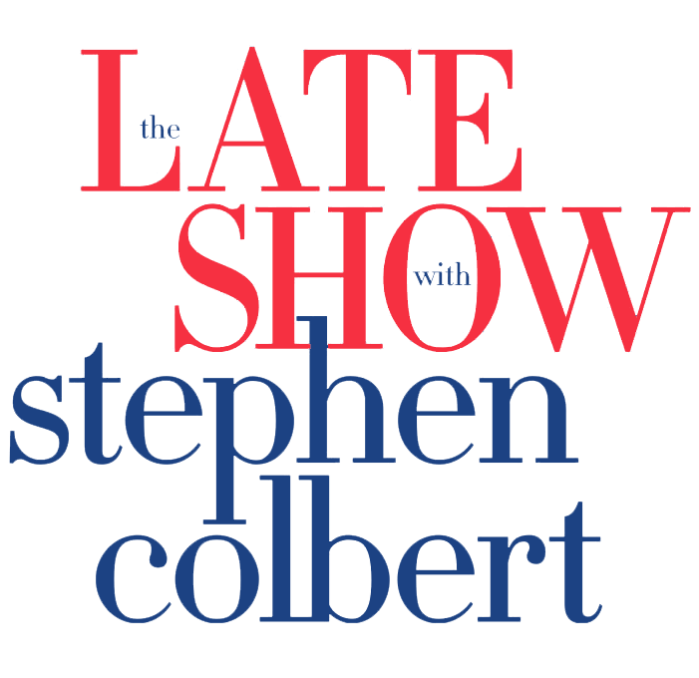
May 18, 2020

https://www.cbs.com/shows/the-late-show-with-stephen-colbert/video/xi3kI5V_W_t_5ollzDBbAc_qCiHAHkL4/andra-day-pays-tribute-to-bill-withers-ain-t-no-sunshine-use-me-late-show-playathome/

YouTube: https://www.youtube.com/watch?v=V1ORft18Cx0

