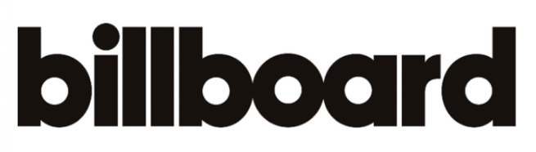

July 29, 2020

https://www.billboard.com/articles/news/pride/9425669/best-lgbtq-songs-2020-so-far

