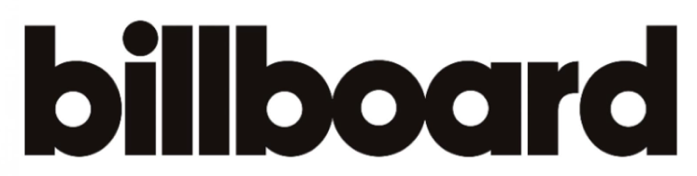

June 18, 2020

https://www.billboard.com/articles/business/9404459/freddie-gibbs-warner-records-exclusive

