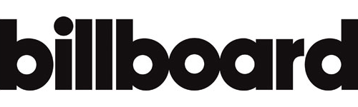

August 17, 2020

“In just a year, NLE Choppa carved out a lane in hip-hop as one of the genre's brightest stars.” – Billboard

https://www.billboard.com/articles/columns/hip-hop/9435360/20-questions-with-nle-choppa

