JOSH GROBAN UNVEILS TRACKLISTING FOR NEW ALBUM BRIDGES

FEATURING THE SINGLES “GRANTED” AND “SYMPHONY” AS WELL AS DUETS WITH
SARAH MCLACHLAN, ANDREA BOCELLI,
& JENNIFER NETTLES

IN STORES EVERYWHERE SEPTEMBER 21ST
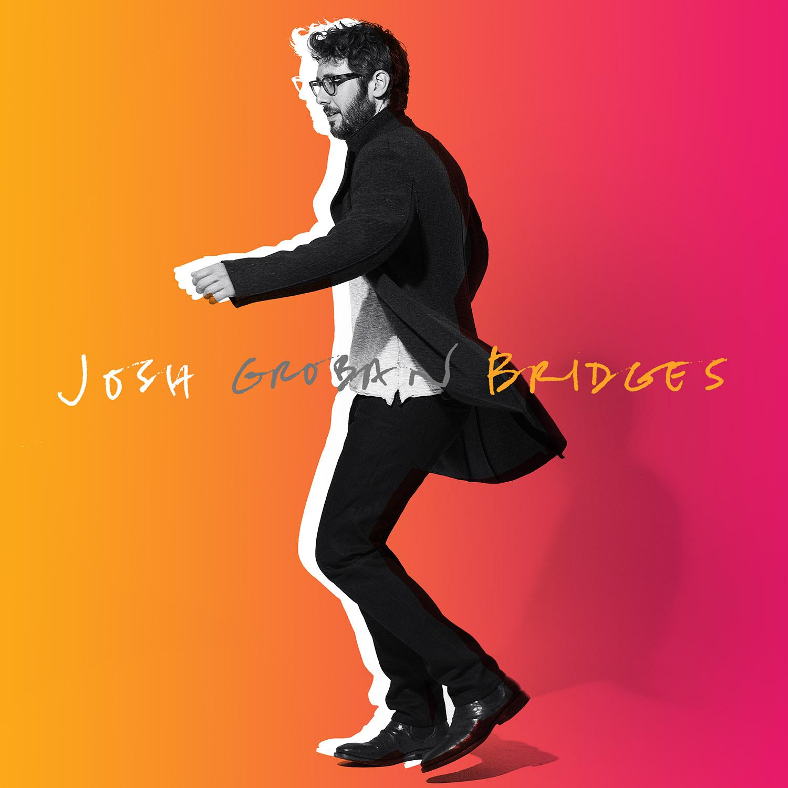
ARENA TOUR WITH IDINA MENZEL
KICKS OFF OCTOBER 18

August 13, 2018 (Los Angeles, CA) - Today, multi-platinum award-winning singer, songwriter, and global superstar Josh Groban uncovers the tracklisting for his anxiously awaited eighth full-length studio album, Bridges [Reprise Records]—in stores and at all DSPs Friday September 21, 2018.

The pre-order is live now, unlocking instant grat downloads of recent singles “Granted” and “Symphony” as well as “S’il Suffisait D'Aimer.” Get it HERE.

Consisting of nine songs co-written by the artist, it marks the first album to feature his writing since 2013’s All That Echoes.

“I wanted to find a balance,” Groban says of the new record. “That’s one of the reasons behind the title. I’ve always enjoyed singing about light and dark and love and loss as well as friendship. I really emphasized choosing the songs and the order to serve a continuity of energy. The album is about learning lessons, appreciating when love comes your way, being Zen about it when love leaves, and keeping a more energetic and positive spirit moving forward. Music has that way of uniting people unlike anything else in the world. This time, I felt more comfortable writing. I’m really conveying my message and story.”

Beyond the recently released tracks, the Standard incarnation features 12 new songs, including a historic Italian duet with Andrea Bocelli entitled “We Will Meet Once Again” in addition to the studio recording of the live fan favorite “Run” featuring Sarah McLachlan and a collaboration alongside Sugarland’s Jennifer Nettles, “99 Years.”

Over the course of Bridges, Groban delivers a dynamic, diverse, and definitive body of work. “River” stands out as an emotional track wherein his powerhouse tone underscores the details of the rejuvenating effect of walking to the Hudson River alongside his dog. Meanwhile, “Musica Del Corazon” continues a lifelong love affair with the romance languages as Groban belts in Spanish backed by the fleet-fingered fret fireworks of world-renowned virtuosic classical guitarist Vicente Amigo. The conclusion “Bigger Than Us” sees him carry an uplifting message of unity to the heavens and back with inspiring charisma and spirit as the hook—“I feel so small with my hands up to the sky, I am reaching up tonight ‘cuz this is bigger than us”—soars.

The Deluxe Edition features a soulful and striking cover of Billy Joel’s “She’s Always A Woman” as well as one other song.

To bring this vision to life, he recorded in Los Angeles, London and New York with multiple producers including Bernie Herms and Toby Gad, Steve Jordan, Dan Huff, and others.

Expanding his influence, Groban co-stars on the highly anticipated new NETFLIX original series, The Good Cop, alongside Tony Danza. The series begins streaming on September 21 the same day Bridges arrives. Watch the trailer HERE.

Next up, he embarks on a Fall 2018 arena tour supported by Tony-Award winning, multi-platinum recording artist and actress, Idina Menzel. Check out the dates below!
Josh Groban connects like never before with Bridges.

TRACKLISTING:
STANDARD
1. “Granted”
2. “Symphony”
3. “River”
4. “Musica Del Corazon” feat. Vicente Amigo
5. “Bridge Over Troubled Water”
6. “Run” feat. Sarah McLachlan
7. “S’il Suffisait D'Aimer”
8. “Won’t Look Back”
9. “We Will Meet Once Again” feat. Andrea Bocelli
10. “More Of You”
11. “99 Years” feat. Jennifer Nettles
12. “Bigger Than Us”
DELUXE
13. “You Have No Idea”
14. “She’s Always A Woman”

BRIDGES TOUR DATES:
Thurs., October 18 Duluth, GA Infinite Energy Center
Fri., October 19 Nashville, TN Bridgestone Arena
Tues., October 23 Houston, TX Toyota Center
Wed., October 24 Dallas, TX American Airlines
Center
Fri., October 26 Phoenix, AZ Talking Stick Resort
Arena
Sat., October 27 Inglewood, CA The Forum
Mon, October 29 Salt Lake City, UT Vivint Smart Home
Arena
Tues, October 30 Denver, CO Pepsi Center
Fri., November 2 St. Paul, MN Xcel Energy Center
Sat., November 3 Milwaukee, WI WI Entertainment &
Sports Center
Tues., November 6 Chicago, IL United Center
Wed., November 7 Detroit, MI Little Caesars
Fri., November 9 Boston, MA TD Garden
Sat., November 10 Uncasville, CT Mohegan Sun Arena
Mon., November 12 Philadelphia, PA Wells Fargo Arena
Tues., November 13 Rochester, NY Blue Cross Arena
Thurs., November 15 Washington DC Capital One Arena
Fri., November 16 Pittsburgh, PA PPG Paints Arena
Sun., November 18 New York, NY Madison Square
Garden

JoshGroban.com | Facebook.com/JoshGroban | Twitter:@JoshGroban | Instagram:@JoshGroban

# # #

For further information please contact:
Luke Burland, BB Gun Press / 323 904 9094
luke@bbgunpress.com

