BRYCE VINE STICKS TO HIS ALT-ROCK ROOTS ON NEW TRACK “AMERICAN DREAM”
LISTEN HERE – WATCH VIDEO HERE

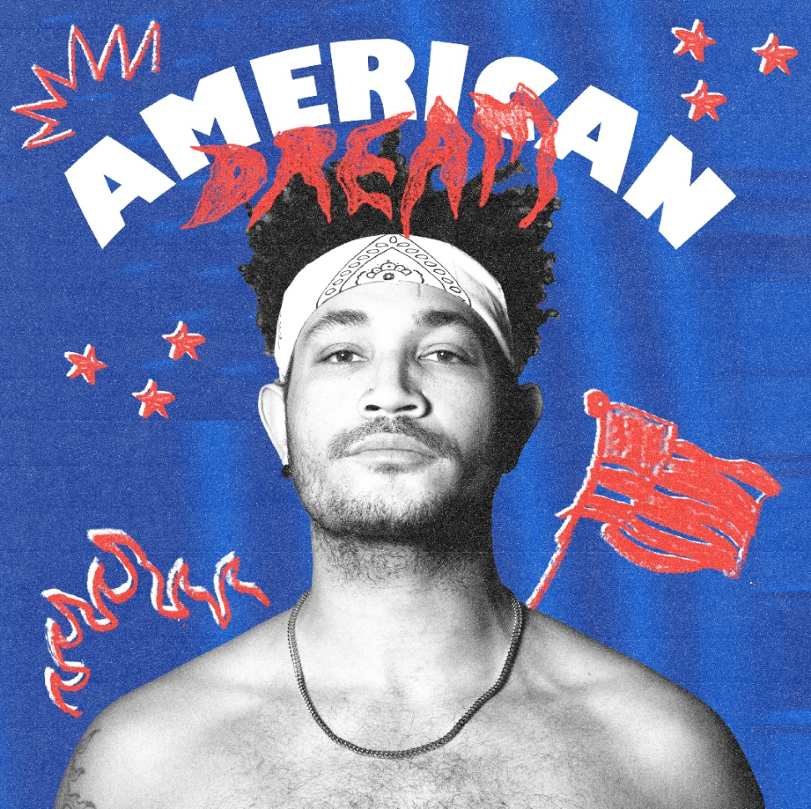

March 11, 2022 (Los Angeles, CA) – Multi-platinum pop/hip-hop maverick Bryce Vine returns with new track “American Dream,” out today on Warner Records. Arriving on the heels of a massive North American headline run, the song continues Bryce’s return to his first love of ‘90s punk and alt-rock and follows his release of “Empty Bottles” (feat. MOD SUN), which was crafted with the help of legendary pop-punk producer John Feldmann [Blink-182, Avril Lavigne]. Listen to “American Dream” HERE and watch the accompanying video HERE.

About the track, Bryce explains, “America has never been a stranger place. People are consistently divided, so rather than further that divide, I wanted to take the angst and unease that many of us are feeling, put a tongue-in-cheek spin on it, and make a song you can bang your head to. I think it’s best summed up with the lyric “The American Dream ain’t what it used to be, it’s kind of a nightmare.”

Since popping off with the double-platinum smash “Drew Barrymore” and platinum “La La Land” [feat. YG], Bryce has tallied up nearly 2 billion streams to date, and delivered a series of unforgettable performances on Late Night with Seth Meyers, Jimmy Kimmel LIVE!, Wendy Williams, The Kelly Clarkson Show, The Late Late Show with James Corden, Live with Kelly and Ryan, Good Morning America, and more. He’s pushed himself outside the confines of genre, collaborating with everyone from lovelytheband and FITZ to Cheat Codes, Loud Luxury, Parmalee, and Jeremih.

Stay tuned for more to come in 2022!

###
FOLLOW BRYCE VINE:
Website | Facebook | Twitter | Instagram | Youtube | TikTok

For more information, please contact:
Ceri Roberts – Ceri.Roberts@warnerrecords.com
Patrice Compere – Patrice.Compere@warnerrecords.com

