BRYCE VINE FUELS THE POP-PUNK REVIVAL WITH
NEW SINGLE “EMPTY BOTTLES” FEAT. MOD SUN
LISTEN HERE – WATCH HERE

“MISS YOU A LITTLE” TOUR DATES JUST ANNOUNCED FOR 2022
TICKETS ON-SALE HERE

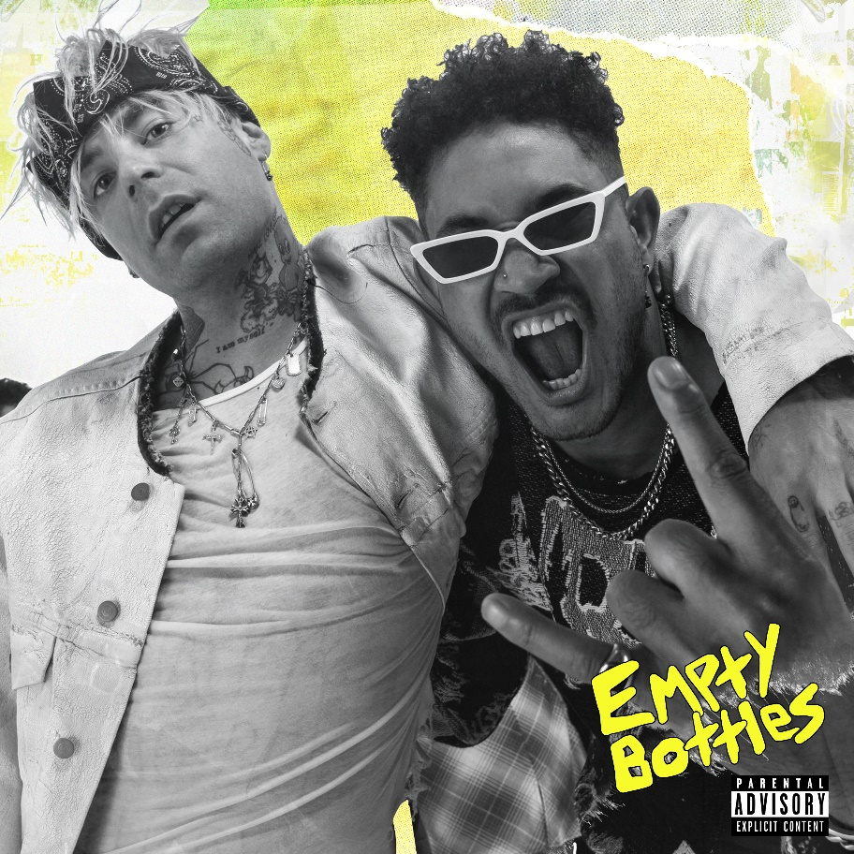

November 19, 2021 (Los Angeles, CA) – Continuing his streak of genre-spanning collaborations, Bryce Vine officially enters his pop-punk era with new single “Empty Bottles” (feat. MOD SUN), out today on Sire Records. Crafted with the help of legendary rock producer John Feldmann (Blink-182, Good Charlotte), the nostalgic guitar-driven track marks an entirely new evolution for Bryce as he reignites his pop-punk influences from the late ‘90s/early ‘00s. Listen to it HERE and watch the accompanying video HERE.

“My first memories of writing music were in my high school pop punk band,” Bryce explains. “I’ve always tried to infuse the energy and spirit of punk into my writing and performance, even across other genres. Working with legendary producer John Feldmann (lead singer and guitarist of Goldfinger) on ‘Empty Bottles’ has felt like a return to my roots in the purest form. I’ve been a fan of Mod Sun for years and this collab between us feels like a childhood dream come true.”

Bryce also just announced 2022 dates for his “Miss You A Little Tour,” bringing his explosive live show to major markets across the country. Beginning January 13th in San Diego, CA, the 25+ date tour will make stops in New York City, Los Angeles, Boston, and Chicago, to name a few. See a full list of dates below, and tickets are available now at www.brycevine.com.

UPCOMING U.S. TOUR DATES
January 13 San Diego, CA House of Blues
January 14 Santa Ana, CA The Observatory
January 16 Las Vegas, NV House of Blues
January 18 Dallas, TX Studio at the Factory
January 19 Austin, TX Empire Garage
January 20 Houston, TX Warehouse Live
January 21 New Orleans Republic
January 22 Nashville, TN Brooklyn Bowl
January 23 Atlanta, GA Buckhead
January 25 Silver Spring, MD The Filmore
January 26 Philadelphia, PA The Filmore
January 28 New York, NY Irving Plaza (Sold Out!)
January 29 New York, NY Irving Plaza (2nd Show Added!)
January 30 Boston, MA Big Night Live
February 2 Columbus, OH Bluestone
February 3 Indianapolis, IN Egyptian Room
February 5 Detroit, MI St. Andrews Hall
February 6 Chicago, IL Park West
February 8 Milwaukee, WI Turner Hall
February 9 Minneapolis, MN Varsity Theater
February 10 Lincoln, NE Bourbon
February 11 Denver, CO Cervantes
February 15 Seattle, WA Showbox
February 16 Portland, OR Roseland Theater
February 18 Sacramento, CA Ace of Spades
February 19 San Francisco, CA August Hall
February 20 Santa Cruz, CA The Catalyst
February 21 Los Angeles, CA The Wiltern

MORE ABOUT BRYCE VINE:
Distilling nimble wordplay, hyper-charged hooks, and intimate guitars into genre-less and timeless songcraft, Bryce Vine leaves his stamp on pop music and culture. Since emerging in 2013, the Los Angeles-based multi-platinum singer, songwriter, producer, and guitarist has quietly built a devoted audience with EPs such as Lazy Fair (2014) and Night Circus (2016). However, he popped off on an international scale with the double-platinum smash “Drew Barrymore.” It paved the way for the platinum “La La Land” [feat. YG] and his first full-length in 2019, Carnival. When the world shut down in 2020, Bryce also looked inward and released the contemplative EP Problems, and in 2021 he’s become a genre-spanning collaborator, joining Parmalee on their reimagined pop version of #1 country smash “Just the Way”; indie-pop artist FITZ on “Congratulations” ; Shaylen and KyleYouMadeThat for “Do Si Do,” and most recently, lovelytheband on “Miss You A Little.” Along the way, Bryce has attracted widespread acclaim from Bustle, Billboard, Teen Vogue, American Songwriter, VIBE, Flaunt and more, with TIME declaring “Bryce Vine is the epitome of low-key cool.” In addition to tallying over 1 billion total streams, he delivered a series of unforgettable performances on Late Night with Seth Meyers, Jimmy Kimmel LIVE!, Wendy Williams, The Kelly Clarkson Show, The Late Late Show with James Corden, Live with Kelly and Ryan, Good Morning America, ELLEN and more.

###
FOLLOW BRYCE VINE:
Website | Facebook | Twitter | Instagram

For more information, please contact:
National: Ceri Roberts – Ceri.Roberts@warnerrecords.com
National: Darren Baber – Darren.Baber@warnerrecords.com
Tour: Patrice Compere – Patrice.Compere@warnerrecords.com

