BRYCE VINE SHINES ON NEW SUMMER ANTHEM “NOBODY” OUT NOW

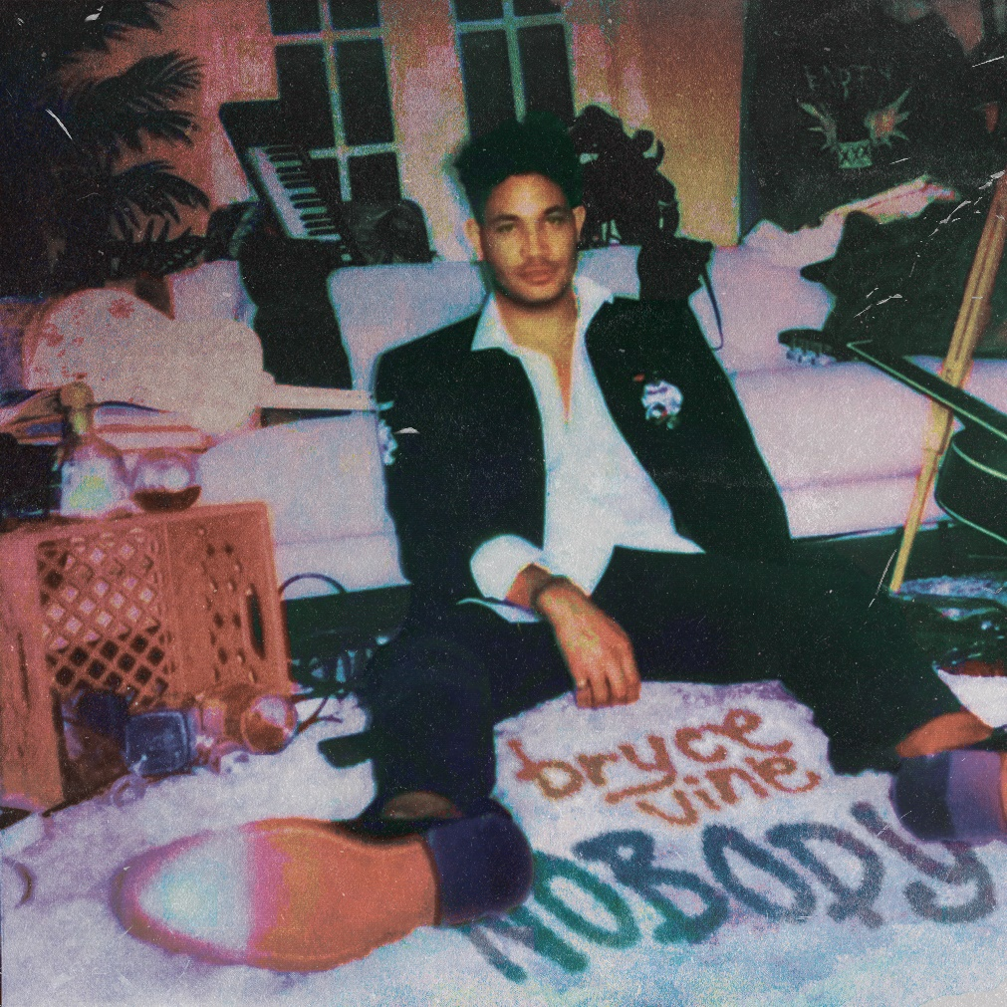
Hi-res art here

June 17, 2022 (Los Angeles, CA) – Maintaining unprecedented momentum, multi-platinum maverick Bryce Vine shares a new single entitled “Nobody” today via Warner Records. Listen to “Nobody” HERE and watch the lyric video HERE.

The track rides a bright piano melody as he leans into a slick and simmering laidback flow. He cruises right towards the hummable refrain (sung by a children’s choir) as he declares, “Don’t matter if I said it already, I’ll say it again, ‘Ain’t no fucking body, ain’t nobody like me’.” It shines as a quintessential summer anthem for 2022 with a message meant to uplift.

Bryce explains, “When I started this song, it was intended to hype me up when I was feeling down. With everything going on in the world today, I realize now that this song is for everybody. I think with depression and suicide at an all-time high, it’s important to help people find reasons to feel positive, capable, and self-loving. It’s a song anyone can sing to themselves in the mirror.”

“Nobody” arrives on the heels of latest singles “y can’t we b friends?” and “American Dream,” as well as his recent collaboration on Snakehips’ “WATER” which dropped this Spring. He kicked off this hot streak with “Empty Bottles” (feat. MOD SUN), which was produced by iconic pop-punk producer John Feldmann [blink-182, Avril Lavigne].

Following his massive North American headline run earlier this year, Bryce will perform select dates throughout the summer. See www.brycevine.com for all dates and info.

Ain’t nobody like Bryce Vine!

ABOUT BRYCE VINE
Since popping off with the double-platinum smash “Drew Barrymore” and platinum “La La Land” [feat. YG], Bryce has tallied up more than 2 billion streams to date, and delivered a series of unforgettable performances on Late Night with Seth Meyers, Jimmy Kimmel LIVE!, Wendy Williams, The Kelly Clarkson Show, The Late Late Show with James Corden, Live with Kelly and Ryan, Good Morning America, and more. He’s pushed himself outside the confines of genre, collaborating with everyone from Wale, lovelytheband and FITZ to Cheat Codes, Loud Luxury, Parmalee, and Jeremih. At the same time, brands such as Pepsi, TRULY, Malibu Rum, Capitol One, and Fender have sought him out for collaborations.

###

FOLLOW BRYCE VINE:
Website | Facebook | Twitter | Instagram | Youtube | TikTok

For more information, please contact:
Ceri Roberts – Ceri.Roberts@warnerrecords.com
Patrice Compere – Patrice.Compere@warnerrecords.com

