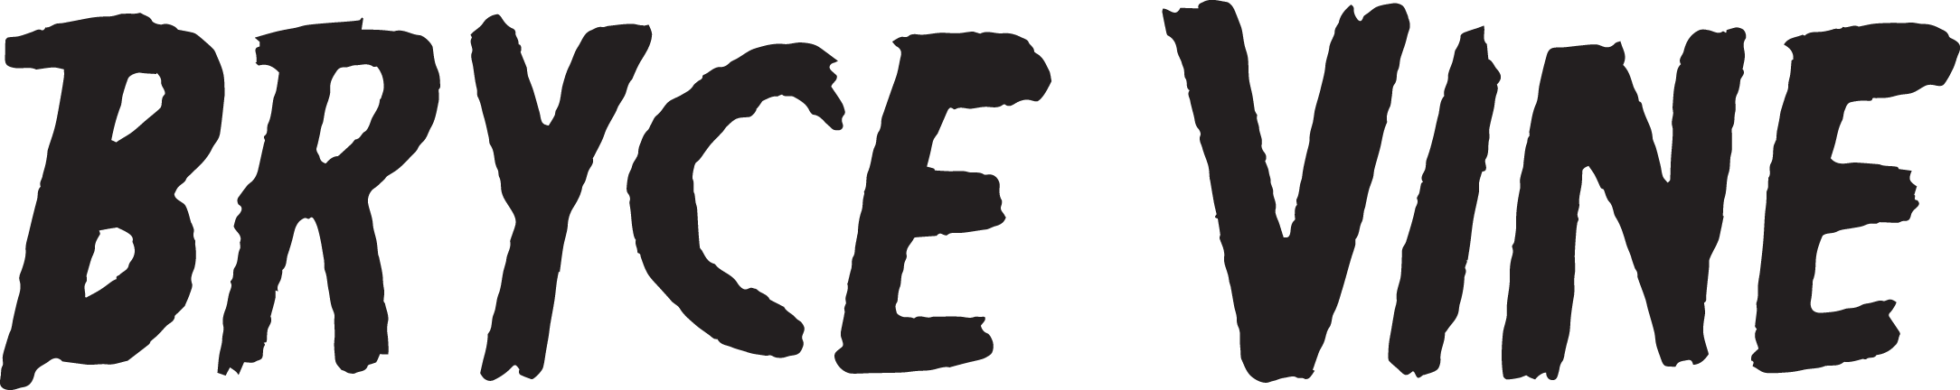

Circumstances ultimately push us to react, change, and improve.
As the world turned upside down and all around, Bryce Vine grabbed a guitar, sequestered himself in a tiny bedroom, and cataloged the moment as it unfolded right in front of him. Without a filter, each feeling slipped through the cracks and onto tape. The multiplatinum singer, songwriter, and producer let his guard down, spoke from the heart, and allowed a tear or two to fall on the fretboard. By doing so, he fashioned his 2020 Problems EP [Sire Records] out of eloquent observations, delicate instrumentation, catchy confessions, and emotionally charged delivery.
“As life gets harder, I try to write things that make me feel better,” he explains. “It’s what I do. I never want to make the same song twice. A lot of this music was inspired while I was sitting by myself in my room during quarantine with nothing else to do but get better at guitar. That’s how I wrote as a kid in the living room or in my garage. It was a return to that.”
However, he never lost sight of that in the first place…
Bryce stands out as the rare kind of guy who can speak for hours on end about sci-fi classics like Alien and authors a la Ted Chiang and Stephen King—or stay out until sunrise at a house party. He always proved to be an outlier though. Of African-American, Native American, and Italian descent, Bryce grew up between Manhattan, NY and Thousand Oaks, CA. Inspired by everyone from blink-182 and Rancid to Tupac and OutKast, he fronted a scrappy punk band in high school before attending Berklee College of Music for a year on a scholarship. Returning to Los Angeles, he held down a series of odd jobs, drove for Lyft, hosted at a restaurant, and worked in a bar—all while residing “in a living room in Hollywood with two other dudes.” Simultaneously, he crafted a rich style of his own. As if hosting a banquet, Bryce set the table with a myriad of ingredients, encompassing hip-hop, pop, alternative, and rock.
“My dad was a restaurant owner,” he says. “He’s a very humble guy. Everyone was invited at his restaurant. He has no prejudices and wants people to be together around food. My grandma was the same way. My way to bring everyone together is around music.”
As such, he built a devoted audience with EPs such as Lazy Fair [2014] and Night Circus [2016]. However, he popped off on an international scale with the double-platinum smash “Drew Barrymore.” It paved the way for the platinum “La La Land” [feat. YG] and his first full-length in 2019, Carnival. Along the way, Bryce attracted widespread acclaim from Bustle, Billboard, Teen Vogue, VIBE, and more, with TIME declaring “Bryce Vine is the epitome of low-key cool.” In addition to tallying over 1 billion total streams, he delivered a series of unforgettable performances on Late Night with Seth Meyers, Jimmy Kimmel LIVE!, Wendy Williams, The Kelly Clarkson Show, The Late Late Show with James Corden, Live with Kelly and Ryan, Good Morning America, and more.
Placing a busy schedule on hold at the onset of the Global Pandemic, Bryce locked down at home without a show or a plan for the first time in three years. Crafting what would become the EP, he the cut title tune “Problems” with up-and-coming artist Grady and recorded guitar for the first time on a project. Upon arrival, E! News crowned it “a track for the times.”
Produced by longtime collaborators Sir Nolan and JP Clark, the single “Life Goes On” pairs deep intonation with stark acoustic strumming and a syncopated background beat. Over this soundscape, he discloses, “I can’t think around the noise,” before assuring, “Life goes on.”
“I was at the Staples Center for the GRAMMYs when the news about Kobe Bryant broke,” he sighs. “Everything stopped. He was almost like a superhero, especially for black kids. He was a master at his craft, spoke four languages, had a wonderful family, and was helping children everywhere through his foundation alongside his wife, Vanessa. I thought the reward for that would be more, so it really shook my faith in good individuals getting what they deserve. After two days, I was going through it. I vented on ‘Life Goes On.’ I said things that made me feel better in the moment about the situation. When I listen to it, it still makes me feel better.”
Then, there’s “Fall Apart.” Electric guitar cuts through a haze of skittering beats as he admits, “I’m just as lost as you are, blame it all on the stars, if it falls apart, it falls apart.”
“If everything falls apart, at least we’re together,” he goes on. “It’s a day-in-the-life of a shitty time. All of these songs have a sadness to them, but there’s hopefulness—because I will always try to stay hopeful.”
In the end, Bryce Vine turns up with a little bit of hope for everyone by doing what he’s always done and being himself.
“I’m just a nerdy kid who played Yu-Gi-Oh!, likes horror movies, was awkward with girls until he grew up, and is insecure” he leaves off. “I feel like that chubby kid. I think fans relate, because I wouldn’t know how to put on a front even if I wanted to. I really love to make a music. I’m trying to be a good person, but I fuck up all the time like everyone else does. I still strive to be like that Kobe Bryant figure though and bring people together. I don’t think I’ll stop.”

BOILER
Distilling nimble wordplay, hyper-charged hooks, and intimate guitars into genre-less and timeless songcraft, Bryce Vine leaves his stamp on pop music and culture. Since emerging in 2013, the Los Angeles-based multiplatinum singer, songwriter, producer, and guitarist has quietly built a devoted audience with EPs such as Lazy Fair [2014] and Night Circus [2016]. However, he popped off on an international scale with the double-platinum smash “Drew Barrymore.” It paved the way for the platinum “La La Land” [feat. YG] and his first full-length in 2019, Carnival. Along the way, Bryce attracted widespread acclaim from Bustle, Billboard, Teen Vogue, VIBE, and more, with TIME declaring “Bryce Vine is the epitome of low-key cool.” In addition to tallying over 1 billion total streams, he delivered a series of unforgettable performances on Late Night with Seth Meyers, Jimmy Kimmel LIVE!, Wendy Williams, The Kelly Clarkson Show, The Late Late Show with James Corden, Live with Kelly and Ryan, Good Morning America, and more. When the world turned upside down and all around, Bryce Vine grabbed a guitar, sequestered himself in a tiny bedroom, and cataloged the moment as it unfolded right in front of him. Without a filter, each feeling slipped through the cracks and onto the tape let his guard down, spoke from the heart, and allowed a tear or two to fall on the fretboard. By doing so, he crafted his 2020 Problems EP [Sire Records] out of eloquent observations, catchy confessions, and emotionally charged delivery. He kicked off this chapter with “Problems” with up-and-comer Grady and “Life Goes On.”

