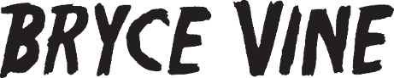

BRYCE VINE ASKS “y can’t we b friends?” ON NEW SINGLE

LISTEN HERE – WATCH LYRIC VIDEO HERE

MORE NEW MUSIC COMING SOON

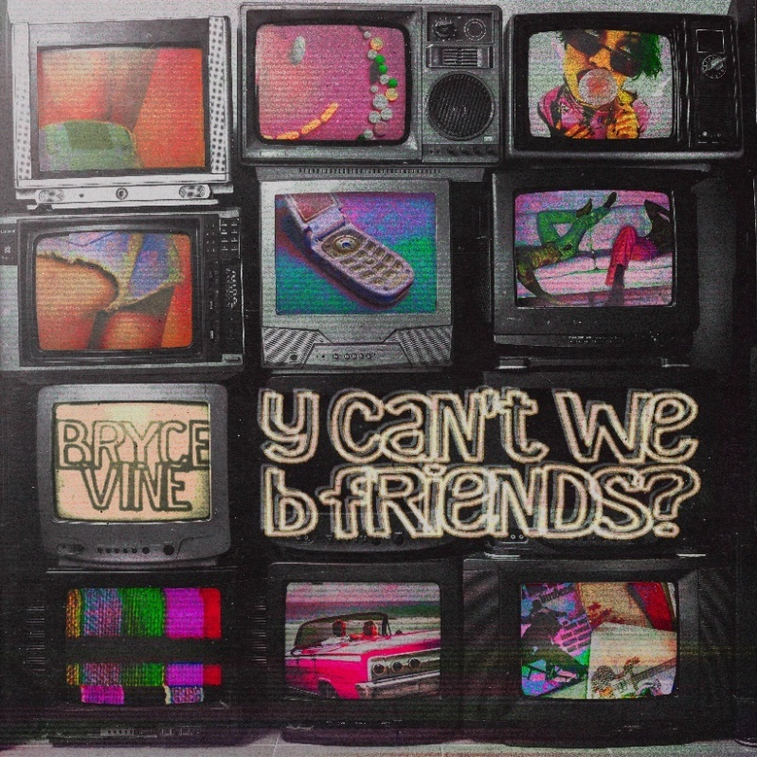

May 27, 2022 (Los Angeles, CA) – Gearing up for a scorching summer, multi-platinum maverick Bryce Vine unveils a new single entitled “y can’t we b friends?” today via Warner Records. Listen to “y can’t we b friends?” HERE and watch the lyric video HERE.

Co-produced by One Love [Madison Beer, Tate McRae, Quinn XCII], Sweater Beats [Lizzo, Panic! At The Disco, Hayley Kiyoko], and Bumbasee, the track skates along on a head-nodding beat punctuated by glitchy claps. Emanating confidence and charisma, Bryce locks into a slick and singable flow as he muses, “I think it’s better we go our separate ways I’ve been asking you the same fucking question for days, why can’t we be friends?” The hummable melody nods to the WAR classic “Why Can’t We Be Friends?” with a modern twist as a breezy and bold breakup bop!

About the single, Bryce shared, “The hook for WAR’s ‘Why Can’t We Be Friends?’ is so iconic that it works in any style, but it took on a new meaning for me last year. I tried mushrooms for the first time in Joshua Tree and wrote and recorded this whole song in one night with my buddy JP Clark. During that evening, my phone dinged, and a message from my mysterious cyber stalker flickered on my screen reading “hi friend.” The song is now dedicated to them.”

The song paves the way for a steady string of music to be released over the summer!

It also arrives on the heels of latest single “American Dream,” as well as his recent collaboration on Snakehips’ “WATER” which dropped earlier this month. He kicked off this hot streak with “Empty Bottles” (feat. MOD SUN), which was produced by iconic pop-punk producer John Feldmann [blink-182, Avril Lavigne].

Following his massive North American headline run earlier this year, Bryce hits the road next month for a handful of dates, performing at Petco Park in San Diego, CA on June 4 with Dirty Heads and Mandalay Beach at Mandalay Bay Resort in Las Vegas, NV with Sublime With Rome on July 2. Check out the full confirmed itinerary below.

Since popping off with the double-platinum smash “Drew Barrymore” and platinum “La La Land” [feat. YG], Bryce has tallied up more than 2 billion streams to date, and delivered a series of unforgettable performances on Late Night with Seth Meyers, Jimmy Kimmel LIVE!, Wendy Williams, The Kelly Clarkson Show, The Late Late Show with James Corden, Live with Kelly and Ryan, Good Morning America, and more. He’s pushed himself outside the confines of genre, collaborating with everyone from Wale, lovelytheband and FITZ to Cheat Codes, Loud Luxury, Parmalee, and Jeremih. At the same time, brands such as Pepsi, TRULY, Malibu Rum, Capitol One, and Fender have sought him out for collaborations.

TOUR DATES
6/4 San Diego, CA Petco Park^
6/19 Huntington, NY The Paramount
7/2 Las Vegas, NV Mandalay Beach at Mandalay Bay Resort*
8/6 Kansas City, MO Breakaway Festival

^with Dirty Heads
*with Sublime With Rome

###
FOLLOW BRYCE VINE:
Website | Facebook | Twitter | Instagram | Youtube | TikTok

For more information, please contact:
Ceri Roberts – Ceri.Roberts@warnerrecords.com
Patrice Compere – Patrice.Compere@warnerrecords.com

