

**AUSTRALIAN R&B ARTIST BUDJERAH SHARES NEW SINGLE + VISUALIZER “WASH MY SORROWS AWAY” OUT NOW WORLDWIDE**

**WINS *BREAKTHROUGH ARTIST* AT AUSTRALIA’S 2021 ARIA AWARDS**

**ANNOUNCED AS SPECIAL GUEST FOR VANCE JOY IN AUSTRALIA,**

**USA AND CANADA**

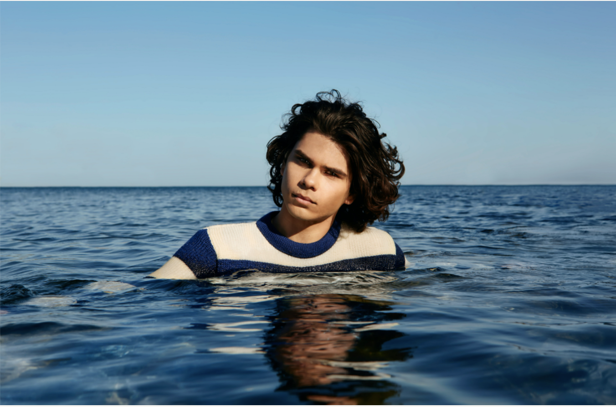

Photo credit: Elliott Lauren Smith

“.. the presence of his sound like sunlight for the senses.”

* **VOGUE**

“Budjerah pieces together elements of traditional R&B, pop and gospel, all underpinned by a dreamy, soul-infused chord progression."

**- NME**

"Shining voice of a star in waiting."

**- SYDNEY MORNING HERALD**

**November 25, 2021 (Los Angeles, CA)** - Following his ARIA Award win this week for **Breakthrough Artist**, performance and **New Talent of the Year** at the **National Indigenous Music Awards,** today [**Budjerah**](https://www.instagram.com/budjerah/) reveals his timeless **new single “Wash My Sorrows Away**,”alongside the track’s **visualizer**via **Warner Records**.

Produced by Budjerah’s collaborator and artistic confidante [**Matt Corby**](https://www.instagram.com/mattcorby/)and mixed by [**Eric J**](https://www.instagram.com/ericjdub/), on “Wash My Sorrows Away,”Budjerah’s luminous vocals smoothly glide over the lo-fi production to elevate the track to spiritual proportions.

“*Wash My Sorrows Away* is my teenage heartbreak song. Everyone has tough times and we all have our own ways of dealing with sadness, and this song tells what it's like for me when I'm in those situations. If I'm ever having a tough time I like to go home and get into the ocean, whether it's surfing or just diving under for a few seconds, it helps me get out of my own head. ‘You know I try to keep myself out of mind’. It's also about wanting to be with someone in particular, someone that takes up that space in your head ‘But I still keep you inside,’” muses Budjerah.

The new song follows on from his gleaming, soulful single[***Talk* feat. MAY-A**](https://budjerah.lnk.to/Talk) - an appeal to look up, take a beat, take a breath, and reconnect with your loved ones. The track is a joyful, much-needed tonic for a world riddled with misunderstanding and miscommunication and takes a clear cue from his idols and antecedents Sam Cooke and The Clark Sisters — patron saints of clarity and honesty.

He might be young, but there’s always been something wise-beyond-his-years about Budjerah. His **debut, self-titled EP**, released earlier in 2021, displayed an aptitude for the sheen and indelibility of old-school soul singers, a quality that spoke to the classic records he was raised on growing up in coastal New South Wales.

Budjerah’s phenomenal run commenced in October 2020 with his acclaimed debut single [***Missing You*,**](https://www.youtube.com/watch?v=PFq9h4GYAd8) which landed the #1 most played position on triple j, and soon followed with his runaway hit single[***Higher***](https://positive-feedback.us13.list-manage.com/track/click?u=47d12b32f851a79a3139bb75f&id=b5090fc363&e=0a8ccd0bac)*,* which achieved **Top 30 national airplay.**  Budjerah performed on **The Sound, Music From The Home Front,** and at the **AFL Dreamtime match**; and collaborated with dance music superstars **PNAU.** He announced a partnership with **Warner Records US,** was named an **Apple Music Up Next artist** and most recently was selected as one of the artists from around the globe for **#YouTubeBlack Voices Artist Class of 2022**.

**BUDJERAH - 2022 TOUR DATES**

[Tickets](https://www.budjerah.com/#tour)

Saturday 2 April + Sunday 3 April | Yours and Owls, Wollongong NSW

**Friday 27 May | Rogers Arena, Vancouver, BC\***

**Thursday 2 June | Ryman Auditorium, Nashville, TN\***

**Saturday 4 June | Pier 17, New York City, NY\***

**Thursday 9 June | Budweiser Amphitheatre, Toronto, ON\***

Saturday 17 September | Gardens Amphitheatre, Darwin NT*

Saturday 24 September | Munro Martin Parklands, Cairns QLD*

Saturday 1 October | Queen Elizabeth Park, Gold Coast QLD*

Saturday 8 October |- Patrick White Lawns, Canberra ACT*

Saturday 15 October | Foreshore Park, Newcastle NSW*

Saturday 22 October | Lardner Park, Lardner VIC*

Saturday 29 October | Botanic Gardens, Hobart TAS*

Saturday 5 November | Glenelg Beach, Adelaide SA*

Saturday 12 November | Barnard Park, Busselton WA*

Saturday 19 November | Sydney Opera House Forecourt, Sydney NSW*

Saturday 26 November | Sidney Myer Music Bowl, Melbourne VIC*

*Performing as special guest for Vance Joy

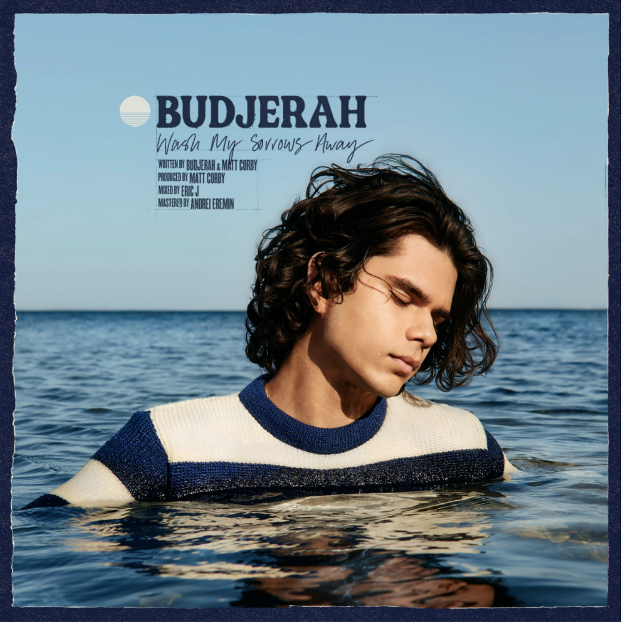

Budjerah *Wash My Sorrows Away* out Friday 26 November

MORE INFO:

[WEBSITE](http://www.budjerah.com/)

[INSTAGRAM](https://www.instagram.com/budjerah/?hl=en)

[FACEBOOK](https://www.facebook.com/Budjerah)

[TWITTER](https://twitter.com/budjerahs?lang=en)

[YOUTUBE](https://www.youtube.com/channel/UCFQXeU__ExeTFCFqeuiZXxA)

[SPOTIFY](https://open.spotify.com/artist/4hOb2WdQMQWyG6RQAhR7iE?si=hxx3-KZhQP68iDCX-DN14Q)

[APPLE MUSIC](https://music.apple.com/au/artist/budjerah/1535027426)