**HYPER POP PHENOMENON CMTEN UNLEASHES NEW SINGLE “ALONE (FEATURING RILEY THE MUSICIAN)”**

**SENDING SHOCKWAVES THROUGH INTERNET CULTURE WITH GENRE-BLURRING ANTHEMS**

**Listen** [**HERE**](https://cmten.lnk.to/alone)

**Watch** [**HERE**](https://cmten.lnk.to/alonevisual)

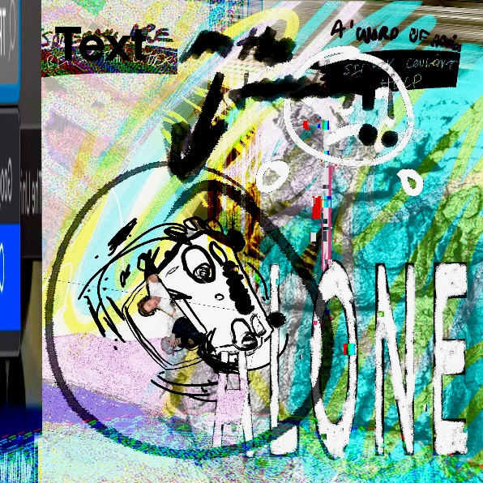

(Click [**here**](https://press.warnerrecords.com/wp-content/uploads/2021/02/alone.jpg) for hi-res artwork)

**February 5, 2021 (Los Angeles, CA)** – Setting the pace for sonic disruption in 2021, 19 year old [**CMTEN**](https://www.instagram.com/cmt3n/?hl=en) reveals an incisive and introspective new single entitled **“ALONE [Feat. RILEY THE MUSICIAN]”** available today on **Masked Records**/**Warner Records**. Click [**HERE**](https://cmten.lnk.to/alone) to stream and [**HERE**](https://cmten.lnk.to/alonevisual) to watch/share.

This time around, **CMTEN** dives inward between a deluge of wobbling bass, warped video game-style synths woven around an infectious slice of pure pop. **CMTEN’s** first new music of 2021 locks into a seesawing vocal call-and-response with fellow maverick **RILEY THE MUSICIAN** as they extol the virtues of isolation. Sneaking lovelorn emotionally charged lyrics under a blanket of distorted glitch, it culminates on one final high register transmission, *“Drive me home, I just want to be alone, yeah*.*”* A new anthem for the pandemic era.

About the song, **CMTEN** comments, *“I’ve been a fan of* ***RILEY THE MUSICIAN*** *for a while, and I reached out to him to make a song together around a year ago. This was the first version of* ***‘ALONE****,****’*** *as well as my first time ever collaborating with someone else musically. Since then, a lot has changed, from the way our whole world operates to the way I make music. To me, the track stands today as a reminder of how quickly things can change, for better or worse. I hope you love the song as much as we do.”*

**CMTEN** just capped off a breakthrough year with the critically acclaimed call-to-arms **“I LOVE GLITCHCORE”** **[Feat. XIX]**.**”** It has already racked up over 200K streams and counting. Additionally, [***FLOOD Magazine***](https://floodmagazine.com/83547/in-conversation-xix-cmten-i-love-glitchcore/) conducted a fascinating joint interview between **CMTEN** and labelmates **XIX**, while [***RAIN***](https://rain-mag.com/cmten-talks-never-met-tiktok-and-glitchcore/) ***Magazine***fittingly described his breakthrough [**“Never Met! [Feat. Glitch Gum]”**](https://www.youtube.com/watch?v=xUEg2mXJx0M) as*“an instantly relatable song to an entire generation that interacts nearly entirely through hazy online interactions*.*”* To date, he’s gathered nearly **50 million streams** in matter of months making **CMTEN** one of the most impactful and impressive underground successful stories in recent years.

In the seventies, eighties, or nineties, this story might’ve started in a garage with a guitar…

However, the genre-smashing artist, songwriter, producer/mixer, vocalist, and Danville, CA native unassumingly turned his University of Utah dorm room into ground zero for Glitchcore in early 2020. Translating a passion for old school pop punk and the likes of 100 gecs, Porter Robinson and Soundcloud Rap into a sound of his own, he uploaded **“NEVER MET!”** and organically attracted a groundswell of support to the tune of 30 million total streams, 1 million-plus TikTok videos, and more. Not to mention, his ascent has been chronicled by [***Rolling Stone***](https://www.rollingstone.com/music/music-features/alt-tiktok-music-xix-cmten-1038719/) and [***Pitchfork***](https://pitchfork.com/thepitch/is-glitchcore-a-tiktok-aesthetic-a-new-microgenre-or-the-latest-iteration-of-glitch-art/).

Recklessly blurring lines with no apologies, **CMTEN**’s brand of subversion is as caustic as it becomes an ultra-modern classic. Brace yourself for more.

**About CMTEN:**

**What/who is CMTEN?** Some saypop, punk, Future Trap, Cloud Rap, Techstep Noize. Maybe it’s just what it sounds like when this 19-year-old college student sounds like when he creates music on his computer in his room. California-raised CMTEN is a songwriter/producer/mixer combines scraps of all the music he’s ever been into and has created a futuristic vision of his own sonic design that’s unlike any of the above tags. His first recordings from two years ago started out with a handful of monthly listeners on Spotify before he released **“NEVER MET!”** That single hooky ear spasm exploded globally and has accumulated over 1,000,000 videos on TikTok, racked up over 5 million Youtube views, and amassed over 20 million streams on Spotify alone, making **“NEVER MET!”** one of the biggest underground tracks of the year. **Masked Records’ Roger Gengo** points out that the track has been a bright spot in the midst of a dark year. “I wish I never met the year 2020,” he says. “But I'm thrilled I met **CMTEN** because his infectious breakout song **‘NEVER MET!’** has been the one bright spot in this abysmal year bringing joy to literally millions of fans who have made videos on Tik Tok and 30+ million who have streamed the song.” **CMTEN** will be continuing to spread gleeful abandon for a long time to come.

**# # #**

**Contact Warner Records Publicity:**

**Rick Gershon** | [rick.gershon@warnerrecords.com](mailto:rick.gershon@warnerrecords.com)

**FOLLOW CMTEN:**

[Instagram](https://nam04.safelinks.protection.outlook.com/?url=https%3A%2F%2Fwww.instagram.com%2Fcmt3n%2F&data=02%7C01%7CRick.Gershon%40warnerrecords.com%7C79df1453f95d453ad85908d84b779047%7C8367939002ec4ba1ad3d69da3fdd637e%7C0%7C0%7C637342324182639422&sdata=BYY6CVM0hLs1EMWmasiP%2BzJSiOwPN5tZ2iDfb9kGN9c%3D&reserved=0) | [Twitter](https://nam04.safelinks.protection.outlook.com/?url=https%3A%2F%2Ftwitter.com%2Fcmt3n%3Flang%3Den&data=02%7C01%7CRick.Gershon%40warnerrecords.com%7C79df1453f95d453ad85908d84b779047%7C8367939002ec4ba1ad3d69da3fdd637e%7C0%7C0%7C637342324182649386&sdata=HFvu8FaMJHTE6we2%2FV%2BsGhS9C9xnNdRO0ZITHUKKxJo%3D&reserved=0) | [Spotify](https://nam04.safelinks.protection.outlook.com/?url=https%3A%2F%2Fopen.spotify.com%2Fartist%2F3ReVTyprRfKmKquryr9UeA&data=02%7C01%7CRick.Gershon%40warnerrecords.com%7C79df1453f95d453ad85908d84b779047%7C8367939002ec4ba1ad3d69da3fdd637e%7C0%7C0%7C637342324182649386&sdata=CkSue%2FghgwoPLAgKxqCS5LUFrIvq5dG%2B9cAGDj3XWhg%3D&reserved=0)

