HYPERPOP PHENOMENON CMTEN REVEALS ANOTHER SIDE OF HIMSELF
ON NEW SINGLE “BORED”

Listen HERE
Watch HERE

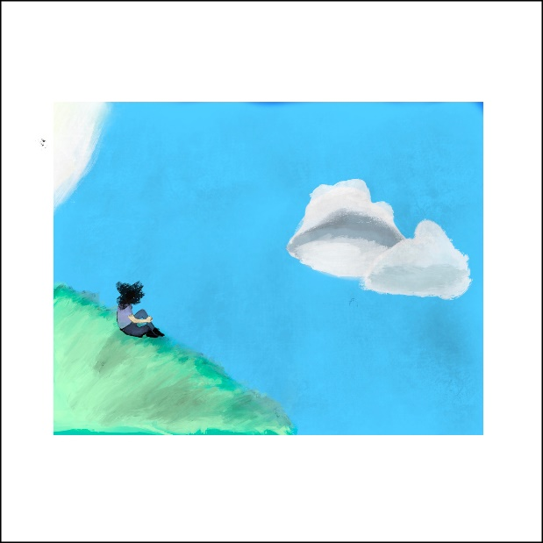
(Click here for hi-res link)

March 5, 2021 (Los Angeles, CA) – Showing yet another side of his artistry, 19 year-old CMTEN shares an intimate guitar-laden single entitled “BORED” available today on Masked Records/Warner Records. Click here to stream and here to watch/share.

On the track, he opts for minimal production and a predominant yet delicate guitar line. This backdrop highlights his expressive voice and palpable vulnerability. The vocals coast over a soft riff before dissolving into glitchy feedback. Between the sound of a touch tone phone, he confesses, “I can’t put on this face no more, yeah I love you, but you just seem bored.”

Regarding the single, CMTEN said, “’BORED’ is about my internal struggle between apathy and sensitivity. It’s essentially a love song to myself. When I say, “love you but you just seem bored,” I mean that there’s a part of me I’m trying my best to love despite its callousness. This has everything to do with a super fun little thing called dissociation - where on a near daily basis I feel mentally detached from myself. It’s basically a coping mechanism for my brain; when my emotions and/or anxiety get too strong, I’ll completely shut down. In ‘BORED,’ I’m experiencing the polar opposite of this. I’m at the height of my emotions, and I’m talking to this detached version of myself. This song means the world to me, and I hope it can mean something for you, too.”

CMTEN recently dropped the fan favorite single “ALONE [feat. RILEY THE MUSICIAN].” Right out of the gate, it earned critical acclaim with Lyrical Lemonade professing, “These two use all the passionate and learned energy in their bodies to craft together a brief, yet impactful experience that not only proves these previously-mentioned ideas, but at the same time, an experience that stands out as a simply blissful pop offering by itself.”

Right now, he’s working on more music to be released very soon.

CMTEN capped off a breakthrough year with the critically acclaimed call-to-arms “I LOVE GLITCHCORE” [Feat. XIX].” It has already racked up over 200K streams and counting. Last year’s breakthrough single “Never Met! [Feat. Glitch Gum]” (over 5M streams & counting) signaled the crest of a new youth movement mashing together a love of post punk-pop with electronic hip-hop beats which has resonated with millions of fans round the world. “Never Met! (Feat. Glitch Gum) [100 gecs r3mix]” only added fuel to the international fire.

To date, he’s gathered nearly 50 million streams in matter of months making CMTEN one of the most impactful and impressive underground successful stories in recent years.

In the seventies, eighties, or nineties, this story might’ve started in a garage with a guitar…However, the genre-smashing artist, songwriter, producer/mixer, vocalist, and San Francisco Bay area native unassumingly turned his University of Utah dorm room into ground zero for Glitchcore in early 2020. Translating a passion for old school pop punk and the likes of 100 gecs, Porter Robinson and Soundcloud Rap into a sound of his own, he uploaded “NEVER MET!” and organically attracted a groundswell of support to the tune of 30 million total streams, 1 million-plus TikTok videos, and more. Not to mention, his ascent has been chronicled by Rolling Stone, Pitchfork and The Atlantic. Brace yourself for more.

About CMTEN:
CMTEN (pronounced See Em Ten), is a 19-year-old artist/songwriter/producer/vocalist from N. California at the forefront of the emerging Hyperpop/Glitchcore scene. CMTEN chops, channels and recombines elements of pure pop songcraft with hip-hop beats, informed by the energy and honesty of punk rock and an unabashed expressive sincerity at the heart of its musical vortex. CMTEN grew up singing in his local choir, has perfect pitch, and has so far made all of his music within the confines of his bedroom. Starting with the release of “NEVER MET!”, CMTEN has exploded globally and has accumulated over 1,000,000 videos on TikTok, racked up over 5.5 million YouTube views, and amassed over 40 million streams on Spotify alone, making him one of the biggest underground success stories of 2020/2021. CMTEN is now part of the Masked Records/ Warner Records roster.

# # #

Contact Warner Records Publicity:
Rick Gershon | rick.gershon@warnerrecords.com

FOLLOW CMTEN:
Instagram | Twitter | Spotify | Press Materials

