**EMERGING HYPER POP-SENSATION CMTEN DROPS “I LOVE GLITCHCORE” FEATURING RISING DUO XIX TODAY**

**19-YEAR-OLD HYPERPOP SENSATION CONTINUES HIS SONIC SUBVERSION VIA HIS LAPTOP ON A GLOBALLY EMERGING SCENE**

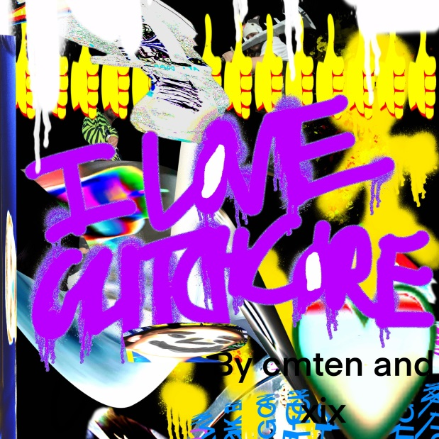

**LISTEN** [**HERE**](https://cmten.lnk.to/glitchcore)

**WATCH** [**HERE**](https://cmten.lnk.to/glitchcorevideo)

**December 4, 2020 (Los Angeles, CA)** – After quietly overtaking the internet D.I.Y. with 40 million-plus streams and counting this year with his disruptive pop hit [**“Never Met! [Feat. Glitch Gum],”**](https://www.youtube.com/watch?v=xUEg2mXJx0M) [**CMTEN**](https://www.instagram.com/cmt3n/?hl=en) unleashes a new ultra-high-energy banger entitled **“I LOVE GLITCHCORE”** **[Feat. XIX]”** on **Masked Records**/**Warner Records** out now. Click [**HERE**](https://cmten.lnk.to/glitchcore) to stream and [**HERE**](https://cmten.lnk.to/glitchcorevideo) to watch/share.

The rising hyperpop futurist recruits fellow sonic insurgents **XIX** to provide glitchcore with its own national anthem. Over a rush of digital distortion and skittering shock and awe, a deluge of warbly vocals comes in jittery waves jammed between razor sharp rhymes and the cacophonously catchy chorus. The track unites two of the genre’s most explosive voices to unapologetically profess, *“I LOVE GLITCHCORE.”*

**CMTEN** says, *“’I LOVE GLITCHCORE’ is an aggressive, energetic, and slightly ironic track that was an absolute blast to make. XIX and I have been talking about this collab since June, and it’s so satisfying to see it finally come to fruition. Karm and Skayda (aka XIX) are two of the most talented musicians I know and has so much fun working on this song with them.”*

**XIX** adds, *"We first heard the track and were like 'hell yeah, we got this.'"* says Skayda, *"its super heavy, which is the same vibe of our upcoming EP. I just hope we went hard enough."*

In the dizzy wake left by the recently released remix, [**“Never Met! [Feat. Glitch Gum) [100 gecs R3Mix],”**](https://www.youtube.com/watch?v=646C_ProQaI)  **“I LOVE GLITCHCORE”** **[Feat. XIX]”** furthers the meteoric rise of **CMTEN** this year. In the seventies, eighties, or nineties, this story might’ve started in a garage with a guitar…

However, the 19-year-old artist, songwriter, producer/mixer, vocalist, and Danville, CA native unassumingly turned his University of Utah dorm room into ground zero for Glitchcore in early 2020. Translating a passion for old school pop punk and the likes of 100 gecs, Porter Robinson and Soundcloud Rap into a sound of his own, he uploaded **“NEVER MET!”** and organically attracted a groundswell of support to the tune of 30 million total streams, 1 million-plus Tik Tok videos, and more. Not to mention, his ascent has been chronicled by [*Rolling Stone*](https://www.rollingstone.com/music/music-features/alt-tiktok-music-xix-cmten-1038719/) and *[Pitchfork](https://pitchfork.com/thepitch/is-glitchcore-a-tiktok-aesthetic-a-new-microgenre-or-the-latest-iteration-of-glitch-art/)*.

Linking up with **Masked Records/Warner Records**, he’s cooking up more music for release very soon.

Recklessly blurring lines with no apologies, **CMTEN**’s brand of subversion is as caustic as it becomes an ultra-modern classic. Brace yourself for more.

**About CMTEN:**

**What/who is CMTEN?** Some saypop, punk, Future Trap, Cloud Rap, Techstep Noize. Maybe it’s just what it sounds like when this 19 year old college student sounds like when he creates music on his computer in his room. California-raised CMTEN is a songwriter/producer/mixer combines scraps of all the music he’s ever been into and has created a futuristic vision of his own sonic design that’s unlike any of the above tags. His first recordings from two years ago started out with a handful of monthly listeners on Spotify before he released **“NEVER MET!”** That single hooky ear spasm exploded globally and has accumulated over 1,000,000 videos on TikTok, racked up over 5 million Youtube views, and amassed over 20 million streams on Spotify alone, making **NEVER MET!”** one of the biggest underground tracks of the year. **Masked Records’ Roger Gengo** points out that the track has been a bright spot in the midst of a dark year. “I wish I never met the year 2020,” he says. “But I'm thrilled I met **CMTEN** because his infectious breakout song **‘NEVER MET!’** has been the one bright spot in this abysmal year bringing joy to literally millions of fans who have made videos on TikTok and 30+ million who have streamed the song.” **CMTEN** will be continuing to spread gleeful abandon for a long time to come.

**About XIX:**

The punk spirit is alive and well in **XIX.** The Connecticut duo, comprised of **Yung Skayda** and **Karm** **the Tool,** began their musical journey in high school playing metal and punk in cramped clubs, and that energy has remained as they’ve tackled one genre after another. **XIX** songs are like Russian nesting dolls, containing an entire album’s worth of sounds in one roller coaster drop of a track. It has taken some fans a minute to catch up with the warp speed development of **XIX**, but no matter how different each song sounds, the unpredictability remains constant. After honing their style with 2018’s **Pajamas** and 2019’s **Valyntynes Day**–both improbably recorded on iPhones–**XIX** broke through with [**“Kismet,”**](https://www.youtube.com/watch?v=ikBruwZwm3o) a frenetic, bruising track that would be frightening if it wasn’t so catchy. As with all of their music, there’s a rebellious, rule breaking streak to **“Kismet”** that sets **XIX** apart from their peers. The pair is currently working on new music that, as usual, sounds nothing like what came before it. Whether they’re making a U.K. post-punk song about Japanese motorcycles or chiptune trap, there’s no telling what you’ll hear from **XIX**, but in the coming years, expect them to check every box imaginable.

**# # #**

**Contact Warner Records Publicity:**

**Rick Gershon** | [rick.gershon@warnerrecords.com](mailto:rick.gershon@warnerrecords.com)

**FOLLOW CMTEN:**

[Instagram](https://nam04.safelinks.protection.outlook.com/?url=https%3A%2F%2Fwww.instagram.com%2Fcmt3n%2F&data=02%7C01%7CRick.Gershon%40warnerrecords.com%7C79df1453f95d453ad85908d84b779047%7C8367939002ec4ba1ad3d69da3fdd637e%7C0%7C0%7C637342324182639422&sdata=BYY6CVM0hLs1EMWmasiP%2BzJSiOwPN5tZ2iDfb9kGN9c%3D&reserved=0) | [Twitter](https://nam04.safelinks.protection.outlook.com/?url=https%3A%2F%2Ftwitter.com%2Fcmt3n%3Flang%3Den&data=02%7C01%7CRick.Gershon%40warnerrecords.com%7C79df1453f95d453ad85908d84b779047%7C8367939002ec4ba1ad3d69da3fdd637e%7C0%7C0%7C637342324182649386&sdata=HFvu8FaMJHTE6we2%2FV%2BsGhS9C9xnNdRO0ZITHUKKxJo%3D&reserved=0) | [Spotify](https://nam04.safelinks.protection.outlook.com/?url=https%3A%2F%2Fopen.spotify.com%2Fartist%2F3ReVTyprRfKmKquryr9UeA&data=02%7C01%7CRick.Gershon%40warnerrecords.com%7C79df1453f95d453ad85908d84b779047%7C8367939002ec4ba1ad3d69da3fdd637e%7C0%7C0%7C637342324182649386&sdata=CkSue%2FghgwoPLAgKxqCS5LUFrIvq5dG%2B9cAGDj3XWhg%3D&reserved=0)

**FOLLOW XIX:**

[Twitter](https://nam04.safelinks.protection.outlook.com/?url=https%3A%2F%2Ftwitter.com%2Fwhokilledxix&data=04%7C01%7CBreanne.Flores%40warnerrecords.com%7C503b7270c31e4e122cc908d890ca6300%7C8367939002ec4ba1ad3d69da3fdd637e%7C0%7C0%7C637418546196489731%7CUnknown%7CTWFpbGZsb3d8eyJWIjoiMC4wLjAwMDAiLCJQIjoiV2luMzIiLCJBTiI6Ik1haWwiLCJXVCI6Mn0%3D%7C1000&sdata=EkNQPQm8mpRQLZgqqUx2FUT%2BQ3VHi8fE3YV0VNY1N%2FU%3D&reserved=0) | [Instagram](https://nam04.safelinks.protection.outlook.com/?url=https%3A%2F%2Fwww.instagram.com%2Fwhokilledxix%2F&data=04%7C01%7CBreanne.Flores%40warnerrecords.com%7C503b7270c31e4e122cc908d890ca6300%7C8367939002ec4ba1ad3d69da3fdd637e%7C0%7C0%7C637418546196499724%7CUnknown%7CTWFpbGZsb3d8eyJWIjoiMC4wLjAwMDAiLCJQIjoiV2luMzIiLCJBTiI6Ik1haWwiLCJXVCI6Mn0%3D%7C1000&sdata=GOlFc07KPP8a89NNERcWXYFGINu885dyE3ixL1hNFbQ%3D&reserved=0) | [YouTube](https://nam04.safelinks.protection.outlook.com/?url=https%3A%2F%2Fwww.youtube.com%2Fchannel%2FUC3nj9J0Lp6VOGmpe1bl_XlA&data=04%7C01%7CBreanne.Flores%40warnerrecords.com%7C503b7270c31e4e122cc908d890ca6300%7C8367939002ec4ba1ad3d69da3fdd637e%7C0%7C0%7C637418546196509718%7CUnknown%7CTWFpbGZsb3d8eyJWIjoiMC4wLjAwMDAiLCJQIjoiV2luMzIiLCJBTiI6Ik1haWwiLCJXVCI6Mn0%3D%7C1000&sdata=O9FNyAF5mfn4cG8DFpK2m3TjDo6Oag6q%2B4CGgvxN90Y%3D&reserved=0)

