CMTEN RELEASES DEBUT EP MUSIC BOX TODAY VIA WARNER RECORDS
FEATURING THE TRACK “angel (so bad)”

Listen HERE

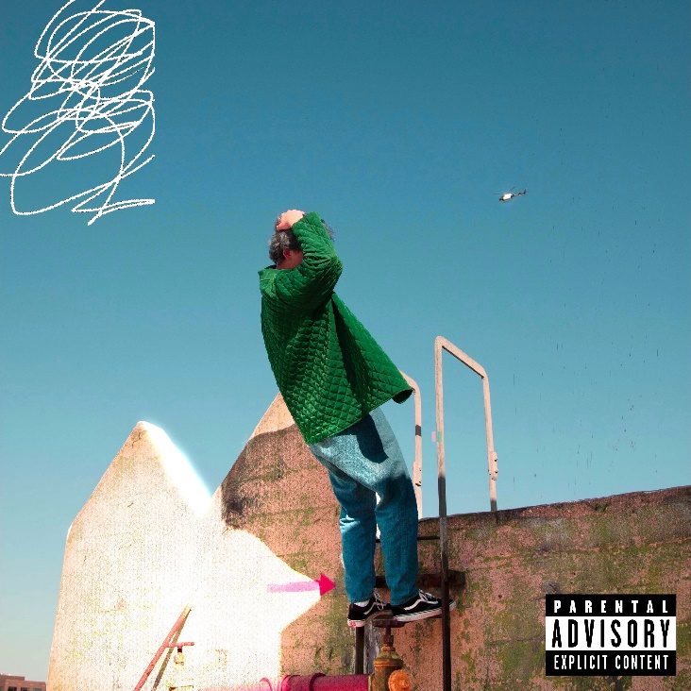
(Click here for Hi-Res image)

May 14, 2021 (Los Angeles, CA) – Bubbling up with a distinct and diverse sense of sonic alchemy, 19-year-old CMTEN unveils his anxiously awaited debut EP, MUSIC BOX, available today on Masked Records/Warner Records and features the track “angel (so bad),” which premiered earlier this week on Apple Music. Click here to stream MUSIC BOX EP.

The nine-song project ebbs and flows between manic electronic transmissions, warm piano, and simultaneously shuddering and soothing vocalizations moving in sync at full throttle towards 21st century pop oblivion. On the EP, “angel (so bad)” pairs heavenly keys and warbling vocal delivery as he details GEN-Z romantic follies by recalling an invitation, “just come and kiss me already, you dumbass.” Then, there’s “sorry I don’t get what you’re saying” where gorgeous piano underscores ponderous lyrics. Everything culminates on “walking to a place I’ve never been.” Acoustic guitar wraps around thumping bass as he cleverly decries, “Open up the spreadsheet, tally all my mistakes,” before one last hypnotic hook.

CMTEN explains: “Although MUSIC BOX is technically an EP, I see it more as a random collection of cool-ass music. The project consists of several songs that vary drastically in style, coming together to showcase every little thing that makes the creation of music so fulfilling to me. Whether a track is something emotional, experimental, or just straight-up fun, each has a special place in my heart. I’m constantly experimenting with different sounds, styles, and influences, so it only makes sense that my debut body of work reflects that. So, when it comes down to it, MUSIC BOX is all about the magic of making music just for the hell of it. I love these songs, and I hope you will, too.”

After racking up nearly 60 million total streams thus far and averaging 1 million monthly listeners on Spotify, he set the stage for the EP with a series of fan favorites, including the title track “MUSIC BOX,” “BORED” and “ALONE [feat. RILEY THE MUSICIAN].” Of the latter, Lyrical Lemonade raved, “These two use all the passionate and learned energy in their bodies to craft together a brief, yet impactful experience that not only proves these previously-mentioned ideas, but at the same time, an experience that stands out as a simply blissful pop offering by itself.” He also caps off the EP with his 2020 breakthrough single “Never Met! [Feat. Glitch Gum]” (over 50M streams & counting). It signaled the crest of a new youth movement mashing together a love of post punk-pop with electronic hip-hop beats which has resonated with millions of fans round the world. “Never Met! (Feat. Glitch Gum) [100 gecs r3mix]” only added fuel to the international fire.

MUSIC BOX EP TRACKLISTING
1. cynical
2. ALONE (feat. RILEY THE MUSICIAN)
3. angel (so bad)
4. NEVER MET! (Feat. Glitch Gum)
5. BORED
6. MUSIC BOX
7. sorry, I don't get what you're saying'
8. walking to a place I've never been
9. ADHD (Feat. Phixel)

Wind up MUSIC BOX EP and experience CMTEN’s multi-dimensional pop vision.

In the seventies, eighties, or nineties, this story might’ve started in a garage with a guitar…However, the genre-smashing artist, songwriter, producer/mixer, vocalist, and San Francisco Bay area native unassumingly turned his University of Utah dorm room into ground zero for Glitchcore in early 2020. Translating a passion for old school pop punk and the likes of 100 gecs, Porter Robinson and Soundcloud Rap into a sound of his own, he uploaded “NEVER MET!” and organically attracted a groundswell of support to the tune of 30 million total streams, 1 million-plus TikTok videos, and more. Not to mention, his ascent has been chronicled by Rolling Stone, Pitchfork and The Atlantic.

About CMTEN:
CMTEN (pronounced See Em Ten), is a 19-year-old artist/songwriter/producer/vocalist from Northern California at the forefront of the emerging hyperpop/glitchcore scene. CMTEN chops, channels and recombines elements of pure pop songcraft with hip-hop beats, informed by the energy and honesty of punk rock and an unabashed expressive sincerity at the heart of its musical vortex. CMTEN grew up singing in his local choir, has perfect pitch, and has so far made all of his music within the confines of his bedroom. Starting with the release of “NEVER MET!,” CMTEN has exploded globally and has accumulated over 1,000,000 videos on TikTok, racked up over 5.5 million YouTube views, and amassed over 40 million streams on Spotify alone, making him one of the biggest underground success stories of 2020/2021. CMTEN is now part of the Masked Records/ Warner Records roster.

# # #

Contact Warner Records:
Rick Gershon | rick.gershon@warnerrecords.com

FOLLOW CMTEN:
Instagram | Twitter | Spotify | Press Materials

