CARLIE HANSON DROPS ACOUSTIC VERSION & PERFORMANCE VIDEO OF “DAZE INN”

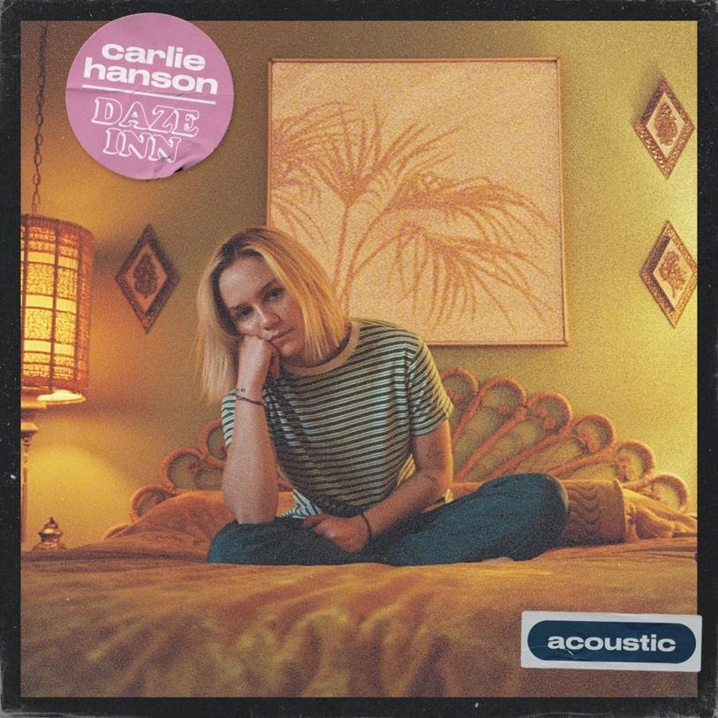

“Alt Pop’s New Teen Queen.” – Billboard
“[Daze Inn]…one of the best new songs of the week.” – Idolator
“Pop Masterpiece” – Alternative Press

May 8, 2020 (Los Angeles, CA) – Today, Carlie Hanson drops an acoustic version of her recent dreamy psych-pop track, “Daze Inn” accompanied by an intimate performance video. Carlie released the original version on March 27. Carlie was inspired to create this video after playing a rocking livestream for Conde Nast’s THEM in what has become all of our new normal.

Carlie also recently performed on the Stonewall Inn “Gives Back” Benefit concert. The track has already reached over 2 million streams.

Listen to “Daze Inn” Acoustic HERE.
Watch the performance video of “Daze Inn” HERE.

Happy Friday y’all –
Bobbie & Darren
bobbie@mixedmediaworks.com
Darren.baber@warnerrecords.com

Follow Carlie Hanson
Official | Instagram | Twitter | Facebook | YouTube | Press Materials

