Carlie Hanson Releases New Track “Good Enough”

Listen HERE

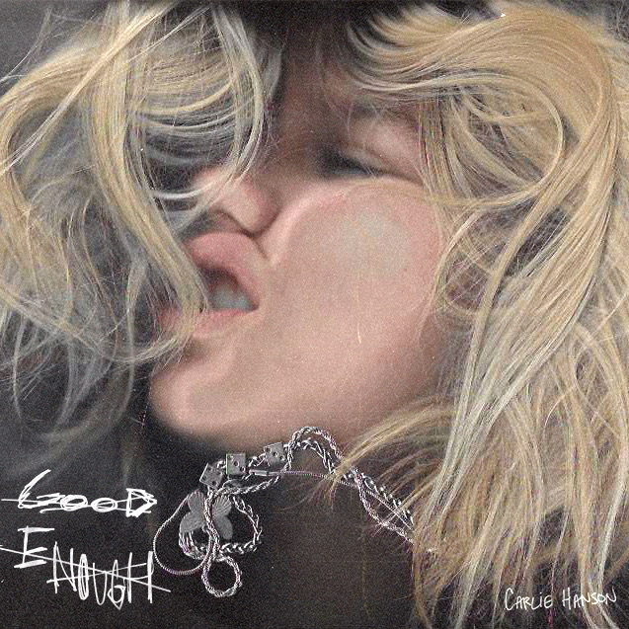

August 20, 2020 (Los Angeles, CA) – Rising alt-pop star Carlie Hanson is back with a sincere new track in “Good Enough.” The 20-year-old opens up about one of the darkest periods of her life and the process of coming out on the other side. The song is filled with passion and emotion which seeps through every lyric sung. With upbeat production from Mitch Allan and Anthony Jones, “Good Enough” comes shortly after her last release, “Stealing All My Friends” which tackled another challenging topic – drug abuse. Carlie performed “Stealing All My Friends” on The Late Show with Stephen Colbert as a #PlayAtHome performance.

Listen to the new track “Good Enough” HERE.
Watch the “Good Enough” lyric video HERE.

“I wrote ‘Good Enough’ during one of the darkest periods of my life. My relationship was fizzling, I missed being with my family and friends, and at the time I was on a prescription medication that was really negatively affecting me. It was hard for me to find a reason to get up in the morning... I just felt so lonely and hopeless. Never leaving my apartment, smoking from morning to night trying to numb my rising anxiety. I shut the whole world out because I felt so lost, hardly ever understanding my own feelings,” Hanson said of the song’s creation. “Fortunately, I was able to find my way out of this depression and push forward by writing about it and coming to terms with my mental health. I also have to credit my family and friends for always guiding me in the right direction.”

Carlie, who is the face of DC Shoes’ Summer 2020 women’s campaign, released her debut EP, JUNK, in June 2019. Before even turning 19, she had toured with TROYE SIVAN, Yungblud and others in the US, Europe and Australia, signed a deal with Warner Records and released JUNK. Named a VEVO DSCVR artist and dubbed a “master of pop bops” by Esquire, Carlie also has fans in superstars like Taylor Swift and Demi Lovato. Carlie has passed 86 million total global streams with her music.

Follow Carlie Hanson
Official | Instagram | Twitter | Facebook | YouTube

For more information, contact:
Darren Baber at Warner Records Publicity
Darren.baber@warnerrecords.com

Bobbie Gale at MixedMediaWorks
323-363-2171 | bobbie@mixedmediaworks.com

