Carlie Hanson Releases New Track And Video
“Gucci Knife ft. MASN”

Watch Video HERE

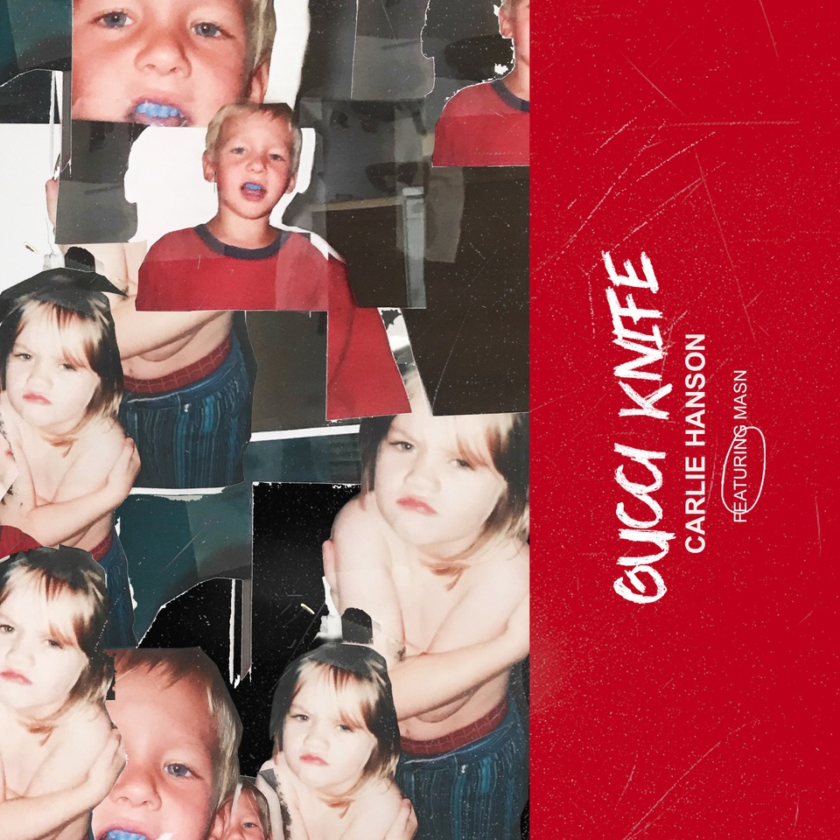

May 21, 2021 (Los Angeles, CA) – Today, newly turned 21 year old alt-pop artist Carlie Hanson has unleashed a new song, “Gucci Knife,” featuring rising alternative singer MASN. It’s the first song from Carlie since the October 2020 release of her sophomore EP, DestroyDestroyDestroyDestroy. The track is an infectious pop song about heartbreak that arrives with a video directed by alternative/hip-hop stalwart, Nicholas Jandora(24kGoldn, Lil Skies); “Gucci Knife” is the first track from Carlie’s forthcoming debut full-length album. Listen to “Gucci Knife” HERE and watch the music video HERE.

“’Gucci Knife’ captures the heavy heartbreak of being so unexpectedly let down by a person after they change their mind, what feels like, overnight,” said Carlie about the track.

In the 8 months since its release, DestroyDestroyDestroyDestroy has clocked in over 53 million streams. The EP was heralded by the press, with American Songwriter calling it “a marker of further mental and creative liberation for Hanson …[with] songs driven by visceral emotions, devastating realities, and frustrated perceptions.” Upon the EP’s release, Billboard Magazine included Carlie in their 2020 “Best of 21 Under 21 List.”

Carlie released her debut EP, JUNK, in June 2019. Before even turning 20, she had toured with Lauv, Troye Sivan, Yungblud and others in the US, Europe and Australia, signed a deal with Warner Records and released JUNK. Named a VEVO DSCVR artist, Carlie also has fans in superstars like Taylor Swift and Demi Lovato. She has passed 86 million total global streams with her music and last year, performed on The Late Show With Stephen Colbert. The first song from DestroyDestroyDestroyDestroy, “Side Effects,” has garnered over 17 million Spotify streams to date while track “Ego (feat. iann dior),” was dubbed by Billboard as “a pop-punk anthem of 2020.” V Magazine also echoed this in a recent feature and named Carlie “One To Watch.”

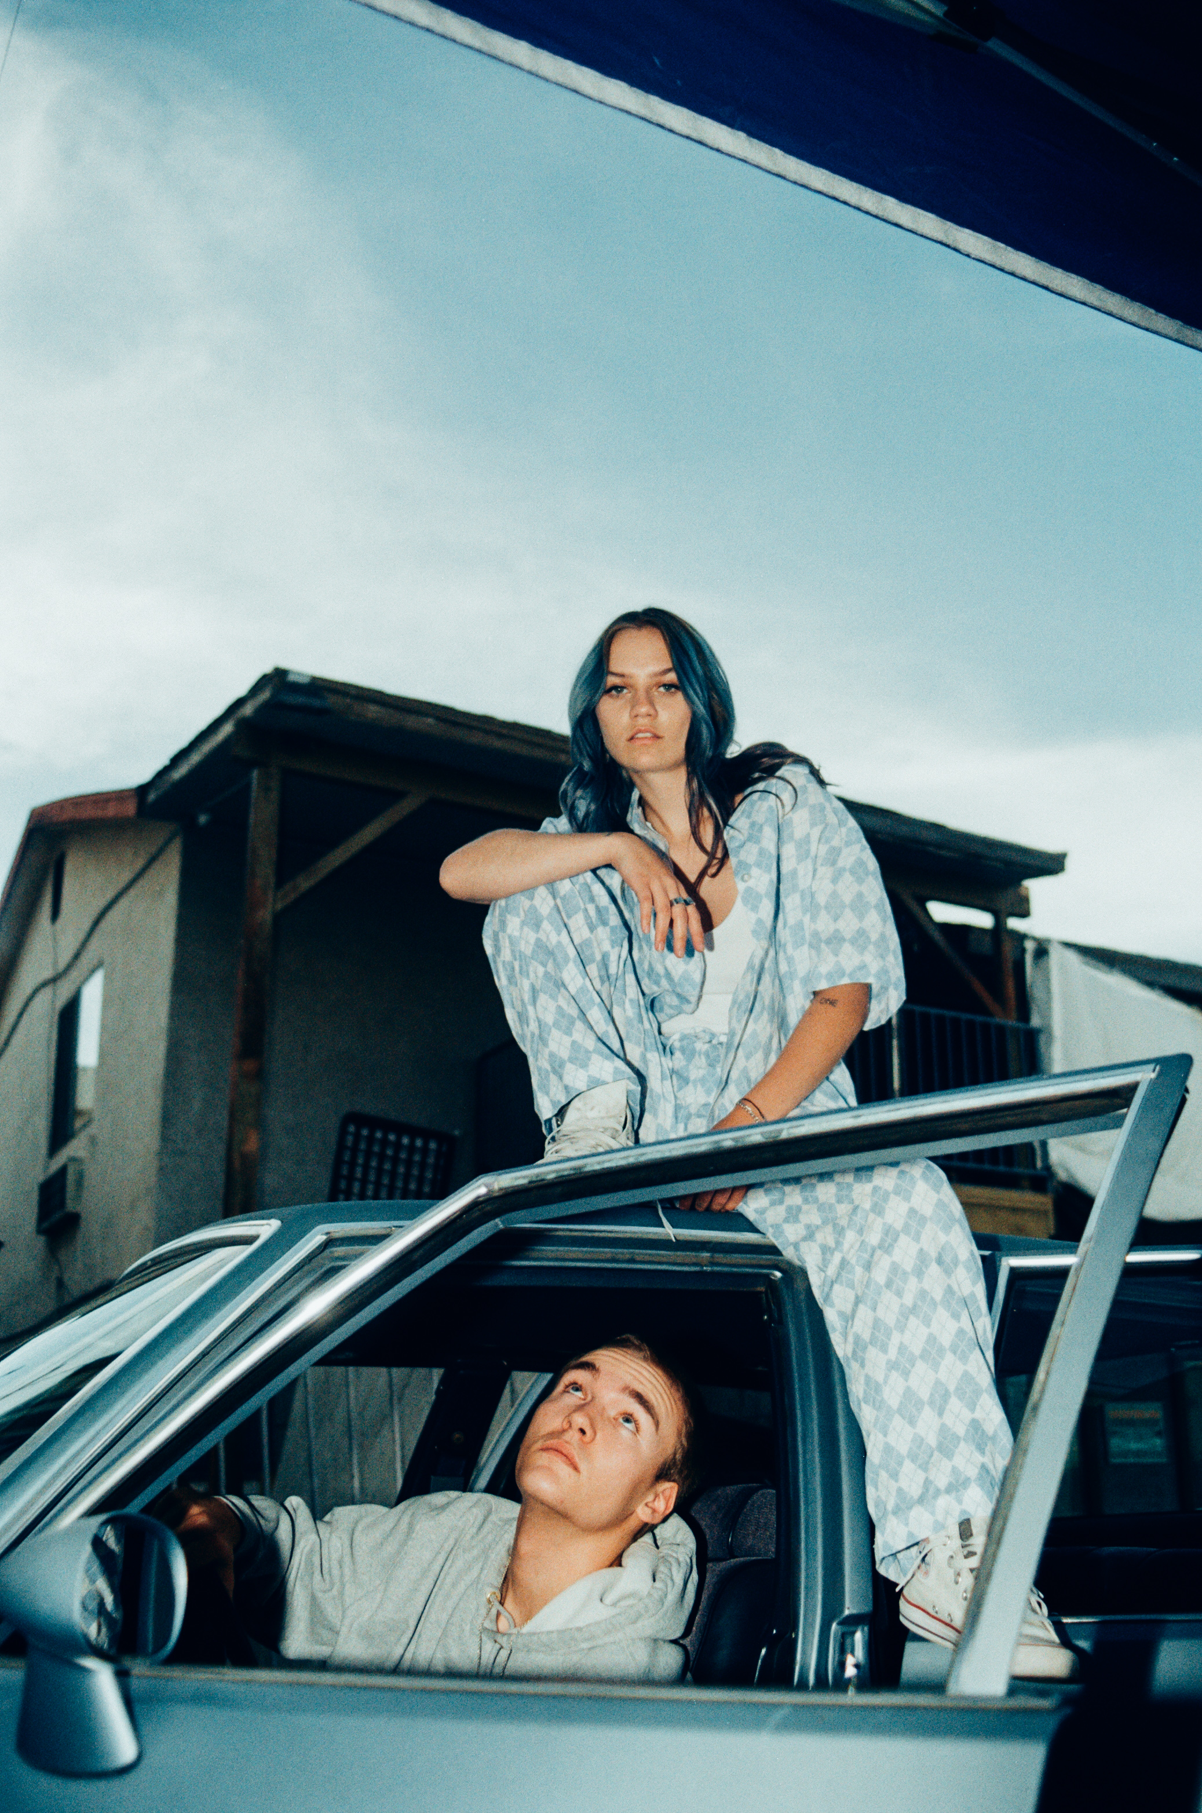
Photo Credit: Alex McDonell

Follow Carlie Hanson
Official | Instagram | Twitter | Facebook | YouTube

For more information, contact:
Bobbie Gale | MixedMediaWorks | 323-363-2171
bobbie@mixedmediaworks.com

Darren Baber | Warner Records | 818-953-3751
Darren.baber@warnerrecords.com

