Carlie Hanson Releases New Track
“I Hate Your Room”
As Part Of Audio Up’s Six-Part Podcast, Valentine’s Day In Hell - Listen HERE

Podcast Also Features iann dior, jxdn, Oliver Tree, phem, Tyler Posey and Adam Carolla

February 12, 2021 (Los Angeles, CA) – Alt pop darling Carlie Hanson has released a new track titled “I Hate Your Room” as part of Audio Up’s six-part, scripted musical-comedy-horror podcast titled Valentine’s Day in Hell – which is distributed by LiveXLive’s PodcastOne. Today, the fourth episode has also been released, along with another one of the podcast’s musical releases featuring Tyler Posey, phem and Audio Chateau. The rest of the musical releases will arrive next week, with other songs from iann dior and jxdn. The podcast cast also includes Oliver Tree and Adam Carolla – who plays the devil. Carlie Hanson’s “I Hate Your Room,” first appeared in the second episode of Valentine’s Day In Hell, which was released on Wednesday, February 10.

Listen to “I Hate Your Room” HERE.
Listen to Valentine’s Day In Hell HERE.

The story of Valentine’s Day in Hell centers around a Los Angeles hype-house, filled with social influencers, YouTubers and TikTok personalities, which becomes a portal to hell when empty-headed Sound Cloud rapper and Instagram star jxdn sells his soul to the devil.

“I Hate Your Room” is Carlie’s first track of the year and her first new song since the October 23, 2020 release of her second EP, DestroyDestroyDestroyDestroy. Billboard said of the EP that, “the lyrics cut deep, the melodies implant themselves in your mind, and her delivery will leave you wondering why you've been sleeping on Carlie Hanson until now” and later included Carlie in their 2020 Best of 21 Under 21 List.

To date, Carlie has amassed over 250 million streams – currently, she is working on new music for the eventual release of her debut full-length album.

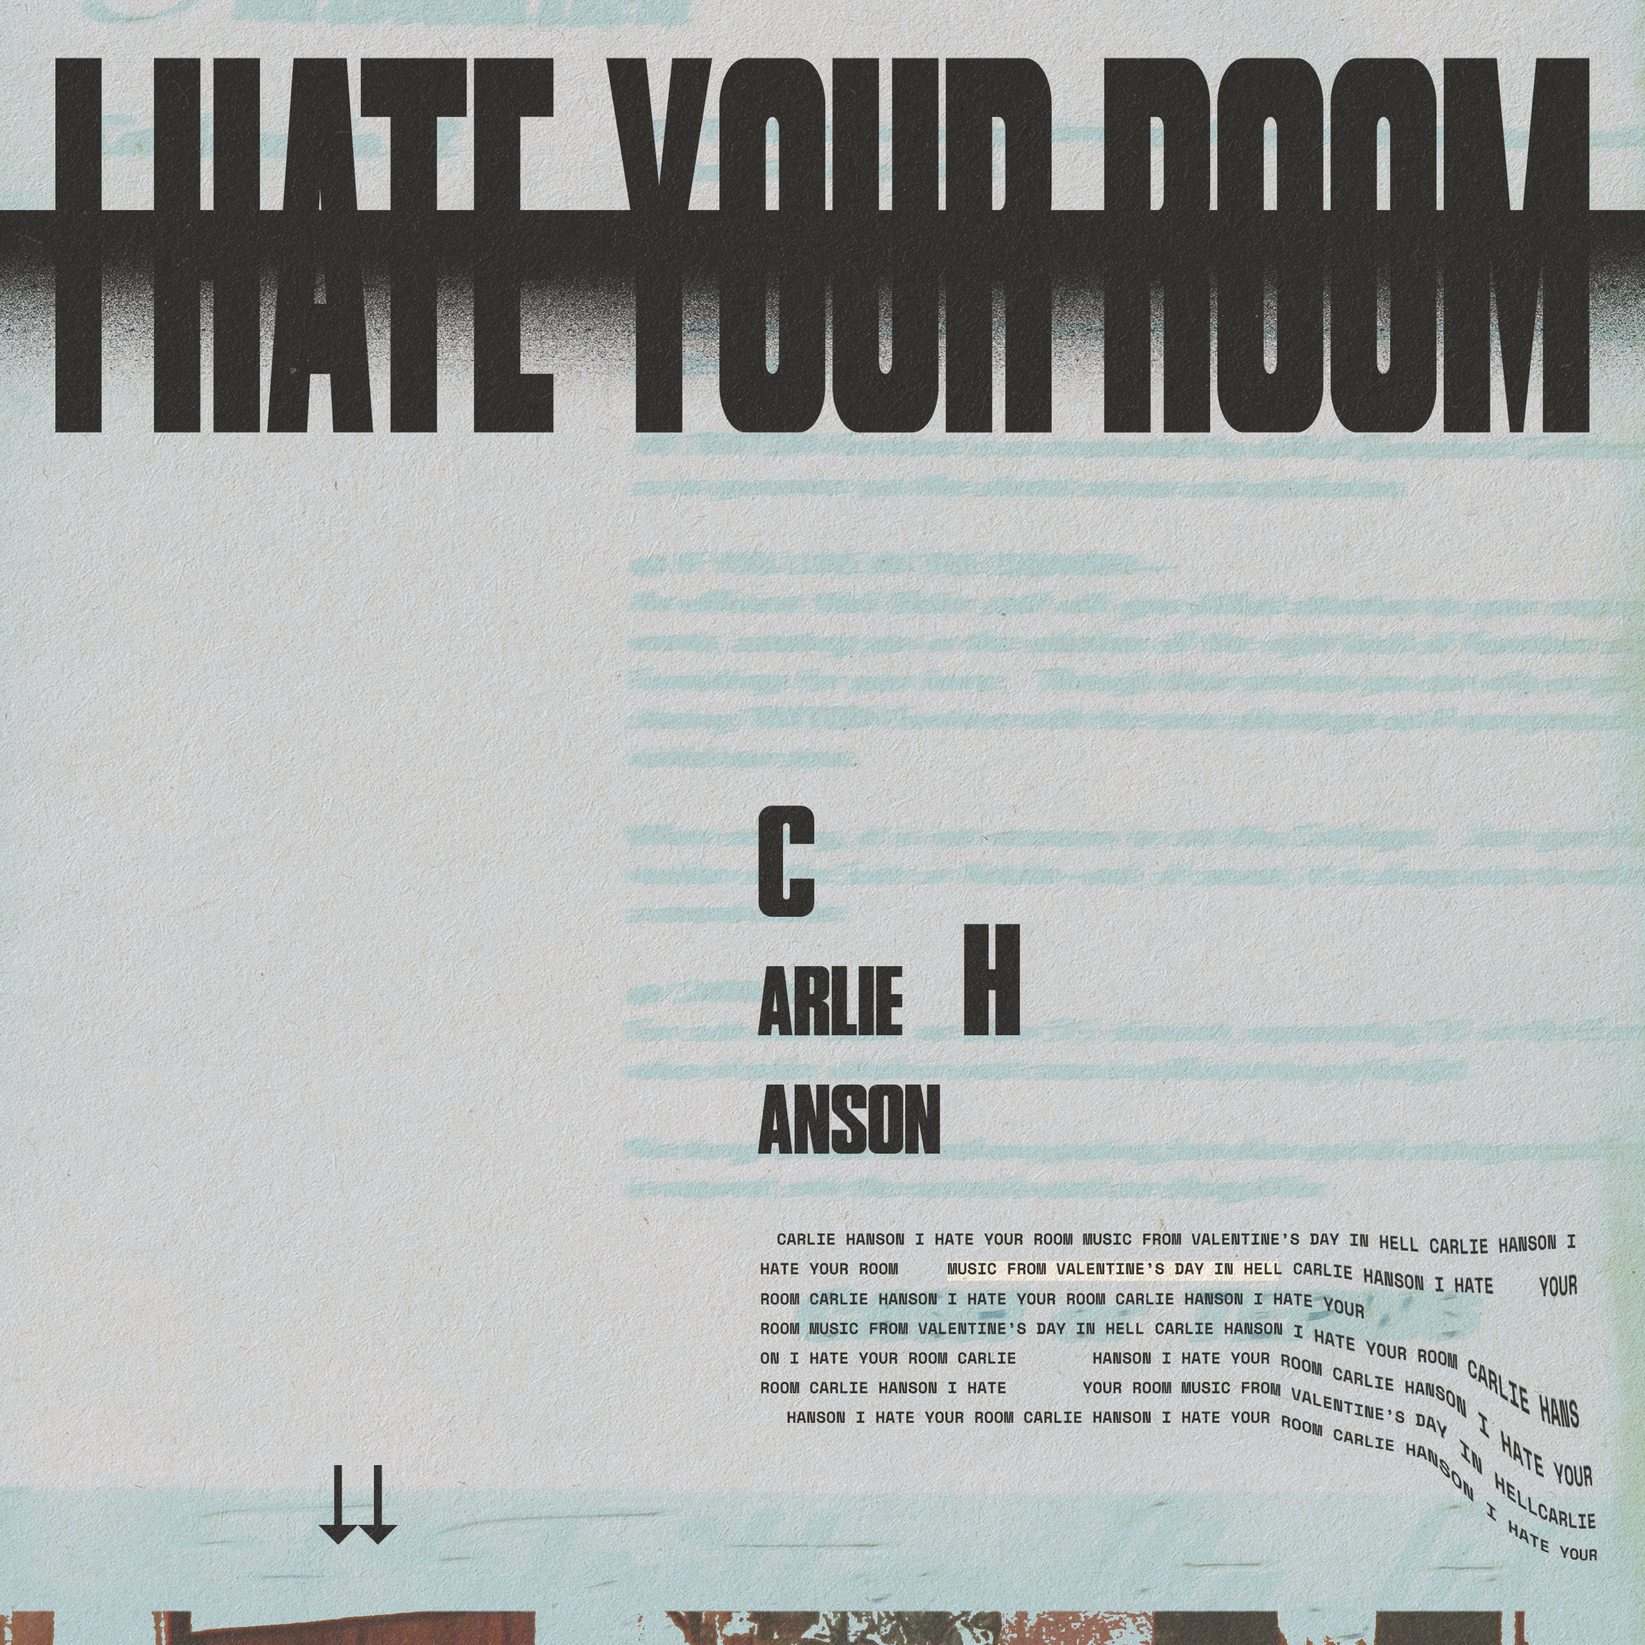
“I Hate Your Room” Cover Art

For more information,contact:
Bobbie Gale at MixedMediaWorks
bobbie@mixedmediaworks.com

Darren Baber at Warner Records
Darren.baber@warnerrecords.com

