SEE THAT GIRL… WATCH THAT GIRL…SHE’S THE DANCING QUEEN

CHER TO RELEASE NEW ALBUM DANCING QUEEN SEPTEMBER 28 - AVAILABLE TO PRE-ORDER TODAY, AUGUST 9

LEGEND PAYS TRIBUTE TO THE MUSIC OF ABBA FOLLOWING GLOBAL MEGA-SUCCESS OF MAMMA MIA! HERE WE GO AGAIN

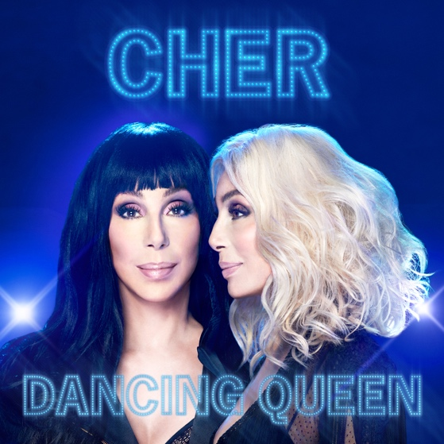
[Click here for Hi-Res Images]

August 9, 2018 (Los Angeles, CA) - The one and only Cher will be releasing Dancing Queen, a new album of all Abba hits on September 28, officially announced today by Warner Bros. Records. Those who pre-order the new album will immediately receive Cher’s rendition of the song “Gimme! Gimme! Gimme! (A Man After Midnight).” Watch the tease HERE!

The Oscar, Emmy and Grammy Award winning icon was inspired to record the album following her stunning performance in the recently-released mega-hit film, Mamma Mia! Here We Go Again.
Commented Cher: "I've always liked Abba and saw the original Mamma Mia musical on Broadway three times. After filming Mamma Mia! Here We Go Again, I was reminded again of what great and timeless songs they wrote and started thinking 'why not do an album of their music?' The songs were harder to sing than I imagined but I'm so happy with how the music came out. I'm really excited for people to hear it. It's a perfect time.”
Dancing Queen was recorded and produced in London and Los Angeles with Cher’s longtime collaborator Mark Taylor, who previously produced Cher's global smash “Believe” which was number one in over 50 countries.

The track listing for Dancing Queen previously announced on Cher's twitter is listed below.
Cher is scheduled to be awarded a Kennedy Center Honor on December 2nd in Washington DC. She is a co-producer of the The Cher Show, the upcoming Broadway musical opening on December 3rd and will be touring Australia and New Zealand in September. She is currently performing a residency at MGM Resorts. Get tickets HERE!
Dancing Queen Tracklisting
1. Dancing Queen
2. Gimme! Gimme! Gimme! (A Man After Midnight)
3. The Name Of The Game
4. SOS
5. Waterloo
6. Mamma Mia
7. Chiquitita
8. Fernando
9. The Winner Takes It All
10. One Of Us

SOCIALS
Website: cher.com
Facebook: facebook.com/cher
Twitter: twitter.com/cher
Instagram: instagram.com/cher

For press inquiries, please contact:
Liz Rosenberg | Liz Rosenberg Media
liz@lizrosenbergmedia.com

