ALT BREAKOUT CHRISTIAN LEAVE UNCOVERS MAGNETIC
NEW SINGLE “10 STEPS”
LISTEN HERE

U.S. TOUR WITH BEABADOODEE KICKS OFF NOV. 1ST

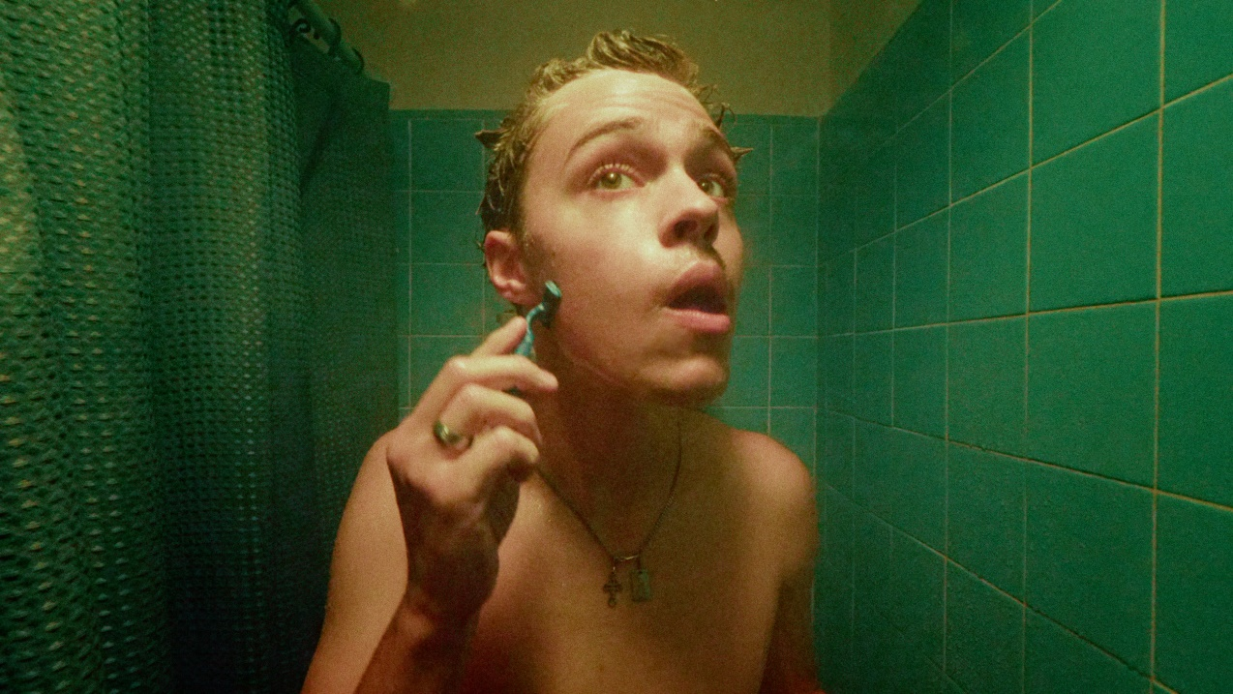

“Boy-next-door turned superstar” – VMAN

“One spin of Christian Leave’s music, and you’re immediately sucked in longing for more.” – FLAUNT

“Unique and infectious … a modern indie feel with a classic R&B sound.” – American Songwriter

“charismatic tone and soothing vocals” – Office Magazine

“Christian Leave just keeps rolling out great songs.” – The Interns

September 3, 2021 (Los Angeles, CA) – Critically-acclaimed alt-breakout Christian Leave returns with a magnetic new single “10 Steps” today on Warner Records. Listen to “10 Steps” HERE and stay tuned for the accompanying official video coming soon.

On the track, bright and breezy electric guitar bristles up against his buoyant verses before building towards a chantable chorus. It nods to the nineties with throwback alternative feels and magnetically sunny melodies, tapering off into a hummable lead. He siphons this harmony out of confessional reflections on the ups, downs, and everything in between during his time in Los Angeles.

Christian explains, “I’ve lived in LA for about 4 years now and, in that time, I’ve had some of the most overwhelming and confusing periods of my life but also some of the most encouraging, promising, and uplifting moments I’ve ever experienced; yet I find myself being influenced by the negative more than the positive. This song basically represents a promise to myself to not get run down by the downfalls of everyday life but to be uplifted by the things I’ve won.”

The new track makes its debut ahead of Christian’s upcoming North American run supporting beabadoobee on 25+ dates this fall alongside BLACKSTARKIDS, beginning November 1st in Washington, D.C. Tickets are available now at christianleave.world – see a full list of dates below.

Earlier this year, he garnered widespread critical acclaim for his Heavy Hitting Hurts My Head EP, featuring infectious standouts “Filth,” “Bedache,” and “Your Life Your Time,” which Billboard called a “catchy gem.” Beyond piling up 6 million total streams and counting, the record earned him the top spot on high-profile playlists, including Spotify’s Lorem, Amazon Music’s Breakthrough Indie and Fresh Indie, Apple Music’s INDIY, and Pandora’s New Music Now, just to name a few.

Stay tuned for more from Christian Leave soon.

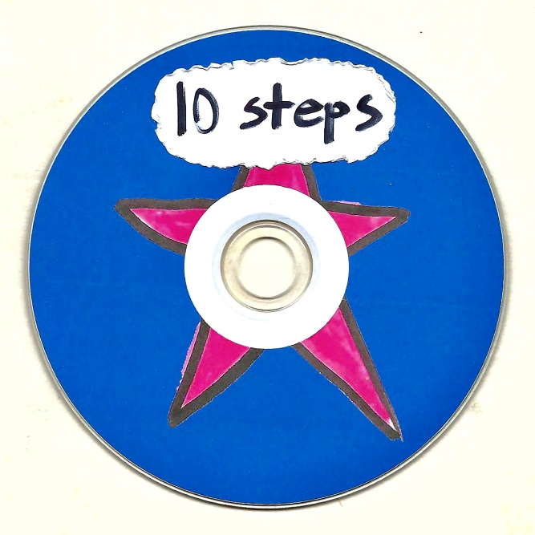

FALL 2021 TOUR DATES:
Nov. 1 Washington D.C. 9:30 Club
Nov. 2 Philadelphia, PA Union Transfer
Nov. 4 New York, NY Webster Hall
Nov. 5 Boston, MA Royale
Nov. 9 Carrboro, NC Cat's Cradle
Nov. 10 Charlotte, NC The Underground
Nov. 11 Atlanta, GA Buckhead Theatre
Nov. 13 Birmingham, AL Saturn
Nov. 15 Houston, TX White Oak Music Hall
Nov. 16 Austin, TX Emo's
Nov. 19 Phoenix, AZ The Van Buren
Nov. 20 San Diego, CA The Observatory North Park
Nov. 21 Los Angeles, CA The Fonda (Night 1)
Nov. 22 Los Angeles, CA The Fonda (Night 2)
Nov. 23 San Francisco, CA The Fillmore
Nov. 26 Portland, OR Crystal Ballroom
Nov. 27 Seattle, WA Neptune Theatre
Nov. 28 Vancouver, BC Rickshaw Theatre
Nov. 30 Salt Lake City, UT The Depot
Dec. 1 Denver, CO The Summit Music Hall
Dec. 4 Kansas City, MO The Truman
Dec. 6 Chicago, IL Metro
Dec. 8 Detroit, MI Majestic Theatre
Dec. 9 Toronto, ON Danforth Music Hall
Dec. 10 Columbus, OH Newport Music Hall
Dec. 11 Pittsburgh, PA Stage AE

ABOUT CHRISTIAN LEAVE:
Growing up in Texas, Christian Leave at 14 was just like any other teenager, wrestling with uncomfortable social dynamics that made it hard for him to balance who he was with who he wanted to be – and then he discovered Vine. The TikTok precursor ultimately let Christian understand himself better, leaning into his awkwardness, riffing on puns and injecting dad jokes with genuine humor. He branched off Vine to other platforms, racking up millions of followers in the process, but something felt off until he started writing his own songs in 2015. Now 21 years old, Christian has spent the past few years working out of his bedroom, writing, producing and creating this sound that is at once naive and wise, the product of teenage heartbreak as viewed through the eyes of a person who grew up just a little too fast. He strikes a balance between subversive vulnerability and catchy palatability, inspired by everyone from The Cure and My Bloody Valentine to Bon Iver. His encyclopedic musical knowledge translates into genre-hopping bops with all the charm of your favorite indie flick.

Follow Christian Leave:
Instagram | TikTok | YouTube | Twitter

For more information, please contact:
Ceri Roberts | Warner Records
Ceri.Roberts@warnerrecords.com

Press Materials:
press.warnerrecords.com/christianleave

