CHRISTIAN LEAVE UNVEILS LATEST EP DAYS LIKE LOST DOGS
LISTEN HERE

WATCH NEW VIDEO FOR “DAYS LIKE LOST DOGS” HERE

U.S. TOUR WITH BEABADOOBEE BEGINS NEXT WEEK

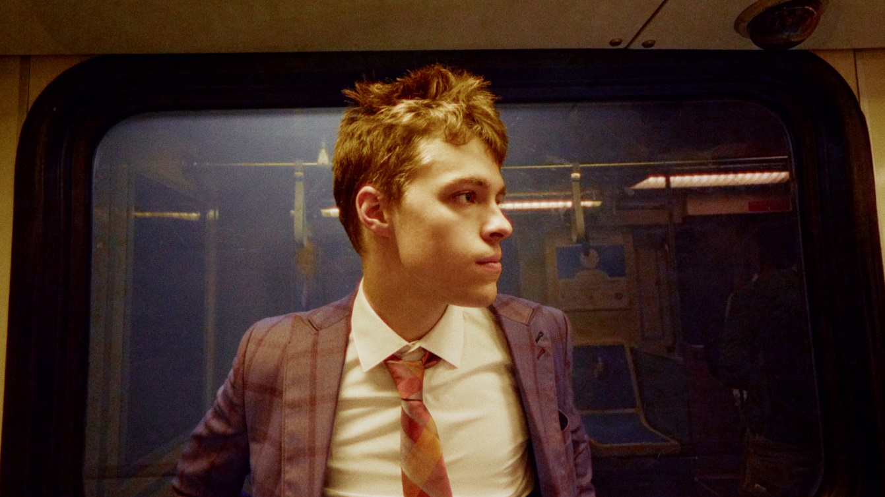

“Boy-next-door turned superstar” – VMAN

“One spin of Christian Leave’s music, and you’re immediately sucked in longing for more.” – FLAUNT

“Unique and infectious … a modern indie feel with a classic R&B sound.” – American Songwriter

“charismatic tone and soothing vocals” – Office Magazine

“Christian Leave just keeps rolling out great songs.” – The Interns

October 29, 2021 (Los Angeles, CA) – Critically-acclaimed alt-breakout Christian Leave returns with his latest EP, Days Like Lost Dogs, out today on Warner Records. The nostalgic, dream-like record features standout singles “Maybe” and “10 Steps,” and arrives alongside a black-and-white film noir style video for title track “Days Like Lost Dogs,” which features a cast of furry friends. Watch it HERE, and listen to the entire 7-track EP HERE.

“Over the past year I’ve been allotted the time to reflect on everything that’s led me to this point in my life,” Christian explains. “I now have contentment and bask in how beautiful the time I’ve spent here is. I’ve come to terms with my frustrations and am now wandering through life without a clear goal in sight, but a determination to appreciate every second of it. I don’t know where I’m going but I know who I am! This project is a collection of songs that I feel amplifies those revelations and states this new path that I am on.”

Days Like Lost Dogs arrives just days before Christian embarks on beabadoobee’s 25+ date U.S. fall tour alongside BLACKSTARKIDS, beginning this coming Monday, November 1st in Washington, D.C. Tickets are available at christianleave.world – see a full list of dates below.

Earlier this year, the 21-year-old garnered widespread critical acclaim for his Heavy Hitting Hurts My Head EP, featuring infectious standouts “Filth,” “Bedache,” and “Your Life Your Time,” which Billboard called a “catchy gem.” Beyond piling up 6 million total streams and counting, the record earned him the top spot on high-profile playlists, including Spotify’s Lorem, Amazon Music’s Breakthrough Indie and Fresh Indie, Apple Music’s INDIY, and Pandora’s New Music Now, just to name a few.

FALL 2021 TOUR DATES:
Nov. 1 Washington D.C. 9:30 Club
Nov. 2 Philadelphia, PA Union Transfer
Nov. 4 New York, NY Webster Hall
Nov. 5 Boston, MA Royale
Nov. 9 Carrboro, NC Cat's Cradle
Nov. 10 Charlotte, NC The Underground
Nov. 11 Atlanta, GA Buckhead Theatre
Nov. 13 Birmingham, AL Saturn
Nov. 15 Houston, TX White Oak Music Hall
Nov. 16 Austin, TX Emo's
Nov. 19 Phoenix, AZ The Van Buren
Nov. 20 San Diego, CA The Observatory North Park
Nov. 21 Los Angeles, CA The Fonda (Night 1)
Nov. 22 Los Angeles, CA The Fonda (Night 2)
Nov. 23 San Francisco, CA The Fillmore
Nov. 26 Portland, OR Crystal Ballroom
Nov. 27 Seattle, WA Neptune Theatre
Nov. 28 Vancouver, BC Rickshaw Theatre
Nov. 30 Salt Lake City, UT The Depot
Dec. 1 Denver, CO The Summit Music Hall
Dec. 4 Kansas City, MO The Truman
Dec. 6 Chicago, IL Metro
Dec. 8 Detroit, MI Majestic Theatre
Dec. 9 Toronto, ON Danforth Music Hall
Dec. 10 Columbus, OH Newport Music Hall
Dec. 11 Pittsburgh, PA Stage AE

ABOUT CHRISTIAN LEAVE:
Growing up in Texas, Christian Leave at 14 was just like any other teenager, wrestling with uncomfortable social dynamics that made it hard for him to balance who he was with who he wanted to be – and then he discovered Vine. The TikTok precursor ultimately let Christian understand himself better, leaning into his awkwardness, riffing on puns and injecting dad jokes with genuine humor. He branched off Vine to other platforms, racking up millions of followers in the process, but something felt off until he started writing his own songs in 2015. Now 21 years old, Christian has spent the past few years working out of his bedroom, writing, producing and creating this sound that is at once naive and wise, the product of teenage heartbreak as viewed through the eyes of a person who grew up just a little too fast. He strikes a balance between subversive vulnerability and catchy palatability, inspired by everyone from The Cure and My Bloody Valentine to Bon Iver. His encyclopedic musical knowledge translates into genre-hopping bops with all the charm of your favorite indie flick.

Follow Christian Leave:
Instagram | TikTok | YouTube | Twitter

For more information, please contact:
National: Ceri Roberts
Ceri.Roberts@warnerrecords.com

Tour Press: Patrice Compere
Patrice.Compere@warnerrecords.com



