**CHRISTIAN LEAVE SHARES NEW EP** ***HEAVY HITTING HURTS MY HEAD***

[**LISTEN HERE**](https://christianleave.lnk.to/hhhmh)

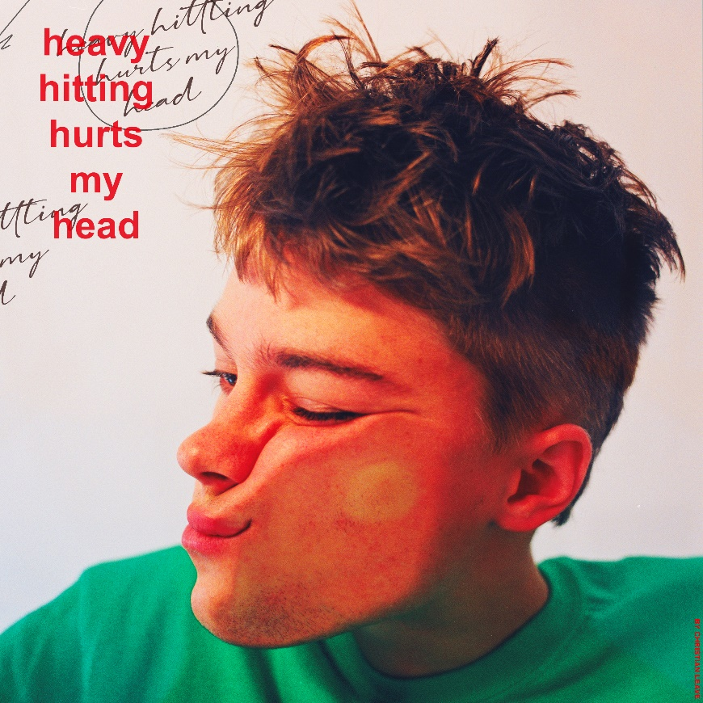

*Hi-res artwork* [*here*](https://press.warnerrecords.com/christianleave)

*“One spin of Christian Leave’s music, and you’re immediately sucked in longing for more.”* ***– FLAUNT***

*“Unique and infectious … a modern indie feel with a classic R&B sound.”* ***– American Songwriter***

*“charismatic tone and soothing vocals”* ***– Office Magazine***

*“Christian Leave just keeps rolling out great songs.”* ***– The Interns***

**February 12, 2021 (Los Angeles, CA)** – Genre disruptor Christian Leave shares his new EP [*Heavy Hitting Hurts My Head*](https://christianleave.lnk.to/hhhmh) today on Warner Records. The five track record features new standout [“Filth,”](https://youtu.be/S0NeCl2obHM) plus anthemic song [“Your Life Your Time”](http://christianleave.lnk.to/yourlifeyourtime_mv) and infectious Brit-pop inspired single [“Bedache,”](https://nam04.safelinks.protection.outlook.com/?url=https%3A%2F%2Fwww.youtube.com%2Fwatch%3Fv%3D9Z7qmV1sxXY&data=04%7C01%7CCeri.Roberts%40warnerrecords.com%7C9ffc4f94f89647a7676308d8b831c34a%7C8367939002ec4ba1ad3d69da3fdd637e%7C0%7C0%7C637461871173517802%7CUnknown%7CTWFpbGZsb3d8eyJWIjoiMC4wLjAwMDAiLCJQIjoiV2luMzIiLCJBTiI6Ik1haWwiLCJXVCI6Mn0%3D%7C1000&sdata=hHXykLwqldc7prbBjdMGnJnqLiNeSH2f6POeJFAjeQ4%3D&reserved=0) which have already propelled him to over two million monthly Spotify listeners and earned him the top spot on high profile playlists, including Spotify’s Lorem, Amazon Music’s Breakthrough Indie and Fresh Indie, Apple Music’s INDIY, and Pandora’s New Music Now, just to name a few.

*Heavy Hitting Hurts My Head* continues Christian’s prolific past year, as he hits the hearts of the bewildered and befuddled by growing up, yet wide-eyed and welcoming of what could be brighter future anyway. About the project, Christian explains, “*‘Heavy Hitting Hurts My Head’ is a collection of 5 songs that reflect the shape of my last year. A lot of stress and confusion mixed with a ton of reflecting on my life so far.* *From my everyday problems to issues I've dealt with since I was a teenager, I've laid it all out and shoved into this project.”*

***EP Tracklisting:***

1. Bedache
2. Filth
3. Hard Wad Body
4. Hearts Melt
5. Your Life Your Time

**ABOUT CHRISTIAN LEAVE:**

Growing up in Texas, Christian Leave at 14 was just like any other teenager, wrestling with uncomfortable social dynamics that made it hard for him to balance who he was with who he wanted to be – and then he discovered Vine. The TikTok precursor ultimately let Christian understand himself better, leaning into his awkwardness, riffing on puns and injecting dad jokes with genuine humor. He branched off Vine to other platforms, racking up millions of followers in the process, but something felt off until he started writing his own songs in 2015. Now 20 years old, Christian has spent the past few years working out of his bedroom, writing, producing and creating this sound that is at once naive and wise, the product of teenage heartbreak as viewed through the eyes of a person who grew up just a little too fast. He strikes a balance between subversive vulnerability and catchy palatability, inspired by everyone from The Cure and My Bloody Valentine to Bon Iver. His encyclopedic musical knowledge translates into genre-hopping bops with all the charm of your favorite indie flick.

**Follow Christian Leave:**

[Instagram](https://www.instagram.com/christi2n/?hl=en) | [TikTok](https://vm.tiktok.com/wjj9kG/) | [YouTube](https://www.youtube.com/channel/UCW0RlqT2XzTpvZM6W-jJO0g) | [Twitter](https://twitter.com/ChristianLeave?ref_src=twsrc%5Egoogle%7Ctwcamp%5Eserp%7Ctwgr%5Eauthor)

**For more information, please contact:**

Ceri Roberts | Warner Records

[Ceri.Roberts@warnerrecords.com](mailto:Ceri.Roberts@warnerrecords.com)

**Press Materials:**

[press.warnerrecords.com/christianleave](https://press.warnerrecords.com/christianleave)

**cid:image004.jpg@01D5E66A.9F2C7370**