**CHRISTIAN LEAVE DROPS ANTHEMIC NEW SINGLE “YOUR LIFE YOUR TIME”**

**WATCH THE VIDEO** [**HERE**](http://christianleave.lnk.to/yourlifeyourtime_mv)

***HEAVY HITTING HURTS MY HEAD* EP COMING FEBRUARY 12**

**PRESAVE** [**HERE**](https://christianleave.lnk.to/HHHMH_ps)

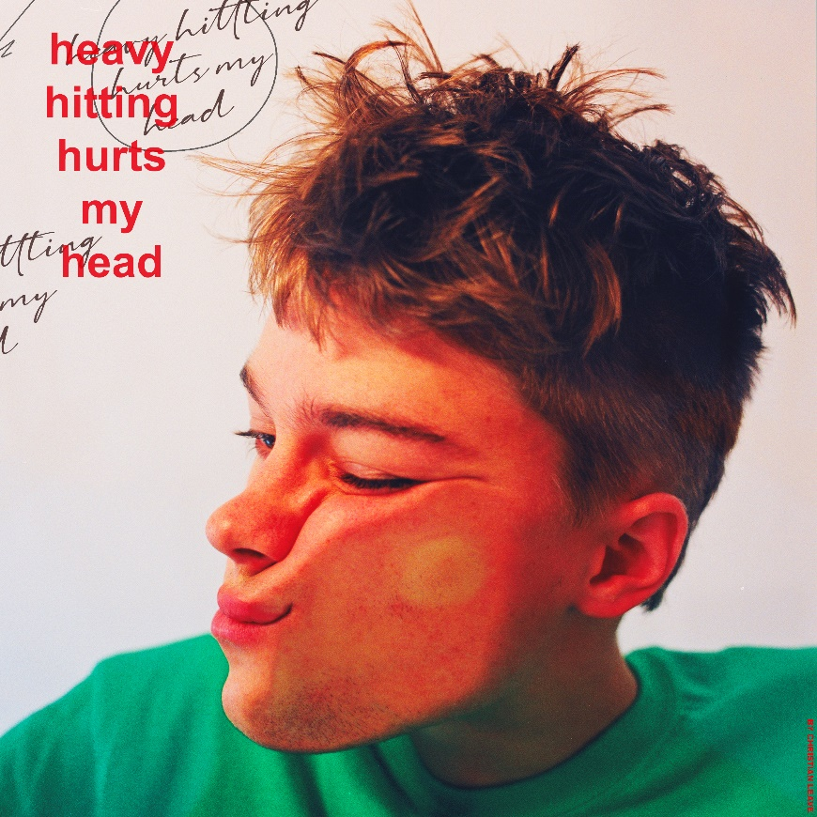

*Hi-res artwork* [*here*](https://press.warnerrecords.com/christianleave)

*“One spin of Christian Leave’s music, and you’re immediately sucked in longing for more.”* ***– FLAUNT***

*“Unique and infectious … a modern indie feel with a classic R&B sound.”* ***– American Songwriter***

*“charismatic tone and soothing vocals”* ***– Office Magazine***

*“Christian Leave just keeps rolling out great songs.”* ***– The Interns***

**January 15, 2021 (Los Angeles, CA)** – Genre disruptor Christian Leave shares new single “Your Life Your Time” today, the latest from his forthcoming EP *Heavy Hitting Hurts My Head* due out February 12 via Warner Records. Written with the help of Ethan Gruska [Fiona Apple, Phoebe Bridgers], the anthemic new track comes with a 90’s inspired color blocked video directed by Chris Cranston. Listen to it [HERE](http://christianleave.lnk.to/yourlifeyourtime), watch the official video [HERE](http://christianleave.lnk.to/yourlifeyourtime_mv), and presave the EP [HERE](https://christianleave.lnk.to/HHHMH_ps).

*Heavy Hitting Hurts My Head* will continue Christian’s prolific past year, as he hits the hearts of the bewildered and befuddled by growing up, yet wide-eyed and welcoming of what could be brighter future anyway. Most recently, Christian shared infectious Brit-pop inspired single [“Bedache,”](https://nam04.safelinks.protection.outlook.com/?url=https%3A%2F%2Fwww.youtube.com%2Fwatch%3Fv%3D9Z7qmV1sxXY&data=04%7C01%7CCeri.Roberts%40warnerrecords.com%7C9ffc4f94f89647a7676308d8b831c34a%7C8367939002ec4ba1ad3d69da3fdd637e%7C0%7C0%7C637461871173517802%7CUnknown%7CTWFpbGZsb3d8eyJWIjoiMC4wLjAwMDAiLCJQIjoiV2luMzIiLCJBTiI6Ik1haWwiLCJXVCI6Mn0%3D%7C1000&sdata=hHXykLwqldc7prbBjdMGnJnqLiNeSH2f6POeJFAjeQ4%3D&reserved=0) earning acclaim from the likes of *American Songwriter*, *office*, *coup de main*, and *FLAUNT* who described him as a,  *“truly unique, one-of-a-kind recording artist … with his own smooth, sultry voice and undeniably relatable lyrics.”*

About the project, Christian explains, “*"Heavy Hitting Hurts My Head’ is a collection of 5 songs that reflect the shape of my last year. A lot of stress and confusion mixed with a ton of reflecting on my life so far.* *From my everyday problems to issues I've dealt with since I was a teenager, I've laid it all out and shoved into this project.”*

**ABOUT CHRISTIAN LEAVE:**

Growing up in Texas, Christian Leave at 14 was just like any other teenager, wrestling with uncomfortable social dynamics that made it hard for him to balance who he was with who he wanted to be – and then he discovered Vine. The TikTok precursor ultimately let Christian understand himself better, leaning into his awkwardness, riffing on puns and injecting dad jokes with genuine humor. He branched off Vine to other platforms, racking up millions of followers in the process, but something felt off until he started writing his own songs in 2015. Now 20 years old, Christian has spent the past few years working out of his bedroom, writing, producing and creating this sound that is at once naive and wise, the product of teenage heartbreak as viewed through the eyes of a person who grew up just a little too fast. He strikes a balance between subversive vulnerability and catchy palatability, inspired by everyone from The Cure and My Bloody Valentine to Bon Iver. His encyclopedic musical knowledge translates into genre-hopping bops with all the charm of your favorite indie flick.

**Follow Christian Leave:**

[Instagram](https://www.instagram.com/christi2n/?hl=en) | [TikTok](https://vm.tiktok.com/wjj9kG/) | [YouTube](https://www.youtube.com/channel/UCW0RlqT2XzTpvZM6W-jJO0g) | [Twitter](https://twitter.com/ChristianLeave?ref_src=twsrc%5Egoogle%7Ctwcamp%5Eserp%7Ctwgr%5Eauthor)

**For more information, please contact:**

Ceri Roberts | Warner Records

[Ceri.Roberts@warnerrecords.com](mailto:Ceri.Roberts@warnerrecords.com)

**Press Materials:**

[press.warnerrecords.com/christianleave](https://press.warnerrecords.com/christianleave)

**cid:image004.jpg@01D5E66A.9F2C7370**