David Guetta 90-Minute United At Home Livestream Performance in Support of COVID-19 Relief to Connect the World Through Music and Raise Money for Global Nonprofits

Saturday, April 18th – 6pm ET – Live from Downtown Miami

UNITED AT HOME Trailer HERE

DAVID GUETTA UNITED AT HOME
https://facebook.com/davidguetta
https://youtube.com/davidguetta
https://instagram.com/davidguetta
https://twitter.com/davidguetta
https://www.twitch.tv/davidguetta
davidguetta.com/donate

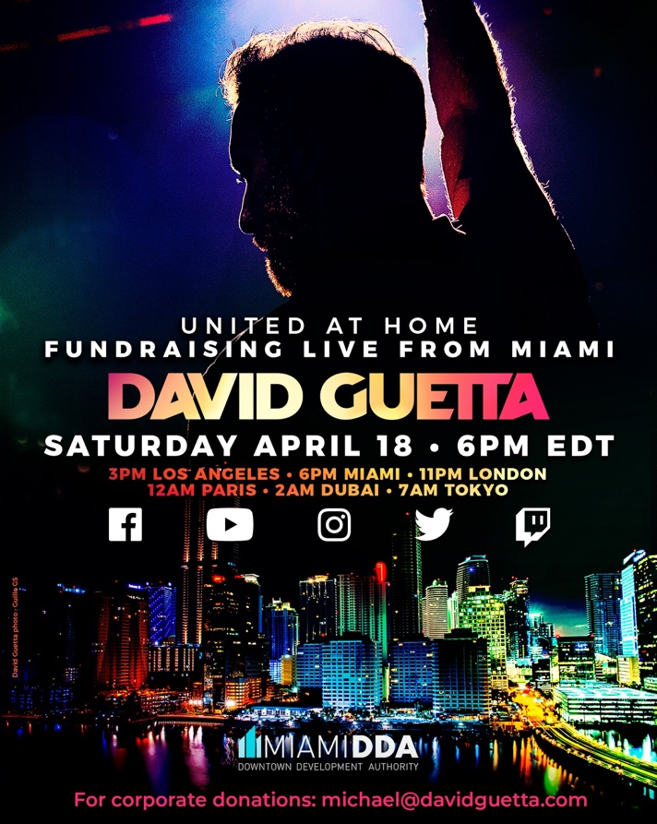

April 16, 2020 (Los Angeles, CA) - Globally acclaimed DJ and producer David Guetta will stream a live, 90-minute set on Saturday, April 18 in support of the global fight against the COVID-19 pandemic. David will perform from a unique location in Downtown Miami to raise funds for the World Health Organization, Feeding South Florida, Feeding America, and the French Fondation Hôpitaux de Paris.

Guetta’s performance, which will begin at 6:00pm (EDT), can be viewed live on social media through the DJ’s Facebook, Instagram, YouTube, Twitter and Twitch channels. While some Miami residents may have a prime view of Guetta’s live performance from their balconies, households worldwide are encouraged to tune in online.

David Guetta aims to inspire and unify fans through music to come together and take action against these unprecedented challenges. The event promises a state-of-the-art production that can be enjoyed from living rooms across the planet, packed with stunning visuals and quality music.

“I’m very excited to share what’s been in the works for some time now,” says David Guetta. “My heart goes out to all those suffering from the global health pandemic and I hope that this livestream event will bring people together and help raise money for those in need.”

Through the livestream, Guetta will raise funds for four nonprofits around the world, including $150,000 for Feeding South Florida, which will allow the charity to distribute over one million meals in the region. The event will also benefit Feeding America, the nation’s largest hunger-relief organization; Fondation Hôpitaux de Paris - Hôpitaux de France's, whose mission is to improve the conditions of healthcare works and patients in hospitals across France; and the World Health Organization’s COVID-19 Solidarity Response Fund, which is ensuring frontline workers are equipped with essential protective wear, patients are receiving proper care, and efforts to develop vaccines, tests, and treatments are accelerated.

To bring the performance to life, Guetta is partnering with the Miami Downtown Development Authority (DDA), an agency committed to marketing Downtown Miami around the world, supporting local businesses, and improving the quality of life for the nearly 100,000 residents in the city’s urban core.

“Downtown Miami is an energetic community beloved by people around the world, and we are determined to keep our city’s spirit alive and our residents safe through this crisis,” says Christina Crespi, Executive Director of the Miami Downtown Development Authority. “David Guetta’s music has always brought people together, and while Miami – and the rest of the world – practices social distancing, there’s no better time to unite virtually for a common cause than now.”

About David Guetta
There are artists and entertainers who achieve stardom and popularity, but few have the influence and endurance to redraw borders between genres and reshape the industry’s dynamics. “When Love Takes Over,” the first single of his 2009 album ‘One Love’, hit #1 in the UK, the Guetta- produced Black Eyed Peas song “I Gotta Feeling” became a worldwide hit, topping the charts in 17 countries. Over the decade since, Guetta’s success has been off the charts. Globally, he’s racked up over 50 million record sales, whereas his total number of streams is over 10 billion. He has received numerous Platinum and Gold certifications, was named ‘EDM Power Player’ by Billboard, and won two Grammy Awards out of six nominations. Besides his hard-won DJ skills, he is prolific in the studio, working with artists like Madonna, Rihanna, Lady Gaga, Snoop Dogg, Martin Garrix, Usher, Sia, John Legend, Nicki Minaj, Sean Paul, Kelly Rowland, Showtek, Avicii, Ne-Yo, and Akon, for starters. His seventh studio album titled ‘7’, included huge electronic pop tracks like “2U” with Justin Bieber, “Flames” with Sia, “Don’t Leave Me Alone” with Anne-Marie, “Goodbye” with Jason Derulo, Nicki Minaj and Willy William and “Say My Name” with J Balvin and Bebe Rexha plus a second disc of underground dance tracks, recorded under Guetta’s Jack Back alias. With his wide-reaching and game-changing approach, he is more than just a DJ and producer: he’s made dance music reach the mainstream, fused urban, electronic and pop music into new popular genres, and managed to stay on top of the game for decades. David Guetta is surely not done with showing the world his incredible sound and it is safe to say that at this stage in his career, David knows exactly where to take it next.

About the Charity Partners
Feeding South Florida
Feeding South Florida® is a member of the Feeding America® network of food banks and the leading domestic hunger-relief organization serving Palm Beach, Broward, Miami-Dade, and Monroe Counties. Providing support for 25 percent of the state’s food insecure population, its mission is to end hunger in South Florida by providing immediate access to nutritious food, leading hunger and poverty advocacy efforts, and transforming lives through innovative programming and education. Feeding South Florida distributed nearly 62 million pounds (51.6 million meals) of food last year, to over 700,000 individuals through direct-service programs and a local network of approximately 300 nonprofit partner agencies.
www.feedingsouthflorida.org

The World Health Organization works worldwide to promote health, keep the world safe, and serve the vulnerable. The WHO goal is to ensure that a billion more people have universal health coverage, to protect a billion more people from health emergencies, and provide a further billion people with better health and well-being.
www.who.int

Feeding America is the largest hunger-relief organization in the United States. Its mission is to feed America’s hungry through a nationwide network of member food banks and engage our country in the fight to end hunger.
www.feedingamerica.org

Fondation Hôpitaux de Paris - Hôpitaux de France's mission is to improve conditions of health workers and patients within hospitals throughout France.
www.fondationhopitaux.fr

About the Miami Downtown Development Authority
The Miami DDA is an independent agency of the City of Miami funded by a special tax levy on properties in its district boundaries. It is governed by a 15-member Board comprised of three public appointees and 12 downtown property owners, residents and/or workers who are tasked with overseeing the direction of the agency and setting policy. The agency is committed to grow, strengthen and promote the economic health and vitality of downtown Miami. As an autonomous agency of the City of Miami, the Miami DDA advocates, facilitates, plans, and executes business development, planning and capital improvements, and marketing and communication strategies.
For all media inquiries, please contact:
Darren Baber darren.baber@warnerrecords.com
José Woldring jose@themediananny.nl

