Debut EP Kathleen I out now
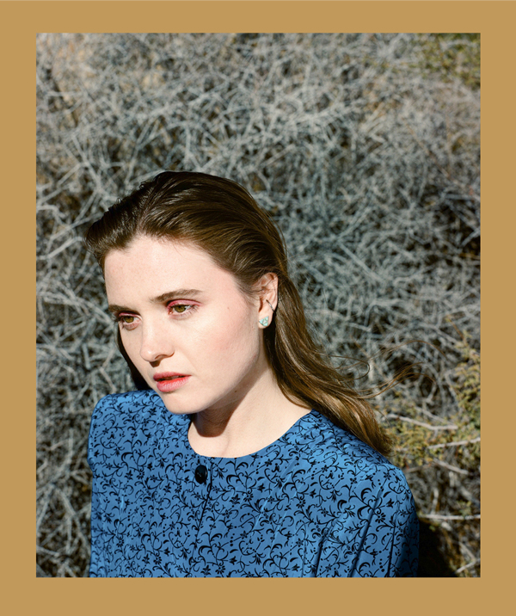
photo credit: Chimera Singer
May 8, 2020 (Los Angeles, CA) - Rising songwriter, multi-instrumentalist and vocalist Kathleen shares her debut EP Kathleen Itoday via Let Me Know/Warner Records—stream here.
Kathleen describes her debut EP Kathleen I as, “Love and the fall of love in the time of the great implosion.”
The EP features previously shared tracks “Asking The Aspens”—written by Kathleen and Daniel Nigro and produced by Noah Conrad and Ariel Rechtshaid (Adele, Beyoncé, Vampire Weekend, HAIM, Kelela)—and her debut single “The Longest Year,” which Consequence of Sound praised for its relatability while Idolator noted, “calling this song a mood is something of an understatement.” The EP also features two new tracks, “Seven Miles” and “Half My Mind Ago.”
Born on an island in Washington and raised in the Rocky Mountains by a park ranger turned physician’s assistant and a doctor, alongside a sister who is studying evolutionary biology, Kathleen finds her foremost inspiration in nature. From the age of seven, when she began writing songs, she found herself directly engaged with the world around her—its maximalism in the mountain landscapes of Colorado and its minutiae, the pattern of leaves as a vine climbs a wall or the insects living in a fallen log. She grew up ski racing, but was always more interested in the great silence of the snow beneath the chairlifts and the total freedom inside the forests of the back bowls over competitions or techniques. Her work investigates these natural extremes and how they apply to our everyday lives—“I want you to cry in public,” she says of its intended effect.

