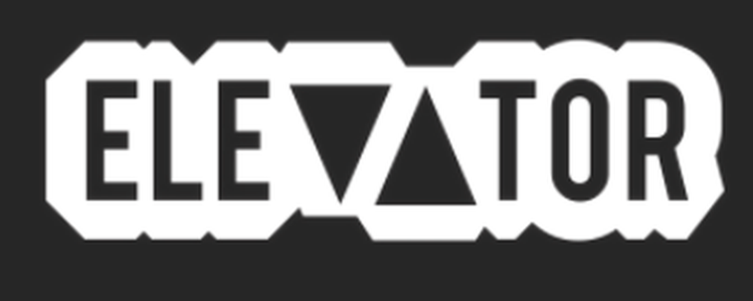

May 15, 2020

“Nashville's Bren Joy is leading a new, jazz-fused wave in R&B.” – Elevator Magazine

“one of the most exciting names in Tennessee” – Elevator Magazine

https://www.elevatormag.com/bren-joy-interview

