UNDER EMBARGO UNTIL 12PM ET, SEPTEMBER 10
ROCK ICONS
GREEN DAY, FALL OUT BOY, AND WEEZER
ANNOUNCE GLOBAL STADIUM HELLA MEGA TOUR PRESENTED BY HARLEY-DAVIDSON
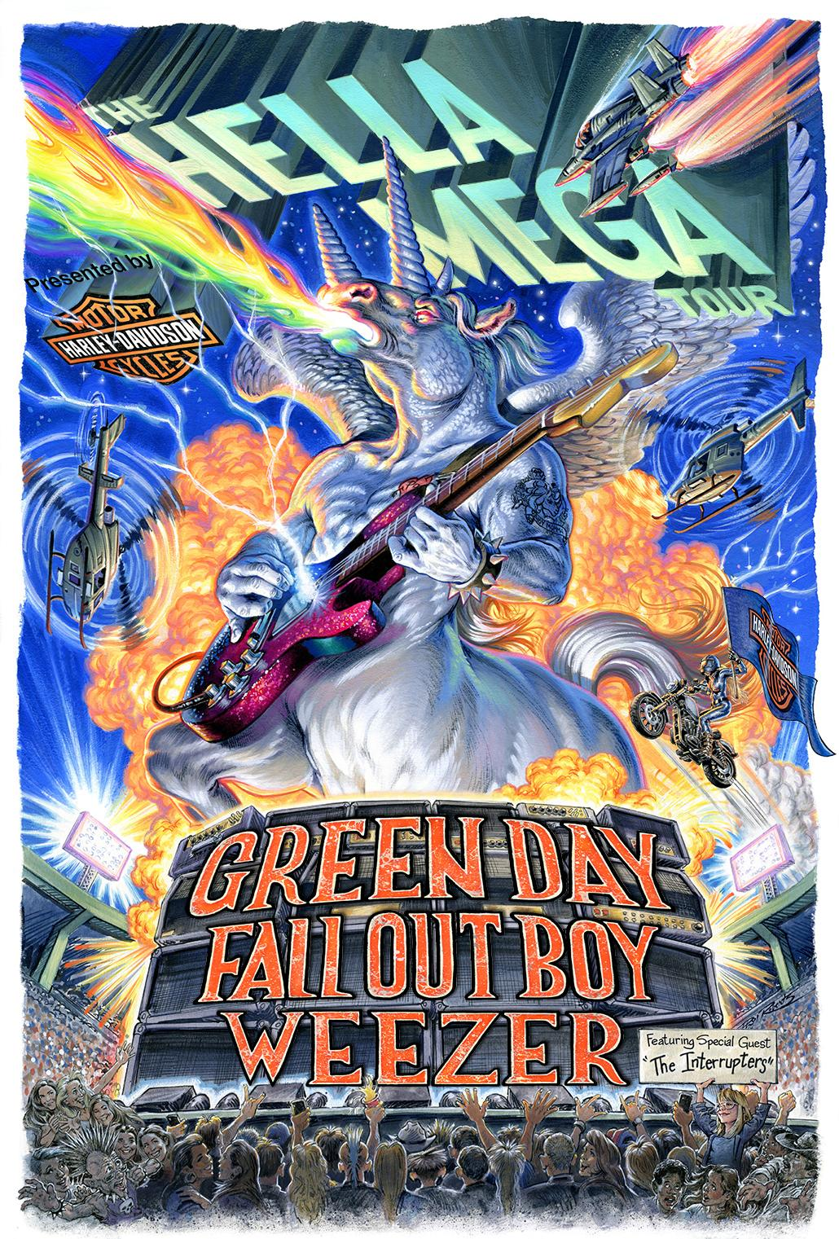
Click here for hi-res image

Green Day photo: https://bit.ly/2kDj3EB (Photo Credit: Pamela Littky)
Weezer photo: https://bit.ly/2m1wG0H (Photo Credit: Sean Murphy)
Fall Out Boy: https://bit.ly/2k44AkO (Photo Credit: Brendan Walter)
All Three Bands Performing Historic Los Angeles Show Tonight For Intimate Crowd

Tickets On Sale To The General Public Starting Friday, September 20 at Ticketmaster.com

All Three Bands Performing New Music from Forthcoming Albums on Jimmy Kimmel Live! This Week

LOS ANGELES, CA (September 10, 2019) - Today Green Day, Fall Out Boy, and Weezer, three of the biggest acts in rock music, announced they will be heading out on the road together for the first time ever on THE HELLA MEGA TOUR presented by Harley-Davidson. To celebrate the tour reveal, all three bands will perform a historic show tonight at the legendary Whisky A Go Go in Los Angeles.

The global tour kicks off June 13, 2020 in Paris and will visit cities across Europe and the UK throughout the month including Glasgow, London, and Dublin. Produced by Live Nation, the 20-city North American outing will bring the bands to some of the most renowned stadiums including Dodger Stadium, Wrigley Field, Citi Field, Fenway Park, and more. Beginning July 17 in Seattle, WA, the outing makes stops in Houston, Miami, Toronto, New York and more, before wrapping August 29 in Philadelphia, PA. More dates will be announced. The Interrupters will appear as special guest on the tour.

“Harley-Davidson and rock & roll have been synonymous throughout history,” said Neil Grimmer, President of Brand for the Harley-Davidson Motor Company. “So it’s only natural for Harley to present the most epic, full throttle rock tour in history!”

Concert-goers will see and experience the newest Harley-Davidson motorcycles, including the fully electric LiveWire and their new, exciting lineup of electric bicycles.

American Express® Card Members can purchase tickets before the general public beginning Monday, September 16 at 10am local time through Thursday, September 19 at 10pm local time. Tickets will go on sale to the general public beginning Friday, September 20 at 10am local time at Ticketmaster.com. VIP packages will be available next week.

In celebration of this announcement, all three artists are also thrilled to announce new singles which will be a first taste of their respective forthcoming albums. All three singles are available now and the respective albums are available for pre-order.

Five-time Grammy Award-winning Rock and Roll Hall of Fame inductees Green Day unleash their brand new single “Father Of All…,” which is the lead track on their forthcoming thirteenth studio album of the same name, out February 7, 2020 on Reprise / Warner Records. Formed in 1986 in Berkeley, CA, Green Day is one of the world’s best-selling bands of all time, with more than 70 million records sold worldwide and 10 billion cumulative audio/visual streams. Their 1994 breakout album Dookie, which sold over 10 million and achieved diamond status, is widely credited with popularizing and reviving mainstream interest in punk rock, catapulting a career-long run of #1 hit singles. Entertainment Weekly calls Green Day, “The most influential band of their generation,” while Rolling Stone attests, “Green Day have inspired more young bands to start than any act this side of KISS, and that doesn't seem to be changing.” In 2004, Green Day released the rock opera American Idiot which captured the nation’s attention, selling more than 7 million copies in the U.S. alone and taking home the Grammy Award for Best Rock Album. Mojo declared “It's exhilarating stuff, the kind of record that sets new parameters as to what is possible from a punk rock'n'roll band in the 21st century.” In 2010, a stage adaptation of American Idiot debuted on Broadway to critical and commercial acclaim and now they’re taking the world stage once again with their new album and Hella Mega global stadium tour. Green Day will also be performing solo dates in 2020- click here for all dates. Pre-order the album Father Of All… here. Listen to their single “Father of All…” here.

Multi-platinum selling, Grammy-nominated Fall Out Boy’s new single “Dear Future Self (Hands Up)” ft. Wyclef Jean will be featured on their forthcoming record Greatest Hits: Believers Never Die - Volume Two, out November 15 via Island Records. The song marks the band’s first new music since the August 2018 release of the three-song Lake Effect Kid EP, a love letter to their hometown city of Chicago that featured the full version of the band’s previously unreleased title track demo along with two new songs “City in A Garden” and “Super Fade.” In January, Fall Out Boy was featured on the gold-certified track “I’ve Been Waiting,” a collaboration from Lil Peep and iLoveMakonnen. Fall Out Boy’s seventh studio album M A N I A debuted at #1 on the Billboard 200 in January 2018 and garnered a GRAMMY nomination for Best Rock Album. Their worldwide tour in support of the record included a hometown show at Wrigley Field. Pre-order the album Greatest Hits: Believers Never Die - Volume Two here. Listen to their single “Dear Future Self (Hands Up)” here.

Multi-platinum, GRAMMY award-winning Weezer’s new single “The End of the Game,” produced by Suzy Shinn, will be included on their forthcoming 14th studio album, entitled Van Weezer, due out in May 2020. The inspiration for this album derives from the deepest roots of Weezer - metal! What has metal got to do with Weezer, you ask? In his earliest years, Rivers was a huge KISS fan; Brian was a big Black Sabbath fan; Pat worshipped at the altar of Van Halen and Rush; Scott loved Slayer and Metallica. The last time this vein of harder rock was mined by Weezer was on their much-loved 2002 album Maladroit; Van Weezer is primed to take that album's sonics many steps further courtesy of producer Suzy Shinn. "The End of the Game" is Weezer's first new song since this year’s release of Weezer (The Black Album), as well as their covers album, Weezer (The Teal Album), whose streaming numbers have surpassed 100 million. Weezer has sold 10 million albums in the U.S., and over 35 million records worldwide since their debut album’s release in 1994. Their catalogue has included such megahits as “Buddy Holly,” “Undone (The Sweater Song),” “Say It Ain’t So,” “El Scorcho,” “Hash Pipe,” “Island In The Sun,” “Beverly Hills,” “Pork and Beans,” and more. Pre-order the album Van Weezer here. Listen to their single “The End of the Game” here.

Tonight will mark the beginning of a three-day music takeover on ABC’s Jimmy Kimmel Live!, with a first ever TV performance of the new music from Weezer followed by Fall Out Boy tomorrow night and Green Day on Thursday. All episodes begin at 11:35pm on ABC and can be found online at https://abc.go.com/shows/jimmy-kimmel-live. Additionally, each of the band’s new songs were serviced to all Rock and Alternative Radio stations today and will be featured once an hour on a three hour loop all day with Cumulus, Entercom, and iHeart radio chains.

GREEN DAY
Pre-order Father Of All…: https://greenday.lnk.to/fatherofall
Listen to "Father Of All...": https://greenday.lnk.to/fatherofallsong

FALL OUT BOY
Pre-order Believers Never Die - Volume 2: https://store.falloutboy.com
Listen to "Dear Future Self (Hands Up)": https://FallOutBoy.lnk.to/DearFutureSelf

WEEZER
Pre-order Van Weezer: https://weezer.lnk.to/vanweezer
Listen to "The End of the Game": https://weezer.lnk.to/endofthegame

THE HELLA MEGA TOUR Europe & UK Dates:
DATE | CITY | VENUE
Saturday, June 13 | PARIS, FRANCE | La Defense Arena
Sunday, June 14 | GRONINGEN, NETHERLANDS | Stadspark
Wednesday, June 17 | ANTWERP, BELGIUM | Sportpaleis
Sunday, June 21 | VIENNA, AUSTRIA | Ernst Happel Stadium
Wednesday, June 24 | GLASGOW, SCOTLAND | Bellahouston Park
Friday, June 26 | LONDON, ENGLAND | London Stadium
Saturday, June 27 | HUDDERSFIELD, ENGLAND | The John Smith’s Stadium
Monday, June 29 | DUBLIN, IRELAND | RDS Arena

THE HELLA MEGA TOUR North American Dates:
DATE | CITY | VENUE
Friday, July 17 | SEATTLE, WA | T-Mobile Park
Tuesday, July 21 | SAN FRANCISCO, CA | Oracle Park
Friday, July 24 | SAN DIEGO, CA | Petco Park
Saturday, July 25 | LOS ANGELES, CA | Dodger Stadium
Tuesday, July 28 | COMMERCE CITY, CO | DICK’s Sporting Goods Park
Friday, July 31 | ARLINGTON, TX | Globe Life Field
Saturday, August 1 | HOUSTON, TX | Minute Maid Park
Wednesday, August 5 | MIAMI, FL | Hard Rock Stadium
Thursday, August 6 | JACKSONVILLE, FL | TIAA Bank Field
Saturday, August 8 | ATLANTA, GA | SunTrust Park
Tuesday, August 11 | MINNEAPOLIS, MN | Target Field
Thursday, August 13 | CHICAGO, IL | Wrigley Field
Saturday, August 15 | PITTSBURGH, PA | PNC Park
Sunday, August 16 | HERSHEY, PA | Hersheypark Stadium
Wednesday, August 19 | DETROIT, MI | Comerica Park
Friday, August 21 | WASHINGTON, DC | Nationals Park
Saturday, August 22 | NEW YORK, NY | Citi Field
Monday, August 24 | TORONTO, ON | Rogers Centre
Thursday, August 27 | BOSTON, MA | Fenway Park
Saturday, August 29 | PHILADELPHIA, PA | Citizens Bank Park

About Live Nation Entertainment
Live Nation Entertainment (NYSE: LYV) is the world’s leading live entertainment company comprised of global market leaders: Ticketmaster, Live Nation Concerts, and Live Nation Sponsorship. For additional information, please visit www.livenationentertainment.com.

FOR PRESS INQUIRIES:

Live Nation U.S. Concerts:
Emily Bender, emilybender@livenation.com
Monique Sowinski, moniquesowinski@livenation.com

GREEN DAY:
Nadine Pena, nadine@crushmusic.com
Laura Swanson, Laura.Swanson@warnerrecords.com

FALL OUT BOY:
Kristen Foster, kristen.foster@fullcoveragecommunications.com

WEEZER:
Jen Appel, jena@grandstandhq.com
Katie Nelson, katien@grandstandhq.com

