December 16, 2020

FLOOD Magazine In Conversation XIX And CMTEB discuss Their New Collaboration
“I LOVE GLITCHCORE”
https://floodmagazine.com/83547/in-conversation-xix-cmten-i-love-glitchcore/

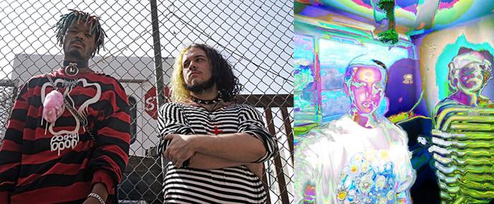
In Conversation: TikTok sensations XIX and CMTEN Discuss Their New Collaboration “I Love Glitchcore”
The artists talk discovering each other’s music, their breakout success, and their hard to pin down sound.
December 16th 2020 by Jonah Bayer
If you’re over the age of thirty, you may not be aware that musicians are getting millions of streams, Rolling Stone features, and major-label record deals through exposure on the social media app TikTok. Just ask XIX or CMTEN.
XIX—the duo of Kareem “Karm the Tool” Patterson and Alex “Yung Skayda” Calderon—have already passed over eleven million streams of their song “Kismet” and have just released a new EP, 19, which combines their glitchy, EDM-style music with a self-described punk sensibility. Alternately their Warner Records labelmate CMTEN has racked up over five million YouTube views and over twenty million streams on Spotify alone for his genre-smashing track “Never Met.”
We caught up with both acts shortly after the release of CMTEN’s new track featuring XIX titled “I Love Glitchcore” to discuss their collective rise to fame, what it was like working together, and why both artists’ music is easier to listen to than it is to describe.
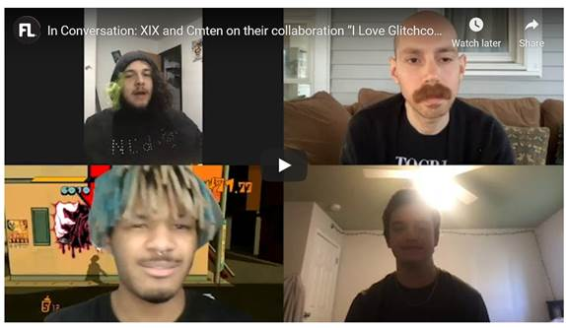
How did the three of you become aware about each other’s music?
CMTEN: We both had songs that went up on TikTok—they had “Kismet” and I had “Never Met”—and part of the reason for both those songs going up is this guy named Iguana Alana who used both of the songs for the edits [editing the music into the videos]. I think I first found “Kismet,” actually, from Alana’s edit of it, and then I was kind of aware of you guys and I reached out at one point on Instagram, “do you guys want to work?” or something.
Karm: Yeah, that’s how we met. We also were going to the same Subculture Partyas well, and then we also found out that we were signed to the same label.
Yung Skayda: Oh yeah, we found out after the fact.
CMTEN: …and after we had the Rolling Stone article together about Subculture Party, right?
Karm: Yeah, exactly.
“It’s nice to have a label sometimes when we’re kind of making a new sound or whatever, but at the same time it kind of goes beyond the confines of that.” — CMTEN
What was the process like for creating the song?
CMTEN: I kind of made a version of it and I sent it over and I was like, “Do you guys like this?” and they were like, “Yeah.”
Karm: Yeah, we fucked with it instantly. That shit went hard. The shit still goes hard.
CMTEN: I’m so excited to drop this…
Karm: Same.
CMTEN: Everybody who I’ve shown it to, they’re like, “What?”
Yung Skayda: I haven’t heard CMTEN rap like that before, so the way he was rapping…I was like, “Let’s go!”
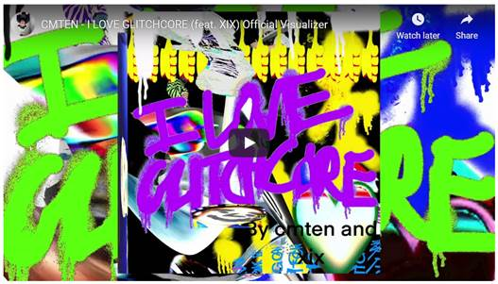
Do you two groups feel a kinship with each other, or like part of a scene?
Karm: I mean, the first time we came out to LA we planned on staying for I think it was three days, and then we ended up staying for two extra days. We called CMTEN and he flew overnight pretty much and met up with us in the morning and we hung out. I think of us as a friendship, really.
CMTEN: I think in terms of music and like a scene or whatever, it’s kind of cool to have the labels that people are putting on our stuff, whether it be like “hyperpop” or the ”glitchore” thing, but I feel like also if you look at the stuff we’re releasing and the stuff both of us are planning to release, there’s a lot more variety than that. I don’t know, it’s nice to have a label sometimes when we’re kind of making a new sound or whatever, but at the same time it kind of goes beyond the confines of that.
Karm: Yeah, we’re working on a lot of different kinds of stuff. Me and Alex have never agreed on a specific genre, so like, whatever comes around that we fuck with and we just kind of make, you know?
Traditionally bands build a fanbase touring, which isn’t possible right now. You’ve experienced a lot of success just using the internet—do you feel you still need to tour?
Karm: We need to tour, we need to tour. [Laughs.] That’s a necessity, ’cause me and Alex have always dreamed of going on tour, and that’s just because personally, we’re even-if-we-didn’t-need-to-we’d-have-to-type people, you know?
“I’m a producer, that’s it—and if they ask me what kind of music I make I just tell them to listen to it, because honestly it’s too much of a rabbit-hole conversation.” — Karm
CMTEN: For sure. Everything I make, part of the variety comes from thinking about what would the energy be like in a live environment? I think that’s part of this song that we’re doing right now, just us going on tour together and doing this live in one of our sets or something…
Yung Skayda: XIX/CMTEN shows are going to fucking smack.
Karm: Oh my god, just wait until we get rid of this fucking virus, bro. We already got rid of the orange dude.
Does it feel like things have happened fast for you, or has it felt more gradual?
Karm: I wouldn’t say it feels like it’s happening too fast.
Yung Skayda: Because we’ve been working at this for years.
Karm: Yeah, all of us.
Yung Skayda: So it’s deserved.
“I just tell people I’m a rapper because I do play a lot of instruments, but rapping is what I pride myself in. It’s like my favorite instrument of all.” — Yung Skayda
CMTEN: I guess I didn’t expect it to increase in streams so quickly because I’ve been doing it for a while, but I thought maybe one year I’d get a song that got 50,000 plays or something. And then after that I’d get another one that was bigger, and instead of that it just kind of instantly went up…
Yung Skayda: That’s literally what I thought! I thought maybe I’ll be famous in a couple years.
Karm: Yeah, so it’s not like it surprised any of us, but it was definitely like, “Woah, that was fast.”
What do you attribute that to?
Karm: I’d say for me and Alex with “Kismet” I think it was just timing. I think the timing for everything was perfect, and the way TikTok works and just the way that we laid out the song. Everything just kind of fell in line.
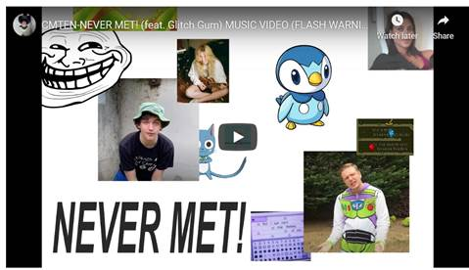
CMTEN: I feel on top of that, too, we both made genuinely really good songs. I wasn’t necessarily trying to make something that would blow up, and I’m pretty sure you guys weren’t, either. I was like, “This is a song that we’re doing because we like to make music,” and people were like, “Oh, it’s catchy” or whatever. I think that’s kind of a cool part of it: We made something that people like without trying to make it too commercial.
What do you tell strangers outside of this community when they ask what you do or what type of music you make?
Karm: I’m a producer, that’s it—and if they ask me what kind of music I make I just tell them to listen to it, because honestly it’s too much of a rabbit-hole conversation.
Yung Skayda: I just tell people I’m a rapper because I do play a lot of instruments, but rapping is what I pride myself in. It’s like my favorite instrument of all.
CMTEN: I don’t even know because I just do anything. I produce all my stuff and then I sing on it or rap on it or whatever, so my answer is kind of different every time. [Laughs.]
Karm: Yeah, the answer is different, and that’s why it’s just one of those questions

