For Immediate Release September 5, 2019
FOALS DEBUT NEW TRACK ‘THE RUNNER’

EVERYTHING NOT SAVED WILL BE LOST – PART 2 TO BE RELEASED VIA WARNER RECORDS ON OCTOBER 18TH
EVERYTHING NOT SAVED WILL BE LOST – PART 1 SHORTLISTED FOR THE MERCURY PRIZE
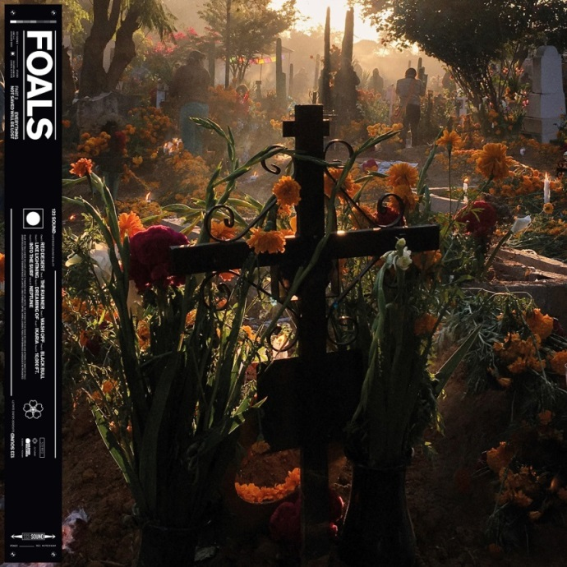
Critical Praise For Everything Not Saved Will Be Lost – Part 1
“big and adventurous... vibrant and versatile…”
-NPR Music

“…feels like the band taking stock of what works and amplifying each element — embossing their sound and creating something more themselves than ever before.”
-The FADER

“post-punk thrust, math-rock patterns and splintered lyrics mirror the daily dystopian media barrage.”
-The New York Times

“This year we are promised not just one Foals album, but two. And after listening to the first, we’re very, very lucky indeed.”
-Associated Press

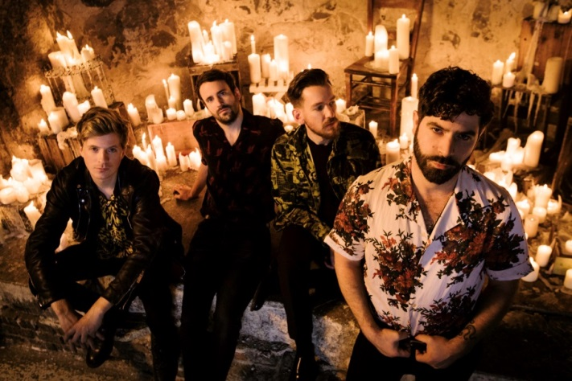
Today, Foals debut “The Runner,” the second song off their forthcoming album, Everything Not Saved Will Be Lost – Part 2 , which will be released on Warner Records on October 18th. Everything Not Saved Will Be Lost – Part 1 has been shortlisted for this month’s Mercury Prize, and both “The Runner” and the previously released song, “Black Bull”, encapsulate Part 2’s stylistic evolution. The song is set in the aftermath of the landscape described in the final songs of Everything Not Saved Will Be Lost – Part 1, a world that reflects our current emotional, political, and environmental predicament. Said lead singer Yannis Philippakis about the song: “It's a call to find a sense of purpose & perseverance despite the odds & despite the troubles we may find inside or outside ourselves.” Listen to “The Runner” here.
Everything Not Saved Will Be Lost – Part 2 completes the artistic statement and striking state-of-the-world-address of Everything Not Saved Will Be Lost – Part 1. The album will be released on CD, digital and vinyl formats. Special editions include orange vinyl that will be available exclusively through indie stores and a picture disc which is designed to be added to the Everything Not Saved Will Be Lost Collector’s Edition boxset. The album is now available to pre-order here, with “Black Bull” and “The Runner” included as an instant download.
Collectively, Every Not Saved Will Be Lost is symbolic of Foals’ trajectory so far. From playing chaotic house parties in their home city of Oxford to becoming major festival headliners across Europe, they’ve earned critical acclaim (NME and Q Award wins, plus Mercury Prize, Ivor Novello and BRIT Award nominations) and fan devotion (1.7 million album sales, plus over half a billion streams at Spotify since 2015) in equal measure.

Foals followed the release of Part 1 by completing an extended tour of the US and Europe. Foals also played triumphant sets at Glastonbury and Radio 1’s Big Weekend before headlining the Truck and Y Not Festivals. Please see http://www.foals.co.uk/tour for a full list of dates and ticket information.

Everything Not Saved Will Be Lost – Part 2 tracklist:
1. “Red Desert”
2. “The Runner”
3. “Wash Off”
4. “Black Bull”
5. “Like Lightning”
6. “Dreaming Of”
7. “Ikaria”
8. “10,000 Feet”
9. “Into the Surf”
10. “Neptune”

Official site
Spotify
Facebook
Instagram
YouTube
Twitter

For more information, please contact Mary Moyer (mary@qprime.com) or Emilio Herce (emilio@qprime.com) at Q Prime 212.302.9790.

