For Immediate Release February 25, 2019

FOALS DEBUT NEW SONG ‘SUNDAY’
WATCH THE LYRIC VIDEO HERE
CONFIRM HEADLINING NORTH AMERICAN TOUR
WITH SUPPORT FROM BEAR HANDS, PREOCCUPATIONS, OMNI, AND KIEV
LAUNCH DUAL ALBUM PROJECT WITH MARCH 8TH RELEASE OF
EVERYTHING NOT SAVED WILL BE LOST – PART 1
PART 2 TO FOLLOW IN AUTUMN

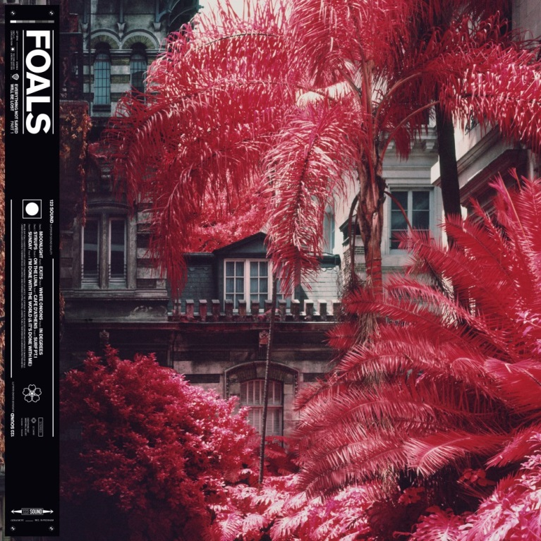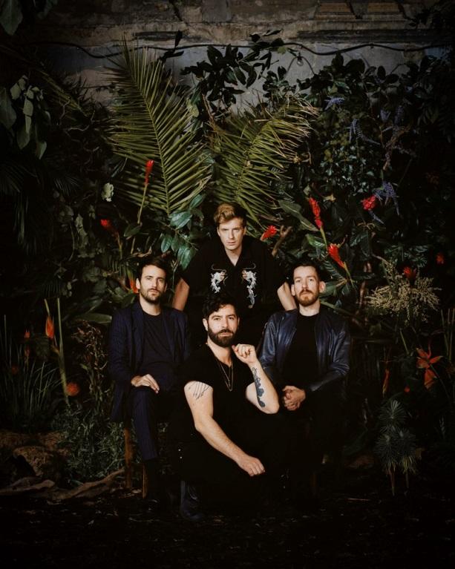
(Foals portrait by Alex Knowles. Download high res images here.)

Today, Foals debut their new song “Sunday,” the third track from their highly anticipated forthcoming album, Everything Not Saved Will Be Lost- Part 1 (March 8th, Warner Music). To coincide with the release of the new dreamy and elegiac song, the band also releases a lyric video. Watch it here.
Last week, the band debuted their frenetic and strident song “On The Luna” and the New York Times said its “post-punk thrust, math-rock patterns and splintered lyrics mirror the daily dystopian media barrage.” Watch the song’s observational, documentary style music video here. The band also sat for an interview with

October (Pitchfork) to talk about performing in the U.S. and their forthcoming albums. Read October’s “Having A Beer With… Foals” interview here.
Recently, Foals confirmed support from Bear Hands, Preoccupations, Omni, and Kiev on their twenty-date headlining U.S. tour. Bear Hands will provide direct support, with Kiev opening, on the first leg of the tour in cities including Portland, Seattle, Los Angeles and Las Vegas. Preoccupations will provide direct support, with Omni opening, on the second leg in cities including Brooklyn, Washington D.C., Boston, and Philadelphia (full details below). Due to high demand, Foals recently added a third NYC show at Brooklyn Steel on April 12, and a second Washington D.C. show at 9:30 Club on April 18. The initial Brooklyn Steel and 9:30 Club dates sold out in under 24 hours, and the band has also sold out their show in San Diego. Tickets for all dates are on sale now here. The band will also perform a headline tour throughout the UK and Europe, and have sold out shows in cities including London, Paris, Amsterdam, Berlin, and Glasgow (full dates below). Twickets is the official ticket resale partner of the tour. To combat touts, resale is restricted to no more than face value. Buying or selling tickets on any other resale platform is strictly prohibited. Learn more here. The band has previously confirmed festival dates throughout North America including Mexico’s Vive Latino 2019 and Atlanta’s Shaky Knees Festival.
Foals have announced that they will return with two new albums in 2019: Everythings Not Saved Will Be Lost – Part 1 & 2, a pair of releases, separate but related, they share a title, themes and artwork. ‘Part 1’ will be released on March 8th, with ‘Part 2’ following in the Autumn. From playing chaotic house parties in their home city of Oxford to becoming major festival headliners across Europe, Foals’ trajectory has been remarkable. They’ve earned critical acclaim (NME and Q Award wins, plus Mercury Prize, Ivor Novello and BRIT Award nominations) and fan devotion (1.7 million sales of their four Gold-certified albums, plus over half a billion streams at Spotify since 2015) in equal measure. Everything Not Saved Will Be Lost – Part 1 is now available to pre-order here, with lead single, “Exits,” provided as an instant download.
The band have also shared the music video for Everything Not Saved Will Be Lost – Part 1’s lead track, “Exits,” which was directed by Albert Moya, features actors Isaac Hempstead-Wright and Christa Théret, and was produced by CANADA. Watch it here.

Profoundly tethered but possessing their own personalities, the two forthcoming albums capture the most compelling, ambitious and cohesive creations that Foals – completed by Jimmy Smith (guitar), Jack Bevan (drums) and Edwin Congreave (keys) – have ever produced. “They’re two halves of the same locket,” frontman Yannis Philippakis explains. “They can be listened to and appreciated individually, but fundamentally, they are companion pieces.”
Eager to break the traditional pop song structure which they felt they were becoming increasingly tapered to, the 20 tracks defy expectation. There are exploratory, progressive-tinged tracks which occasionally break the 10-minute mark alongside atmospheric segues which make the music an experience rather than a mere collection of songs. Yet the band’s renowned ability to wield relentless grooves with striking power also reaches new heights.

Everything Not Saved Will Be Lost – Part 1 tracklisting:

1. Moonlight
2. Exits
3. White Onions
4. In Degrees
5. Syrups
6. On The Luna
7. Cafe D'Athens
8. Surf Pt.1
9. Sunday
10. I'm Done With The World (& It’s Done With Me)

FOALS TOUR DATES
March 4 /// Manchester, UK /// Gorilla
March 5 /// Edinburgh, UK /// The Liquid Room
March 7 /// London, UK /// EartH
March 16 /// Mexico City, Mexico /// Vive Latino 2019#
March 18 /// Vancouver, BC /// Orpheum Theater
March 19 /// Portland, OR /// Roseland Theater*
March 20 /// Seattle, WA /// Paramount Theatre*
March 22 /// Oakland, CA /// Fox Theater*
March 23 /// San Diego, CA /// The Observatory North Park& SOLD OUT
March 24 /// Los Angeles, CA /// Shrine Auditorium*
March 27 /// Las Vegas, NV /// Brooklyn Bowl*
March 30 /// Buenos Aires, Argentina /// Lollapalooza 2019#
March 31 /// Santiago, Chile /// Lollapalooza 2019#
April 2 /// Santiago, Chile /// Lollapalooza Sideshow @ Teatro La Cúpula#
April 5 /// Sao Paulo, Brazil /// Lollapalooza 2019#
April 7 /// Bogota, Columbia /// Estereo Picnic#
April 12 /// Brooklyn, NY /// Brooklyn Steel^
April 13 /// Brooklyn, NY /// Brooklyn Steel ^SOLD OUT
April 14 /// Brooklyn, NY /// Brooklyn Steel^ SOLD OUT
April 16 /// Washington, D.C. /// 9:30 Club^ SOLD OUT
April 18 /// Washington, D.C. /// 9:30 Club^
April 19 /// Boston, MA /// House of Blues^
April 20 /// Philadelphia, PA /// The Fillmore^
April 22 /// Toronto, ON /// Rebel^
April 23 /// Columbus, OH /// Newport Music Hall
April 24 /// St. Louis, MO /// The Pageant^
April 26 /// Detroit, MI /// Saint Andrews Hall^
April 27 /// Chicago, IL /// Riviera Theatre^
April 28 /// Milwaukee, WI /// The Rave^
April 30 /// Minneapolis, MN /// First Avenue^
May 2 /// Kansas City, MO /// Midland Theatre+
May 5 /// Atlanta, GA /// Shaky Knees Festival 2019#
May 12 /// Brussels, Belgium /// Ancienne Belgique SOLD OUT
May 13 /// Paris, France /// Bataclan SOLD OUT
May 15 /// Lausanne, Switzerland /// Les Docks SOLD OUT
May 16 /// Milan, Italy /// Fabrique
May 17 /// Luxembourg, Luxembourg /// Den Atelier SOLD OUT
May 19 /// Amsterdam, Netherlands /// Paradiso SOLD OUT
May 20 /// Berlin, Germany /// Huxleys SOLD OUT
May 24 /// Newcastle, United Kingdom /// This Is Tomorrow 2019#
June 5 /// Hamburg, Germany /// Grosse Freiheit SOLD OUT
June 6 /// Aaarhus, Denmark /// Northside Festival#
June 7 - June 9 /// Nürburg, Germany /// Rock Am Ring 2019#
June 7 - June 9 /// Nuremberg, Germany /// Rock im Park#
June 11 /// Manchester, United Kingdom /// O2 Victoria Warehouse SOLD OUT
June 12 /// Manchester, United Kingdom /// O2 Victoria Warehouse SOLD OUT
June 14 /// Tunbridge Wells, United Kingdom /// Bedgebury Pinetum

June 15 /// Birmingham, United Kingdom /// Digbeth Arena SOLD OUT
June 16 /// Birmingham, United Kingdom /// Digbeth Arena SOLD OUT
June 18 /// Glasgow, United Kingdom /// SWG3 Galvanizers Yard SOLD OUT
June 20 /// Thetford, United Kingdom /// Thetford Forest
June 21 /// London, United Kingdom /// Alexandra Palace SOLD OUT
June 22 /// London, United Kingdom /// Alexandra Palace
June 24 - June 26 /// Zagreb, Croatia /// Inmusic Festival#
June 26 /// Bournemouth, United Kingdom /// International Centre
July 2 /// Dublin, Ireland /// Trinity College
July 5 /// Barcelona, Spain /// Festival Cruïlla 2019#
July 5- 7 /// Ewijk, Netherlands /// Down The Rabbit Hole#
July 25 - 28 /// Pikehall, Derbyshire, UK /// Y Not Festival #
July 26 - 28 /// Benidorm, Spain /// Low Festival 2019#
July 31 /// Freiburg, German /// Zelt – Musik- Festival #
August 1 - 3 /// Lustenau, Austria /// Szene Open Air#
August 7 – 11 /// Newquay, United Kingdom /// Boardmasters#
August 16 /// Osaka, Japan /// Summer Sonic#
August 17 /// Tokyo, Japan /// Summer Sonic#
August 22 - 24 /// Gueret, France /// Check In Party#
August 25 /// Paris, France /// Rock En Seine#
August 27 /// Kiev, Ukraine /// Art Platform
August 29 /// Moscow, Russia /// Adrenaline Stadium
August 30 /// St. Petersburg, Russia /// Morze
* with Bear Hands & Kiev
^ with Preoccupations & Omni
& with The Blue Stones, Preoccupations, The Cordial Sin
# Festival Date
+ Supporting Interpol

Official site
Spotify
Facebook
Instagram
YouTube
Twitter
For more information, please contact Mary Moyer (mary@qprime.com) or Emilio Herce (emilio@qprime.com) at Q Prime 212.302.9790.

