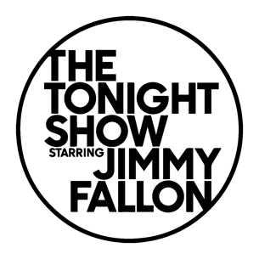
CHIKA

PERFORMS “HIGH RISES” & “CROWN” ON THE TONIGHT SHOW STARRING JIMMY FALLON

Full performance: https://youtu.be/5yJAWBexj2E

