

cid:image002.png@01D59F78.72944830

**UNVEILS NEW VERSION OF “PEARL CADILLAC” FEATURING ANDRA DAY**

**CLARK RECEIVES FOUR NOMINATIONS FOR THE 62nd ANNUAL**

**GRAMMY AWARDS FOR** [***THIS LAND***](https://nam04.safelinks.protection.outlook.com/?url=https%3A%2F%2Fwww.youtube.com%2Fwatch%3Fv%3DH4L1b5xkcbI&data=02%7C01%7CRick.Gershon%40warnerrecords.com%7C25b9b12fa1df4884ec0208d76ddf1997%7C8367939002ec4ba1ad3d69da3fdd637e%7C0%7C0%7C637098677278555935&sdata=cZZwUYEWkyRv%2FOFnoguLF5oSAKapCK8DZqbwEl4UtVc%3D&reserved=0)

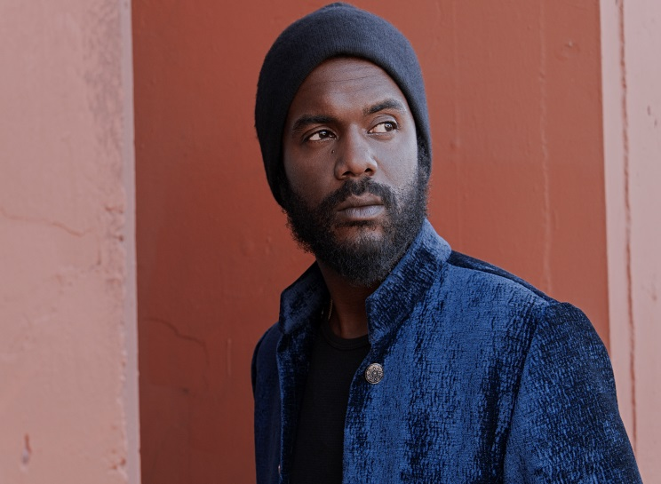

**(Photo credit: Frank Maddocks - Click** [**here**](http://press.warnerrecords.com/wp-content/uploads/2019/03/IMG_0807.jpg)**)**

**December 13, 2019 (Los Angeles, CA) –** Grammy-Award-winning artist [**Gary Clark Jr.**](https://nam04.safelinks.protection.outlook.com/?url=http%3A%2F%2Fwww.garyclarkjr.com%2F&data=02%7C01%7CRick.Gershon%40warnerrecords.com%7C25b9b12fa1df4884ec0208d76ddf1997%7C8367939002ec4ba1ad3d69da3fdd637e%7C0%7C0%7C637098677278575928&sdata=1XJ85dOP%2FwYQqmPkqu%2BG8Yt6Kk5kD2IF5%2F1ZrRstwZA%3D&reserved=0)releases a brand new version of **“Pearl Cadillac”** from his current Warner Records album, ***THIS LAND***. The new mix single features additional vocals by fellow Warner artist and Grammy nominee [**Andra Day**](https://www.andraday.com/)**.** Clark and Day became friends years ago after playing shows together. Both share a musical commonality which incorporates their disparate influences of soul, pop, blues, gospel and rock ‘n’ roll propelled by a strong positive energy which becomes something both new yet timeless. Once introduced into Clark’s live set, **“Pearl Cadillac”** quickly became a fan-favorite sometimes stretching into seven or eight minutes long. The song made its TV debut on [**SNL**](https://www.youtube.com/watch?v=bGA5u-8Oy8A) in February. The new streamlined edit showcasing Day’s commanding vocal performance with Clark now plays like a classic Prince-inspired power ballad. Click [**here**](https://warnerr.ec/pearlcaddyremix) to stream the new version of **“Pearl Cadillac,”** and click [**here**](https://warnerr.ec/pearlcaddyremix_v)to view and share the visualizer.

As previously announced, the GRAMMY® Award-winner has received nods in multiple categories, bringing his total career nominations to six. Clark’s 2020 nominations include: Best Rock Performance for **“This Land,”** Best Rock Song for **“This Land,”** Best Contemporary Blues Album for ***THIS LAND*** and Best Music Videofor[**“This Land.”**](https://nam04.safelinks.protection.outlook.com/?url=https%3A%2F%2Fwww.youtube.com%2Fwatch%3Fv%3D9KgNaRQ_J-c&data=02%7C01%7CRick.Gershon%40warnerrecords.com%7C25b9b12fa1df4884ec0208d76ddf1997%7C8367939002ec4ba1ad3d69da3fdd637e%7C0%7C0%7C637098677278585920&sdata=Qc1DZMmstbViS%2FmkzyosCGYzyXseqHt7JbFHFC%2FZaOE%3D&reserved=0)

The [**62nd Annual GRAMMY Awards®**](https://nam04.safelinks.protection.outlook.com/?url=https%3A%2F%2Fwww.grammy.com%2F&data=02%7C01%7CRick.Gershon%40warnerrecords.com%7C25b9b12fa1df4884ec0208d76ddf1997%7C8367939002ec4ba1ad3d69da3fdd637e%7C0%7C0%7C637098677278575928&sdata=5ewIlkNuQ0QbhPHGIcImDy3OtCsygD8LYEGwT7Lz3P8%3D&reserved=0) air Sunday, January 26th live on [**CBS**](https://nam04.safelinks.protection.outlook.com/?url=https%3A%2F%2Fwww.cbs.com%2Fshows%2Fgrammys%2F&data=02%7C01%7CRick.Gershon%40warnerrecords.com%7C25b9b12fa1df4884ec0208d76ddf1997%7C8367939002ec4ba1ad3d69da3fdd637e%7C0%7C0%7C637098677278595917&sdata=Oa%2F%2FQen1JIN6mw9U76wBFRZe6Ri3DjormoHLBY6ajKY%3D&reserved=0) from the Staples Center in Los Angeles.

Earlier this week, Clark stopped by [***The Kelly Clarkson show***](https://www.nbc.com/kelly-clarkson-show) to perform **“Pearl Cadillac”** with his band, followed by a quick stop at [***The Tonight Show Starring Jimmy Fallon***](https://www.nbc.com/the-tonight-show)to play **“This Land”** with **The Roots.** Click to view and share both stellar performances:[**“Pearl Cadillac”**](https://www.youtube.com/watch?v=g7VEIjBSpKU)and[**“This Land.”**](https://www.youtube.com/watch?v=OciazfKaGZg)

**About Gary Clark Jr.:** Clark made a major impact throughout 2019. Upon release, ***This Land*** – Clark’s third full-length studio album – bowed at #6 on the *Billboard* Top 200, marking his third Top 10 debut. It also attracted acclaim from the likes of *The New York Times*, *The Washington Post*, *The Los Angeles Times*, *Rolling Stone*, *Pitchfork* and more.  He has performed on *Saturday Night Live*, *The Late Show with Stephen Colbert, The Ellen DeGeneres Show, The Tonight Show Starring Jimmy Fallon, The Late Late Show with James Corden*, *Jimmy Kimmel Live!*, *Good Morning America, CBS News Sunday, CBS This Morning, The Today Show, Late Night with Seth Meyers, The Daily Show with Trevor Noah, The Howard Stern Show, WTF with Marc Maron* and more.  Clark embarked on his biggest international headline run to date, topping bills at legendary festivals and venues such as the Hollywood Bowl, and made multiple appearances in stadiums supporting and sharing the stage with The Rolling Stones.

**About Andra Day:**

Carried by enough conviction to incite cultural change, Andra Day’s full-length debut *Cheers to the Fall* (Buskin Records / Warner Records) garnered a 2016 GRAMMY® Award nomination in the category of “Best R&B Album,” while its anthemic Platinum lead single “Rise Up” achieved a nod for “Best R&B Performance.” She’s appeared on *The Late Show with Stephen Colbert*, *Ellen*, *Dancing with the Stars*, *The Vie*w, *Jimmy Kimmel Live!,* and White House *National Christmas*— just to name a few. Quietly recognized amongst some of music’s most legendary names, the singer paid tribute to Ray Charles at The Smithsonian and shared the stage for performances with everyone from Chinese piano virtuoso Lang Lang, Bonnie Raitt, Stevie Wonder to Ellie Goulding, Alicia Keys, and John Legend. Along the way, she covered *Essence Magazine* and achieved the prestigious “Powerhouse Award” at the *Billboard Women in Music* event. Andra is currently filming her starring role in the Lee Daniels-directed Billie Holiday biopic and is putting the finishing touches on her highly-anticipated sophomore album due out in 2020.

**# # #**

**Contacts:**

**Gary Clark Jr.**

**Rick Gershon** at Warner Records

818-953-3473 | [**rick.gershon@warnerrecords.com**](mailto:rick.gershon@warnerrecords.com)

**Andra Day**

**Aishah White** at Warner Records

818-953-3277 | [**aishah.white@warnerrecords.com**](mailto:aishah.white@warnerrecords.com)

**Follow Gary Clark Jr.:**

**Official** **|** **Facebook** **|** [**Twitter**](mailto:@GaryClarkJr) **|** [**YouTube**](http://www.youtube.com/user/garyclarkjr)