

/var/folders/vj/dqzyq6rn24vdbv28yg_dlv800000gp/T/com.microsoft.Outlook/WebArchiveCopyPasteTempFiles/cidimage001.png@01D4B96E.0D77E790

**LAUNCHES NEW VIDEO FOR** [**“PEARL CADILLAC”**](https://warnerr.ec/pearlcaddy)

**FROM HIS CRITICALLY ACCLAIMED ALBUM *THIS LAND***

**Clark to perform on *Jimmy Kimmel Live*! on September 26th**

***The Late, Late Show with James Corden* on September 30th,**

**and Austin City Limits-PBS on October 5th**

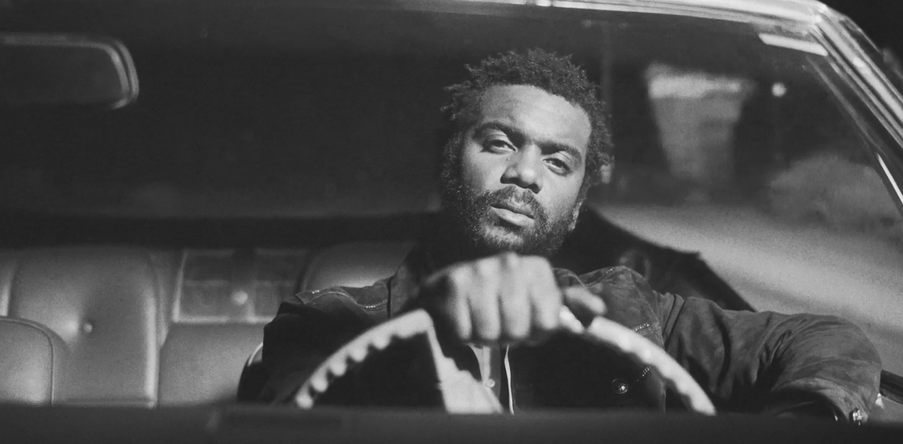

**September 20, 2019 (Los Angeles, CA)** – Grammy Award-winning artist[**Gary Clark Jr**](x-apple-data-detectors://13)**.** releases a brand-new video for his single **“Pearl Cadillac”** today. The track is taken from Clark’s groundbreaking third and current Warner Records studio album ***THIS LAND.*** The short film was shot in Los Angeles and directed by filmmaker [**Clément Oberto**](https://www.clementoberto.com/). “Pearl Cadillac” is Clark’s true coming of age story and a tribute to his mother when he left home for the first time to create a new life on the road. The elegant, noir-ish black and white sequences are presented in classic, 35mm film stock.

Although the car is a side story, the real Cadillac Deville belonged to Clark’s mother who is at the heart of the song and is lovingly attributed for her selfless dedication to her family and for allowing her son to fulfill his musical dreams. The actual pearl white vehicle remains with Clark’s mother to this day. The song immediately became a fan favorite live and is one of many of the show’s most emotionally dramatic moments. Click [**here**](https://warnerr.ec/pearlcaddy) to view and share **“Pearl Cadillac.”**

Gary Clark Jr. has confirmed another round of TV performances for September and October with more to be announced shortly. On September 26th, tune into [***ABC’s Jimmy Kimmel Live!***](https://abc.go.com/shows/jimmy-kimmel-live) at 11:30 PM. On September 30th, Clark and company will appear live on [***The Late Late Show with James Corden***](https://www.cbs.com/shows/late-late-show/) on CBS at 12:35 AM. [**Austin City Limits on PBS**](https://www.pbs.org/show/austin-city-limits/) will feature Gary Clark Jr. for the entire hour as their season opener on October 5th. Click [**here**](http://acltv.com/) for ACL broadcast details in your area.

**Gary Clark Jr.** is currently on tour. Every ticket purchased includes a standard CD or digital copy of ***THIS LAND***. Check out the [**official tour trailer**](https://www.youtube.com/watch?v=H4L1b5xkcbI&feature=youtu.be) and click [**here**](http://www.garyclarkjr.com/tour)for ticket information.

**Remaining tour dates as follows:**

Sep 21 Dallas, TX Crossroads Guitar Festival / American Airlines Center

Sep 24 Phoenix, AZ Comerica Theatre

Sep 27 Santa Barbara County Bowl

Sep 28 Berkeley, CA Greek Theatre

Sep 29 Hollywood, CA Hollywood Bowl

Oct 03 Austin, TX Stubb’s Waller Creek Amphitheater

Oct 04 Austin, TX Stubb’s Waller Creek Amphitheater

Oct 05 Austin, TX Austin City Limits Festival / Zilker Park (weekend 1)

Oct 12 Austin, TX Austin City Limits Festival / Zilker Park (weekend 2)

**Ticket & Tour info**:[**http://www.garyclarkjr.com/tour**](http://www.garyclarkjr.com/tour)

**# # #**

Contact **Rick Gershon** at Warner Records Publicity:

818-953-3473 / [**rick.gershon@warnerrecords.com**](mailto:rick.gershon@warnerrecords.com)

Regional/ Tour Press: **Bre Flores** at Warner Records Publicity:

818-953-3638 / **breanne.flores@warnerrecords.com**

**Follow Gary Clark Jr.:**

Official: [**garyclarkjr.com**](http://www.garyclarkjr.com/)

Facebook: [**facebook.com/GaryClarkJr**](https://www.facebook.com/GaryClarkJr)

Twitter: [**@GaryClarkJr**](https://twitter.com/garyclarkjr)

Instagram: **@garyclarkjr**

YouTube: [**www.youtube.com/user/garyclarkjr**](http://www.youtube.com/user/garyclarkjr)

Press Materials: **press.warnerrecords.com/garyclarkjr/**

