

cid:image002.png@01D59F78.72944830

**CONFIRMED TO PERFORM “THIS LAND” LIVE WITH THE ROOTS**

**ON 62ND ANNUAL GRAMMY AWARDS®**

**GARY CLARK JR. & THE ROOTS UNVEIL**

**“THIS LAND (REMIX) FROM *THE TONIGHT SHOW STARRING JIMMY FALLON* FEATURING BLACK THOUGHT”**

**AVAILABLE NOW**

[***THIS LAND***](https://nam04.safelinks.protection.outlook.com/?url=https%3A%2F%2Fwww.youtube.com%2Fwatch%3Fv%3DH4L1b5xkcbI&data=02%7C01%7CRick.Gershon%40warnerrecords.com%7C25b9b12fa1df4884ec0208d76ddf1997%7C8367939002ec4ba1ad3d69da3fdd637e%7C0%7C0%7C637098677278555935&sdata=cZZwUYEWkyRv%2FOFnoguLF5oSAKapCK8DZqbwEl4UtVc%3D&reserved=0) **NOMINATED FOR FOUR GRAMMY AWARDS®**

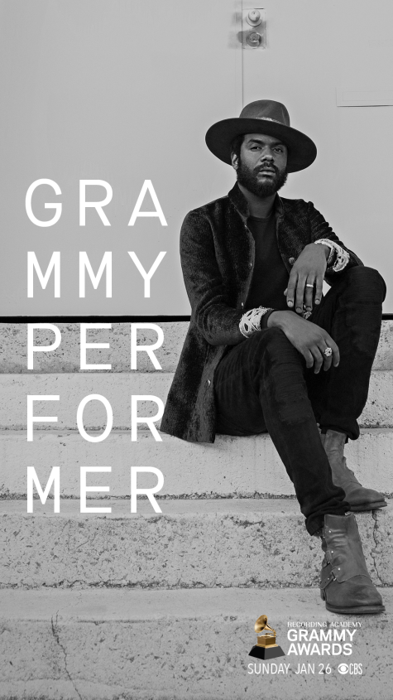

**January 24th, 2020 (Los Angeles, CA) –** **GRAMMY Award®**-winning artist [**Gary Clark Jr.**](https://nam04.safelinks.protection.outlook.com/?url=http%3A%2F%2Fwww.garyclarkjr.com%2F&data=02%7C01%7CRick.Gershon%40warnerrecords.com%7C25b9b12fa1df4884ec0208d76ddf1997%7C8367939002ec4ba1ad3d69da3fdd637e%7C0%7C0%7C637098677278575928&sdata=1XJ85dOP%2FwYQqmPkqu%2BG8Yt6Kk5kD2IF5%2F1ZrRstwZA%3D&reserved=0)has been confirmedto perform live on the 62nd Annual Grammy Awards**®** backed by **The Roots** to play his multi-GRAMMY® nominated song, **“This Land.”** To celebrate, **Clark & The Roots** release a brand-new live version of the track titled **“This Land** **(Remix) from *The Tonight Show Starring Jimmy* Fallon featuring Black Thought.”** The new version was recorded live on [***The Tonight Show Starring Jimmy Fallon***](https://www.youtube.com/watch?v=OciazfKaGZg) this past December 11th, and just may be the most explosive take of the track to date. Click [**here**](https://warnerr.ec/thislandremix) to stream.

Coming off his most successful and electrifying year of his career, Clark capped 2019 with four GRAMMY® Award nominations in multiple categories, bringing his total career nominations to six. Clark’s 2020 nominations include: Best Rock Performance for **“This Land,”** Best Rock Song for **“This Land,”** Best Contemporary Blues Album for ***THIS LAND*** and Best Music Videofor[**“This Land.”**](https://nam04.safelinks.protection.outlook.com/?url=https%3A%2F%2Fwww.youtube.com%2Fwatch%3Fv%3D9KgNaRQ_J-c&data=02%7C01%7CRick.Gershon%40warnerrecords.com%7C25b9b12fa1df4884ec0208d76ddf1997%7C8367939002ec4ba1ad3d69da3fdd637e%7C0%7C0%7C637098677278585920&sdata=Qc1DZMmstbViS%2FmkzyosCGYzyXseqHt7JbFHFC%2FZaOE%3D&reserved=0)

The [**62nd Annual GRAMMY Awards®**](https://nam04.safelinks.protection.outlook.com/?url=https%3A%2F%2Fwww.grammy.com%2F&data=02%7C01%7CRick.Gershon%40warnerrecords.com%7C25b9b12fa1df4884ec0208d76ddf1997%7C8367939002ec4ba1ad3d69da3fdd637e%7C0%7C0%7C637098677278575928&sdata=5ewIlkNuQ0QbhPHGIcImDy3OtCsygD8LYEGwT7Lz3P8%3D&reserved=0) air Sunday, January 26th live on [**CBS**](https://nam04.safelinks.protection.outlook.com/?url=https%3A%2F%2Fwww.cbs.com%2Fshows%2Fgrammys%2F&data=02%7C01%7CRick.Gershon%40warnerrecords.com%7C25b9b12fa1df4884ec0208d76ddf1997%7C8367939002ec4ba1ad3d69da3fdd637e%7C0%7C0%7C637098677278595917&sdata=Oa%2F%2FQen1JIN6mw9U76wBFRZe6Ri3DjormoHLBY6ajKY%3D&reserved=0) from the Staples Center in Los Angeles.

Recently, Clark was featured on an episode of **CBS News Sunday Morning** in both conversation and performance. Its immediate impact hurled ***THIS LAND*** into the #2 spot on the iTunes Rock Album Chart and #3 on the overall Album chart. Clark has had three albums in the Top 15 of iTunes overall Album Chart. At Amazon, ***THIS LAND*** jumped into the #2 spot on the overall CD chart. Clark has had four albums in the Top 10 of the Amazon Chart. Click [**here**](https://www.youtube.com/watch?v=dbQ__dQviGg) to view the episode.

As previously announced, Clark will also be among the performers for **“Let’s Go Crazy: The Grammy Salute To Prince**.” The live concert taping will be held Tuesday, January 28th at 7:30 p.m. PT at the Los Angeles Convention Center. The special will feature a lineup of all-star artists paying tribute to Prince's unprecedented influence on music. The special will be broadcasted later in 2020 on [**CBS**](https://nam04.safelinks.protection.outlook.com/?url=http%3A%2F%2Fwww.cbs.com%2F&data=02%7C01%7CRick.Gershon%40warnerrecords.com%7Cd9a9db486b634d06c5dc08d795f72cdc%7C8367939002ec4ba1ad3d69da3fdd637e%7C0%7C0%7C637142761520551831&sdata=w0V54D18%2BjbuAU7Jc%2B2xhp9Yme%2FqLUmMOjOXBxUqm9g%3D&reserved=0). Tickets are on sale now and available for purchase [**here**](https://nam04.safelinks.protection.outlook.com/?url=https%3A%2F%2Fwww.axs.com%2Fevents%2F389980%2Fletys-go-crazy-the-grammy-salute-to-princey-tickets&data=02%7C01%7CRick.Gershon%40warnerrecords.com%7Cd9a9db486b634d06c5dc08d795f72cdc%7C8367939002ec4ba1ad3d69da3fdd637e%7C0%7C0%7C637142761520561827&sdata=aBiuplB8L%2Fb%2FPSWWCe4aYb3MbPn0WKq%2BpU9F9uWBuUk%3D&reserved=0).

**About Gary Clark Jr.:** Clark made a major impact throughout 2019. Upon release, ***This Land*** – Clark’s third full-length studio album – bowed at #6 on the *Billboard* Top 200, marking his third Top 10 debut. It also attracted acclaim from the likes of *The New York Times*, *The Washington Post*, *The Los Angeles Times*, *Rolling Stone*, *Pitchfork* and more.  He has performed on *Saturday Night Live*, *The Late Show with Stephen Colbert, The Ellen DeGeneres Show, The Tonight Show Starring Jimmy Fallon, The Late Late Show with James Corden*, *Jimmy Kimmel Live!*, *Good Morning America, CBS News Sunday, CBS This Morning, The Today Show, Late Night with Seth Meyers, The Daily Show with Trevor Noah, The Howard Stern Show, WTF with Marc Maron* and more.  Clark embarked on his biggest international headline run to date, topping bills at legendary festivals and venues such as the Hollywood Bowl, and made multiple appearances in stadiums supporting and sharing the stage with The Rolling Stones.

**About The Roots:**

The legendary Roots Crew have become one of the best known and most respected hip-hop acts in the business, winning four GRAMMYS, including "Best R&B Album" for ***Wake Up!,*** "Best Traditional R&B Vocal Performance" for **"Hang in There"** (with John Legend) and "Best Group or Duo R&B Vocal Performance" for **"Shine."** This brings the band's GRAMMY nomination count to twelve. Additionally, "[**The Roots Picnic**](http://rootspicnic.com/philly/),” a yearly star-studded mix of musicians, has become a celebrated institution. The Roots were named one of the greatest live bands around by *Rolling Stone* and serve as the official house band on *The Tonight Show Starring Jimmy Fallon*. Most recently, Black Thought and Questlove have been the executive producers of the acclaimed documentary series *“Hip-Hop: The Songs That Shook America”* on AMC.

**Contacts:**

**Gary Clark Jr.**

**Rick Gershon** at Warner Records

818-953-3473 | [**rick.gershon@warnerrecords.com**](mailto:rick.gershon@warnerrecords.com)

**The Roots**

Carleen Donovan at Donovan Public Relations

212-677-0014 | [**carleen@donovanpublicrelations.com**](mailto:carleen@donovanpublicrelations.com)

Chloe Snyder at Donovan Public Relations

212-677-0014 | [**chloe@donovanpublicrelations.com**](mailto:chloe@donovanpublicrelations.com)

**Follow Gary Clark Jr.:**

[**Official**](https://www.garyclarkjr.com/thisland?ref=Typed/Bookmarked) **|** [**Facebook**](https://www.facebook.com/GaryClarkJr/) **|** [**Twitter**](mailto:@GaryClarkJr) **|** [**Instagram**](https://www.instagram.com/garyclarkjrofficialfanpage/?hl=en) **|** [**YouTube**](http://www.youtube.com/user/garyclarkjr) **|** [**Spotify**](https://open.spotify.com/artist/01aC2ikO4Xgb2LUpf9JfKp) **|** [**Publicity Materials**](https://press.warnerrecords.com/garyclarkjr/)

