MULTI-GRAMMY AWARD-WINNER GARY CLARK JR. RETURNS TO THE ROAD FOR FALL 2022 HEADLINE TOUR

TICKETS ON SALE THIS WEEK

APPEARS IN BAZ LUHRMANN’S ELVIS ALONGSIDE TOM HANKS & AT JON STEWART’S MARK TWAIN PRIZE ACCEPTANCE CEREMONY ON PBS

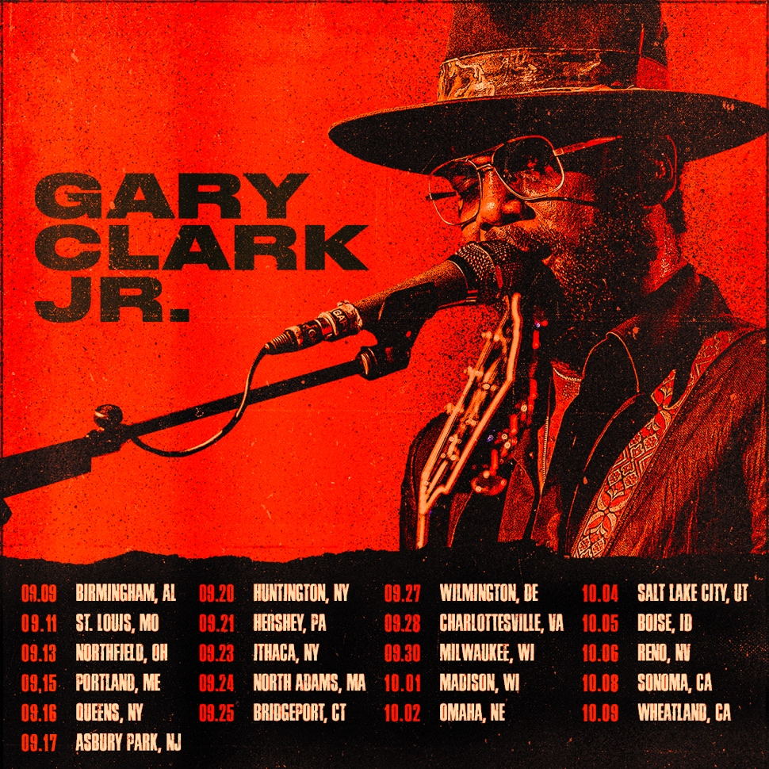

July 12, 2022 (Los Angeles, CA) – Grammy Award-winner Gary Clark Jr. returns to the road for a month-long fall headline tour across North America. This run kicks off September 9 in Birmingham, AL at Avondale Brewery, visits major markets coast-to-coast, and closes out four weeks later on October 9 at Hard Rock Live in Wheatland, CA. Along the way, he takes the stage at Sea.Hear.Now Festival in Asbury Park, NJ on September 17 and Sound on Sound Music & Arts Festival in Bridgeport, CT on September 25. A venue pre-sale goes live on July 13 at 10am local time. General on-sale begins July 15 at 10am local time. Check out the full confirmed itinerary below. Click HERE for concert and ticket information.

Right now, fans can witness his performance as American blues singer-songwriter Arthur “Big Boy” Crudup in legendary filmmaker Baz Luhrmann’s Elvis. Gary appears on the big screen alongside Academy Award-winning icon Tom Hanks as Col. Tom Parker. The film is in theaters everywhere now.

He also notably served as the official Music Director for Jon Stewart’s acceptance of the 23rd Annual Mark Twain Prize for American Humor in the Kennedy Center Concert Hall. In addition to programming the event, he delivered a seismic tribute on stage. It recently aired on PBS nationwide and will continue to throughout the month. Watch Gary and Bruce Springsteen perform “Come Together” HERE.

Right now, Clark is assembling his anxiously awaited fourth full-length offering—coming soon.

With his inimitable fusion of rock, blues, soul, and seismic guitar playing, Gary Clark, Jr. has collected four GRAMMY Awards out of six nominations, sold out amphitheaters everywhere on successive tours, tallied over 1 billion streams, lit up late-night television, adorned magazine covers, and appeared in acclaimed films and series. He’s a generational artist whose music defies boundaries and continues to bring audiences together.

US TOUR DATES 2022:
Sep 09 Birmingham, AL Avondale Brewery
Sep 11 St. Louis, MO Music at The Intersection
Sep 13 Northfield, OH MGM Northfield Park
Sep 15 Portland, ME State Theatre Summer Concert Series at Thompson's Point
Sep 16 Queens, NY Forest Hills Stadium *Big Climate Pledge event
Sep 17 Asbury Park, NJ Sea.Hear.Now Festival
Sep 20 Huntington, NY Paramount Theater
Sep 21 Hershey, PA Hershey Theater
Sep 23 Ithaca, NY State Theatre
Sep 24 North Adams, MA FreshGrass Festival
Sep 25 Bridgeport, CT Sound on Sound Music & Arts Festival
Sep 27 Wilmington, DE Copeland Hall at The Grand
Sep 28 Charlottesville, VA Ting Pavilion
Sep 30 Milwaukee, WI Riverside Theater
Oct 01 Madison, WI The Sylvee
Oct 02 Omaha, NE The Admiral
Oct 04 Salt Lake City, UT Sandy Amphitheater
Oct 05 Garden City, ID Revolution Concert House
Oct 06 Reno, NV Grand Sierra Resort & Casino - Grand Theater
Oct 08 Sonoma, CA Harvest Music Festival
Oct 09 Wheatland, CA Hard Rock Live

About Gary Clark Jr.:
Clark achieved global impact following his first Grammy Award® in 2014 winning Best Traditional R&B Performance for the track “Please Come Home” from his Warner Records debut album Blak And Blu, and seemingly never left the road. 2015’s The Story Of Sonny Boy Slim wrought hard- won international acclaim as a critical force to be reckoned with. Throughout 2019 Clark ascended to greater heights with the release of THIS LAND – his third full-length studio album which bowed at #6 on the Billboard Top 200, marking his third consecutive Top 10 debut. The album and single of the same name attracted acclaim from the likes of The New York Times, The Washington Post, The Los Angeles Times, Rolling Stone, Pitchfork and more. He has performed on Saturday Night Live, The Late Show with Stephen Colbert, The Ellen DeGeneres Show, The Tonight Show Starring Jimmy Fallon, The Late Late Show with James Corden, Jimmy Kimmel Live!, Good Morning America, CBS News Sunday, CBS This Morning, The Today Show, Late Night with Seth Meyers, The Daily Show with Trevor Noah, The Howard Stern Show, WTF with Marc Maron and more. Clark’s domestic tours became instant sell outs and his international profile found him topping bills at legendary festivals around the world and venues including the Hollywood Bowl, along with multiple appearances in stadiums supporting and sharing the stage with The Rolling Stones. Most recently, Clark won three more Grammy Awards including Best Rock Performance “This Land,” Best Rock Song “This Land,” and Best Contemporary Blues Album THIS LAND. Clark also performed his award-winning single “This Land,” backed by The Roots at last year’s Grammy Award® ceremony and released their version of the track. Countless collaborations have been recorded with Stevie Wonder, Andra Day, John Legend, Alecia Keys, Foo Fighters, Nas, Sheryl Crow, Brandi Carlile, Eric Clapton, Gustavo Santaolalla, Booker T. Jones, and many more. To date, Clark has been nominated for six GRAMMY Awards® and won four. Clark is currently working on his follow-up to THIS LAND.

# # #

For further information, contact:
Rick Gershon at Warner Records:
Rick.Gershon@warnerrecords.com
Regional: Jenny Huynh at Warner Records:
Jenny.Huynh@warnerrecords.com

FOLLOW GARY CLARK JR.:
Official | Facebook | Twitter | Instagram | YouTube | Spotify | Publicity Materials

