

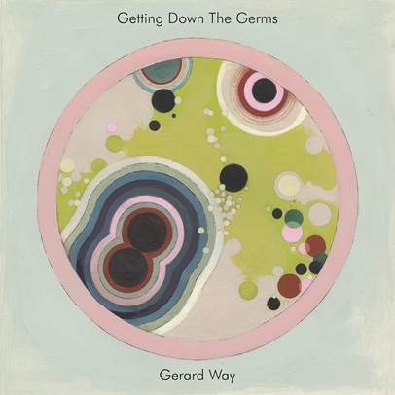

**(November 16, 2018 - Los Angeles, CA) -** Gerard Way releases new single, “Getting Down The Germs” today via Reprise Records.

This is our second release from Gerard in less than a month….seems like someone is busy in the studio!

Of this new track Gerard says; “I had really been wanting a song that featured the flute prominently for quite some time. It sits in there perfectly, like it was made to pay the song a visit. The whole song reminds me of wiggling squiggling wormy germs. It’s a very calm affair that shows a peek into where I may be heading musically. I hope you enjoy it. It was fun to make.”

Click [**HERE**](https://GerardWay.lnk.to/gdtg) to listen.

Click [**HERE**](https://GerardWay.lnk.to/gdtg-video) for the always fun visual.

More to come soon……

###

**Press Contacts:**

Bobbie Gale / Warner Bros. Records

(818) 953-3692 / [**Bobbie.Gale@wbr.com**](mailto:Bobbie.Gale@wbr.com)