GLOBAL POP SUPERSTAR ANITTA REPRISES MARY J. BLIGE’S CLASSIC “REAL LOVE” IN NEW TARGET HOLIDAY CAMPAIGN - LISTEN TO “AMOR REAL” HERE
Anitta Is Set To Perform At The 21st Annual Latin Grammy Awards On Thursday, November 19th And Presenting This Sunday, November 8th At The EMAs On MTV

Anitta’s Summer Anthem “Me Gusta” Feat. Cardi B & Myke Towers Hits 140M Streams, Debuting Top 5 On Billboard Hot Latin Songs Chart

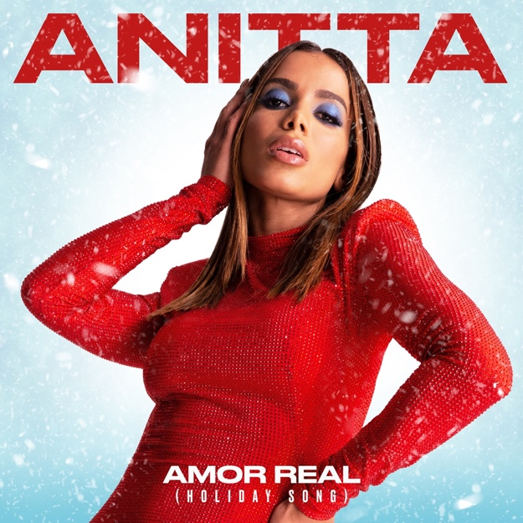

November 6, 2020 (Los Angeles, CA) — Today, global popstar Anitta releases “Amor Real,” a Spanish take on Mary J. Blige’s iconic hit “Real Love,” for Target’s new holiday campaign. Watch the Target campaign HERE and listen to Anitta’s “Amor Real” in full HERE.

“Amor Real” comes after Anitta’s sizzling summer anthem “Me Gusta” featuring Cardi B and Myke Towers that’s made Anitta one of Brazil’s biggest breakout pop superstars. Paired with a stunning video, it’s a taste of her forthcoming album, which is executive produced by the award-winning Ryan Tedder.

On “Me Gusta,” the trio spill simmering verses over a humid guitar riff, flipping effortlessly between English and Spanish. Anitta's gorgeous vocals float like a cloud, Cardi's bars are stinging and self-assured, and Towers' indelible tonality, flow and force prove to be the perfect counterpart for these two female powerhouses. It’s a song that begs for sweaty clubs and crowded beach parties — but for now, dancing in our bedrooms will do.

Announced today, Anitta will perform at the 21st Annual Latin Grammy Awards on Thursday, November 19th on Univision, TNT, and Televisa. Anitta will also present at this Sunday’s European Music Awards airing globally on MTV.

On September 23, Anitta, flanked by Cardi and Towers, performed her television debut of “Me Gusta” on NBC’s The Tonight Show Starring Jimmy Fallon. The Brazilian phenomenon stayed busy this October, headlining the first-ever FIFA 21 World Celebration, performing at iHeart Radio’s Fiesta Latina 2020, and joining Billboard’s Latin Music Week Q&A with Ryan Tedder.

Quarantine has been the story of 2020 for Anitta, but she hasn’t let it slow her down. She’s gone live on socials nearly every day from her home in Rio de Janeiro, keeping her fans up to date on her recording process. She’s also joined Miley Cyrus, J Balvin, Katy Perry, David Guetta, P. Diddy, and more for chats and performances. Before the world slowed down, Anitta was set to take both the Coachella and Rock In Rio stages by storm in 2020.

“Me Gusta” is another impressive notch on Anitta’s belt with 140 million streams. It follows the July release of her single “Tócame,” featuring Arcangel and De La Ghetto, which has amassed over 67 million cumulative streams. Earlier this summer, Anitta signed with Warner Records, the start of a fruitful partnership that has pushed her music even further. Boasting 5 Latin GRAMMY® Award nominations, 6 MTV EMA wins, nearly 5.1 billion YouTube views, and 4.4 billion Spotify streams. Anitta is already a star, and “Me Gusta” has the power to intensify her global shine even more.

ABOUT ANITTA:
Since breaking through in Brazil six years ago, Anitta has become the leading artist of a new generation of Latin American music. As the biggest ever global female popstar to come from Brazil, she has amassed nearly 50 million Instagram followers and over 14 million YouTube subscribers garnering more than 5.1 billion views. Anitta has been named among the world’s 15th most influential musicians on social media by Billboard. In July 2013, she released her self-titled first album, Anitta, which consisted of 14 new tracks, most of which were written by her. Anitta’s second album, Ritmo Perfeito, was released in July 2014, followed by her third album, Bang, in 2016. The album contained 15 original tracks and the music video for the album’s title song, “Bang,” has garnered over 399 million views since its release. Her latest album, Kisses, was released in April 2019 and marks Anitta’s first trilingual album with songs in Spanish, Portuguese, and English. Kisses was nominated for “Best Urban Album'' at the 2019 Latin GRAMMY® Awards. Since 2014, Anitta has been named “Best Brazilian Act” at the MTV Europe Music Awards for five consecutive years. She was a highlight of the 2016 Rio Olympic Games’ Opening Ceremony, where she performed alongside Brazilian singer/songwriters Gilberto Gil and Caetano Veloso. Anitta has graced the covers of countless magazines including Vogue Brazil, Marie Claire Brazil, GQ Mexico, and GQ Brazil. Anitta has worked with the likes of Madonna, Major Lazer, J Balvin, Diplo, Ozuna, and Maluma among others. Most recently she released “Tócame” feat. Arcangel & De La Ghetto” and “Fuego” with DJ Snake and Sean Paul. Anitta is currently in the studio recording her fifth album, which will be in English, Spanish, and Portuguese.

###

FOLLOW ANITTA
Instagram | Facebook | Twitter | YouTube

