SHARE NEW SINGLE “the man himself”
LISTEN HERE

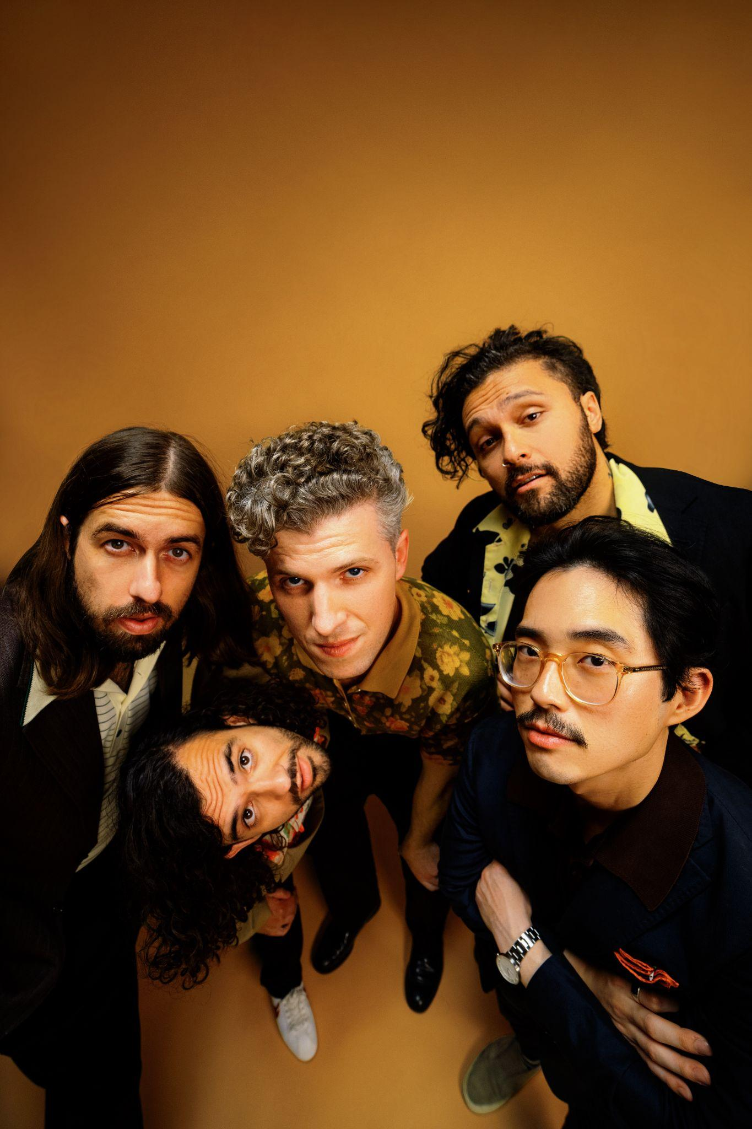
(Photo Credit: Rashidi Noah - Hi-Res here)

October 7, 2021 – (Los Angeles, CA) -- Gang of Youths’ recent EP ‘total serene’ represented a rebirth for the band following their relocation to London. Recent singles, "the angel of 8th ave." and "unison," signaled their growing creativity and ambitions, an approach which has boosted their profile on both sides of the Atlantic. Since its initial release in June, “the angel of 8th ave.” has continued its ascent at radio where it currently resides in the Top 10 in multiple formats.

Today, Gang of Youths unveil their new single “the man himself.” Click here to stream and here for the visualizer.

“the man himself” finds frontman Dave Le’aupepe meditating on the loss of his father. It’s a disorientated experience in which he’s overwhelmed and dislocated by grief. Yet while things will never be the same, he also realizes that he needs to find his own way in the world without the help of that guiding, comforting hand. But the memory will remain, as present in the moment as the painting of his father that hangs in his kitchen.

Those pained lyrics are homed in a song which exudes a far more positive feel. Emerging from the grand, cinematic aspect of the band’s sonic spectrum, it’s full of creative touches from the moment Tom Hobden’s violin provides a scene-setting introduction. From the pulse-racing beat to the atmospheric piano breakdown and a typically whole-hearted hook, it finds Gang of Youths continuing to explore new dimensions to their sound. As with “unison,” “the man himself” features sampled field recordings of Indigenous Pacific music captured by David Fanshawe. And in a song about loss, they possess a pure and elative hymnal quality.

Dave Le’aupepe commented, “If I ever have kids I’m not really sure how to raise them without my dad helping me out.”

Grief, death, faith, and the life and legacy of Le’aupepe father are themes paralleled in all their recent tracks. The grief of losing a parent has been described as a turning point, an insurmountable obstacle, and a part-emptiness in perpetuity for life that has led him through his own journey of discovery, especially that of his family’s Polynesian heritage. Re-establishing a strong collective solidarity and sense of common identity as Polynesian people has found itself intricately wound into each track with the field recordings of David Fanshawe, as well as through the cover art, which drew abstract inspiration from Fanshawe’s own cover art.

Gang of Youths have made a big return to touring the U.K. this summer, including a sold-out underplay headline show at London’s Lafayette which was streamed live on TikTok, plus a pair of festivals appearances at All Points East and Neighborhood Weekender where they debuted live performance of “the man himself.” The band are now set to be introduced to an even bigger audience as guests to Sam Fender on his sold-out U.K. arena tour in November which is complemented with select headline shows. Click here for further details. Gang of Youths hope to announce an extensive U.S. tour for 2022 soon.

Gang of Youths consists of Dave Le’aupepe (vocals, guitar), Max Dunn (bass), Jung Kim (guitar, keyboards), Donnie Borzestowski (drums) and Tom Hobden (keyboards, guitar, violin).

(“the man himself” Single Art)

“Le’aupepe has embraced indigenous music native to his family’s Samoan and Māori cultures, as well as the hip-hop and dance sounds that he grew up on.” – UPROXX
“For Springsteen-level bombast and heart-thumping, widescreen rock, Gang of Youths are the best around.” - NME
“an example of the eclectic evolved direction in which their music is heading.” – Rolling Stone Australia

Contacts:

Grandstand Media
Kate Jackson katej@grandstandhq.com
Katie Nelson katien@grandstandhq.com

Warner Records
Rick Gershon Rick.Gershon@warnerrecords.com
Jenny Huynh Jenny.Huynh@warnerrecords.com

Follow Gang of Youths:
Official website | Instagram | Facebook | Twitter | Spotify | Apple Music | YouTube | Tik Tok
Press Materials

