GRIFF RELEASES HER DEBUT EP THE MIRROR TALK AND SHARES VIDEO FOR TRACK “PARADISE”
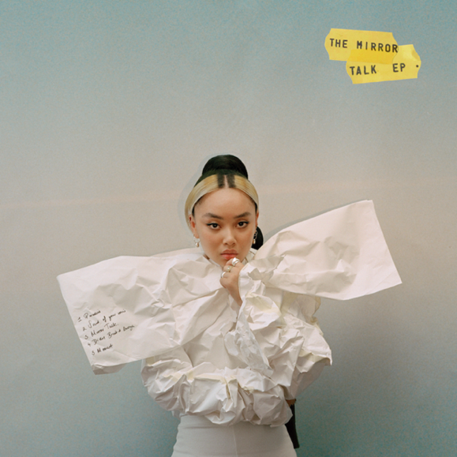
According To A Recent Study Done By USC Annenberg, For Every 47 Producers Who Are Men, There Is 1 Woman
And Then There Is GRIFF
“GRIFF is the hottest new artist to come out of the UK since Dua Lipa.” V Magazine
"Writer, producer, stylist, designer and creative director, it's clear that GRIFF is a force to be reckoned with" British Vogue
"GRIFF looks every bit like pop’s bright new star...it is, quite frankly, all rather brilliant" i-D
“Bedroom pop at its coolest” Nylon
“What Makes GRIFF promising is taste; she doesn’t feel the need to smother her voice in over-produced beats. She understands that less is certainly more…her vocal capability is as rich and as varied as the greatest R’n’B chanteuses" The Line of Best Fit
“Electrifying Debut…” Billboard Magazine
LISTEN TO EP HERE
WATCH VIDEO HERE
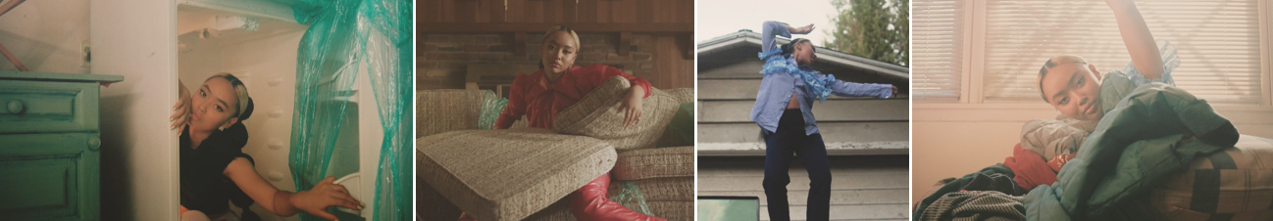

For More Information, Contact:
Bobbie Gale at Warner Records Publicity
Bobbie.Gale@warnerrecords.com

