GARY CLARK JR. BRINGS A BUSY 2020 TO A CLOSE WITH DIVERSE COLLABORATIONS & PERFORMANCES INCLUDING NEW ORIGINAL SONG “VALLEY OF LAST RESORT” CO-WRITTEN BY GUSTAVO SANTAOLALLA

LISTEN HERE
WATCH HERE

CLARK PERFORMS LIVE FOR PLAY ON: CELEBRATING THE POWER OF MUSIC TO MAKE CHANGE TONIGHT ON CBS

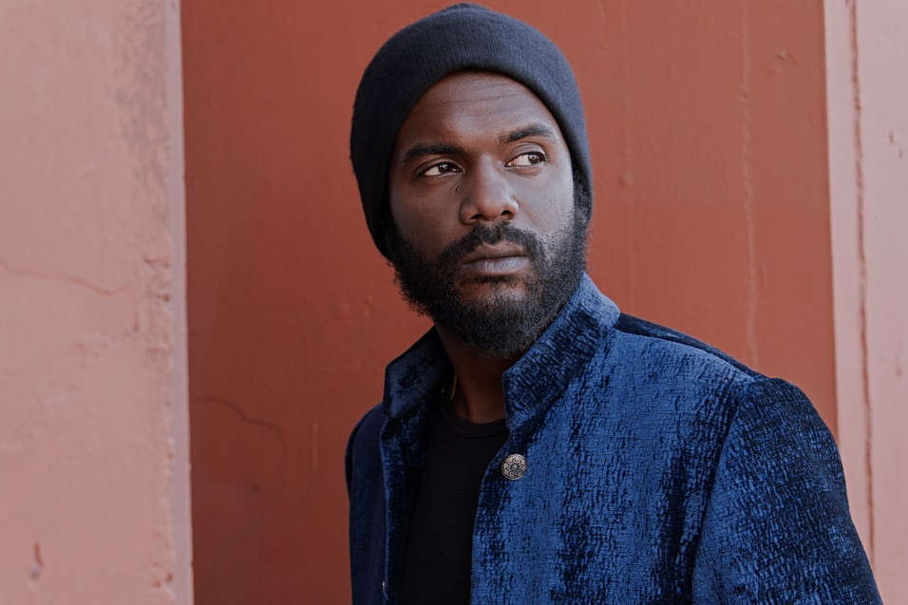
(Click here for hi-res – Photo Credit: Frank Maddocks)

December 15, 2020 (Los Angeles, CA) – Rounding out a prolific year earmarked by diverse collaborations and blockbuster performances including his most recent critically-acclaimed release “Valley of Last Resort.” Clark teamed up with multiple GRAMMY® and two time Oscar®-winning composer Gustavo Santaolalla (Brokeback Mountain, Babel) to co-write “Valley Of Last Resort.” The original new song, features some typically dazzling guitar work and one of Clark’s most unique vocals performances to date. Lyrics were penned by legendary songwriter Paul Williams. “Valley Of Last Resort.” Is featured in the Hunter S. Thompson documentary, Freak Power: The Ballot Or The Bomb, released on Amazon and AppleTV. Click here to stream and here to watch.

Additionally, Clark’s presence could be felt throughout the culture with a bevy of high-profile collaborations. He held down guitar on Stevie Wonder’s widely publicized return anthem “Where Is Our Love Song” and joined John Legend for “Wild” from the critically acclaimed, Bigger Love. Clark was drafted in to add some guitar along with Nas and Joey Bada$$ for StatikSelektah’s “Keep it Moving,” from his 2020 project The Balancing Act?. He charged up Kiana Ledé’s “Youth.” with a dreamy riff and wailing lead. Speaking of film and television, he teamed up with Keedron Bryant and Symba for a version of “I Know I’ve Been Changed” from Nate Parker’s forthcoming film American Skin. Both the film and the song are set for January 2021 release. In September of this year, Clark also served up “Head Hunting Road Dogs” for the HBO Max film Unpregnant and its Original Motion Picture Soundtrack. Plus, he and Suzanne Santo linked on “Fall For That” and spoke to The Joe Rogan Experience together about their collaboration. Brandi Carlile and Clark recorded a powerful duet, along with guitarist John Leventhal for a heartfelt version of Sam Cook’s 1964 classic “A Change Is Gonna Come” from the Live With Carnegie Hall event this past summer.

The Austin-born artist, guitarist, singer, songwriter, and producer also stands out in a series of electrifying performances by Tune in tonight as Clark caps off 2020 with an appearance on the CBS special Play On: Celebrating The Power of Music to Make Change on Tuesday December 15 at 8pm ET/7pm CT. Over the past month, PBS has aired Eric Clapton’s 2019 Crossroads Guitar Festival where Gary delivered a powerful rendition of “I Got My Eyes On You.” Meanwhile, his scorching live take on “Feed The Babies” ignited a promo for the Crossroads Guitar Festival DVD, CD, and Vinyl available at Guitar Center. At the top of December, he joined the all-star lineup at Peace Through Music: A Global Event for Social Justice broadcast on the Playing For Change Facebook with a riveting acoustic version of “This Land.”

Making the most of quarantine, Gary also spent 2020 carefully crafting his anxiously awaited fourth full-length album set for release next year.

Stay tuned for more news soon.

ABOUT GARY CLARK JR:
Gary Clark Jr. has quietly become an impactful and influential voice for his generation as a guitarist, songwriter, producer, and singer. Among numerous accolades, he has garnered four GRAMMY® Awards, receiving 2014’s “Best Traditional R&B Performance” statue for “Please Come Home” and 2020 honors in the categories of “Best Rock Performance” and “Best Rock Song” for “This Land” and “Best Contemporary Blues Album” for his third full-length THIS LAND. Upon release, the latter marked his highest bow on the Billboard Top 200 at #6 in 2019. Over the course of an unbelievable decade, he has performed alongside Eric Clapton, Tom Petty and the Heartbreakers, B.B. King, and The Rolling Stones in addition to recording with everyone from Stevie Wonder and Alicia Keys to John Legend, Foo Fighters. and Tom Morello. Not to mention, he has contributed music to over a dozen film and television productions. He’s cemented himself as the rare talent who can grace the cover of Guitar World multiple times and President Barack Obama’s official playlist. With his fourth album on the horizon, he’s set to make an even bigger mark on culture in 2021.

For further information, contact Rick Gershon at Warner Records:
Rick.Gershon@warnerrecords.com

FOLLOW GARY CLARK JR:
Official | Facebook | Twitter | Instagram | YouTube | Spotify | Publicity Materials

