GRAMMY AWARD-WINNER GARY CLARK JR. READY TO LIGHT UP STAGES ACROSS NORTH AMERICA THIS SUMMER

EUROPEAN STADIUM DATES WITH GUNS N’ ROSES AND SLASH SET FOR 2022

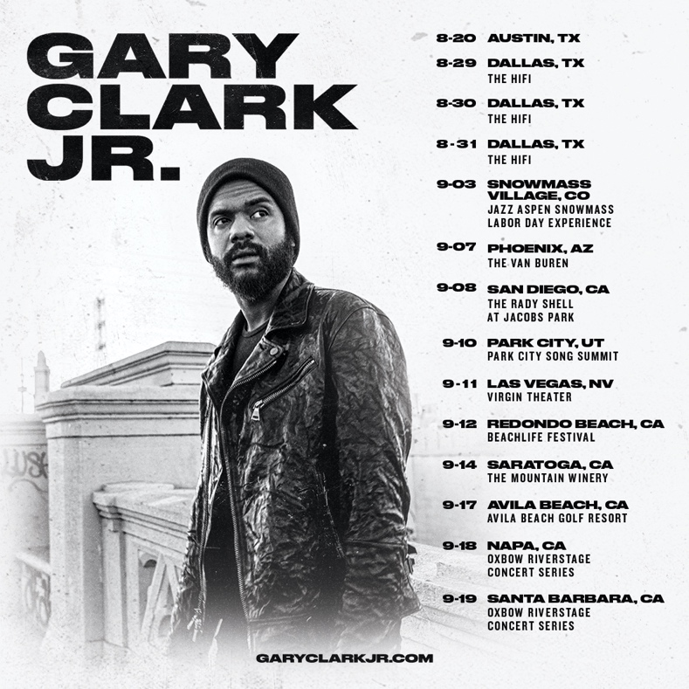

June 23, 2021 (Los Angeles, CA) – Multiple Grammy Award-winner Gary Clark Jr. announces his return to the road in the US this year. The Austin-born artist and producer has confirmed a string of tour dates and festival appearances for 2021. Headline dates have been confirmed in Las Vegas, NV on September 11 at Virgin Theater and in Saratoga, CA at The Mountain Winery on September 14. Additionally, he’ll grace the stages of festivals such as Jazz Aspen Snowmass Labor Day Experience in Snowmass Village, CO on September 3, Park City Song Summit in Park City, UT on September 10, BeachLife Festival in Redondo, CA on September 12, and Oxbow RiverStage Concert Series on September 18. Tickets on sale now. Click here for ticket and concert details.

Renowned worldwide for electrifying live performances, this promises to be a very special run as it’s his first proper tour in 18 months.

He’s already looking ahead as well, revealing his summer 2022 itinerary across Europe as special guest to Guns N’ Roses with Slash. Click here for details.

Fans in Mississippi got a taste of what to expect earlier this month. Clark appeared at the opening of a new 4,500-square-foot wing at the BB King Museum and Delta Interpretive Center in Indianola, MS, on the Blues Trail of America. He took the stage with an incendiary rendition of King’s “Whole Lotta Love” before a simmering tribute on “3 O’Clock Blues” accompanied by house-band guitar-slingers Lil’ Ray Neal and D.K. Harrell. Guitar World could only describe it as “rousing” and “mesmerizing.”

Right now, Clark is assembling his anxiously awaited fourth full-length studio album.

Gary Clark Jr. is officially back to doing what he does best—playing live! Stay tuned for more news soon.

US TOUR DATES 2021:
Aug 20 Austin, TX Moody Theater
Aug 29 Dallas, TX The HiFi
Aug 30 Dallas, TX The HiFi
Aug 31 Dallas, TX The HiFi
Sep 03 Snowmass Village, CO Jazz Aspen Snowmass Labor Day Experience
Sep 08 San Diego, CA The Shell
Sep 10 Park City, UT Park City Song Summit
Sep 11 Las Vegas, NV Virgin Theater (on sale now)
Sep 12 Redondo Beach, CA BeachLife Festival
Sep 14 Saratoga, CA The Mountain Winery (on sale now)
Sep 17 Avila Beach, CA Avila Beach Golf Resort
Sep 18 Napa, CA Oxbow RiverStage Concert Series
Sep 19 Santa Barbara, CA Santa Barbara Bowl
Sep 21 Phoenix, AZ The Van Buren

Europe 2022:
Jun 04 Lisboa, Portugal Passeio Maritimo
Jun 07 Seville, Spain Benito Villamerin Stadium
Jun 15 Rogaland, Norway Forus Travbane (Forus Racecourse)
Jun 18 Prague, Czech Republic Letnany Airport
Jun 20 Warsaw, Poland PGE Narodowy
Jun 23 Groningen, Netherlands Stadspark Groningen
Jun 28 Dublin, Ireland Marlay Park
July 01 London, UK Tottenham Hotspur Stadium
July 02 London, UK Tottenham Hotspur Stadium
July 05 Glasgow, UK TRNSMT Festival (Glasgow Green)
July 08 Munich, Germany Munich Olympic Stadium
July 10 Milan, Italy San Siro Stadium
July 13 Vienna, Austria Ernst Happel Stadion Wien

About Gary Clark Jr.:
Clark achieved global impact following his first Grammy Award® in 2014 winning Best Traditional R&B Performance for the track “Please Come Home” from his Warner Records debut album Blak And Blu, and seemingly never left the road. 2015’s The Story Of Sonny Boy Slim wrought hard- won international acclaim as a critical force to be reckoned with. Throughout 2019 Clark ascended to greater heights with the release of THIS LAND – his third full-length studio album which bowed at #6 on the Billboard Top 200, marking his third consecutive Top 10 debut. The album and single of the same name attracted acclaim from the likes of The New York Times, The Washington Post, The Los Angeles Times, Rolling Stone, Pitchfork and more. He has performed on Saturday Night Live, The Late Show with Stephen Colbert, The Ellen DeGeneres Show, The Tonight Show Starring Jimmy Fallon, The Late Late Show with James Corden, Jimmy Kimmel Live!, Good Morning America, CBS News Sunday, CBS This Morning, The Today Show, Late Night with Seth Meyers, The Daily Show with Trevor Noah, The Howard Stern Show, WTF with Marc Maron and more. Clark’s domestic tours became instant sell outs and his international profile found him topping bills at legendary festivals around the world and venues including the Hollywood Bowl, along with multiple appearances in stadiums supporting and sharing the stage with The Rolling Stones. Most recently, Clark won three more Grammy Awards including Best Rock Performance “This Land,” Best Rock Song “This Land,” and Best Contemporary Blues Album THIS LAND. Clark also performed his award-winning single “This Land,” backed by The Roots at last year’s Grammy Award® ceremony and released their version of the track. Countless collaborations have been recorded with Stevie Wonder, Andra Day, John Legend, Alecia Keys, Foo Fighters, Nas, Sheryl Crow, Brandi Carlile, Eric Clapton, Gustavo Santaolalla, Booker T. Jones, and many more. To date, Clark has been nominated for six GRAMMY Awards® and won four. Clark is currently working on his follow-up to THIS LAND.

For further information, contact Rick Gershon at Warner Records:
Rick.Gershon@warnerrecords.com

FOLLOW GARY CLARK JR.:
Official | Facebook | Twitter | Instagram | YouTube | Spotify | Publicity Materials

