RELEASES NEW SINGLE AND VIDEO “THIS LAND” TODAY

CLARK PERFORMS “THIS LAND” ON THE LATE SHOW WITH STEPHEN COLBERT TONIGHT

NEW ALBUM THIS LAND RELEASES FEBRUARY 22, 2019 VIA WARNER BROS. RECORDS – PRE-ORDERS AVAILABLE NOW

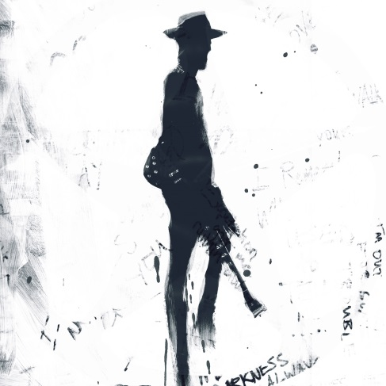

“I’m America, son. This is where I come from. This Land is mine.”

January 10, 2019 (Los Angeles, CA) - Today, Gary Clark Jr. returns with a brand new and powerful single “This Land” from the album of the same name. The song is taken from his forthcoming third full-length album, THIS LAND, to be released on February 22, 2019. Click here to purchase and stream “This Land.”

THIS LAND, the album is available for pre-sale beginning today. All pre-orders will receive an immediate download of the title track single. Click here to pre-order THIS LAND.

Clark and the band will premiere “This Land” live tonight on The Late Show with Stephen Colbert. Tune into CBS at 11:35pm ET/10:35pm CT.

The video for “This Land” launches today. Directed by award-winning filmmaker Savanah Leaf, the clip translates the single’s spirit into a stirring and striking visual. Shot in Clark’s hometown of Austin, Texas, it shocks the vision to life on-screen. Click here to view and share.

The GRAMMY® Award-winning maverick channels his signature sense of soul from the crossroads of rock ‘n’ roll, blues, jazz, hip-hop, reggae and punk. Clark’s most accomplished songwriting and virtuosic performances to date; THIS LAND delivers socially relevant, transcendentally ambitious, and musically rich declaration as unapologetic, undeniable, and unique as he is. He emerges with a body of work that is dynamic in every sense, embodying an ever-evolving sound that transformed him into an artistic force anointed by everyone from President Barack Obama to the late Prince.

Tickets for Clark’s North American tour are on-sale now. Every ticket purchased includes a standard CD or digital copy of THIS LAND. Check out the official tour trailer. Get tickets here.

Gary Clark Jr. welcomes you to THIS LAND in 2019.
*Indicates newly confirmed date

Mar 09 Miami, FL Fillmore Miami Beach at The Jackie Gleason Theater
Mar 10 Tampa, FL Gasparilla Music Festival
Mar 13 Springfield, MO Gillioz Theatre
*Mar 14 Columbia, MO The Blue Note
Mar 15 Chicago, IL Chicago Theatre presented by Chase
Mar 16 Chicago, IL Chicago Theatre presented by Chase
Mar 18 Indianapolis, IN Old National Centre - Murat Theatre
Mar 20 Pittsburgh, PA Benendum Center
Mar 21 New York City, NY Beacon Theatre presented by Chase
Mar 22 New York City, NY Beacon Theatre presented by Chase
Mar 23 New York City, NY Beacon Theatre presented by Chase
Mar 26 Boston, MA House of Blues
Mar 27 Boston, MA House of Blues
Mar 29 Philadelphia, PA Met Opera House
Mar 30 Washington, DC The Anthem
Mar 31 Richmond, VA The National
Apr 02 Durham, NC Durham PAC
Apr 03 Charlotte, NC The Fillmore Charlotte
Apr 05 Nashville, TN Ryman Auditorium
Apr 06 Nashville, TN Ryman Auditorium
Apr 07 Nashville, TN Ryman Auditorium
*May 04 Atlanta, GA Shaky Knees Music Festival
*May 25 Napa, CA BottleRock Music Festival
Ticket & Tour info: http://www.garyclarkjr.com/tour
THIS LAND track listing:
This Land
What About Us
I Got My Eyes On You (Locked & Loaded)
I Walk Alone
Feelin’ Like A Million
Gotta Get Into Something
Got To Get Up
Feed The Babies
Pearl Cadillac
When I’m Gone
The Guitar Man
Low Down Rolling Stone
The Governor
Don’t Wait Til Tomorrow
Dirty Dishes Blues

BONUS TRACKS:
Highway 71
Did Dat
# # #
Contact Rick Gershon Warner Bros. Records Publicity:
818-953-3473 / rick.gershon@wbr.com

For Regional/Tour Press
Contact Bre Flores Warner Bros. Records Publicity:
818-953-3638 / breanne.flores@wbr.com

Follow Gary Clark Jr.:
Official: garyclarkjr.com
Facebook: facebook.com/GaryClarkJr
Twitter: @GaryClarkJr
YouTube: www.youtube.com/user/garyclarkjr

