

/var/folders/vj/dqzyq6rn24vdbv28yg_dlv800000gp/T/com.microsoft.Outlook/WebArchiveCopyPasteTempFiles/cidimage001.png@01D4B96E.0D77E790

**WRAPS UP 2019 WITH A SOLD-OUT TOUR, TRIUMPHANT HOLLYWOOD BOWL SHOW, AND IMPRESSIVE TV PERFORMANCES**

**CLARK TO PERFORM TEXAS HOMECOMING SHOWS THIS WEEK AND PERFORM BOTH WEEKENDS AT AUSTIN CITY LIMITS FESTIVAL**

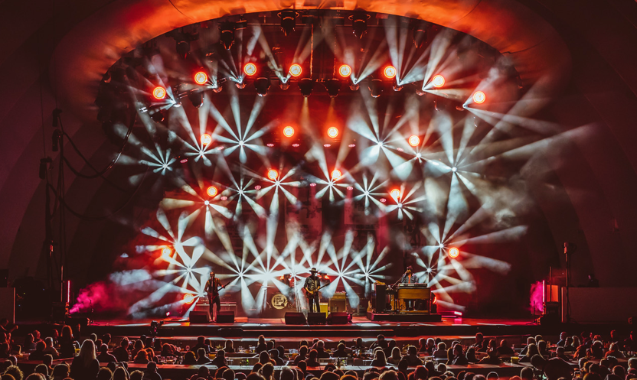

(Photo Courtesy of Gaston Jouany @thejouany)

**October 2, 2019 (Los Angeles, CA)** – Grammy Award-winning artist[**Gary Clark Jr**](x-apple-data-detectors://13)**.** caps off 2019, his most successful year-to-date with an explosive tour finale at the prestigious Hollywood Bowl. The 18,000-strong Bowl embraced Clark from the onset as the band blazed through songs from each of his Warner Records albums. Impassioned versions of “This Land,” “Pearl Cadillac,” and his take on “Come Together” unified Los Angeles to sing along.

[***Variety Magazine***](https://variety.com/2019/music/news/gary-clark-jr-hollywood-bowl-concert-review-1203355176/) raved, “Likely Grammy favorite, Clark established that his ‘heroism’ isn’t strictly limited to guitar theatrics…in the early 70’s Eric Clapton and Marvin Gaye fulfilled very different functions in the rock and soul pantheon. It only took four and a half decades or so for Gary Clark Jr. to come along and be the guy who can do both.” For a visual summary of Clark’s most exciting year, [**click**](https://vimeo.com/362865192/aaa9617767)here.

Before and after the Bowl show, Clark and company continued their run of impressive TV appearances on both the outdoor stage of *Jimmy Kimmel Live!* and *The Late Late Show with James Corden*, treating audiences to fan favorites “Pearl Cadillac” and “When I’m Gone.” Click [**here**](https://www.youtube.com/watch?v=TUxoEJLOMsI) to view and share “Pearl Cadillac” from Corden and [**here**](https://www.youtube.com/watch?v=Z1pVNs3jAjg)for “When I’m Gone” from Kimmel. Click [**here**](https://www.youtube.com/watch?v=dT3Mr7Q9MpI)to view and share the official video for “Pearl Cadillac.”

As previously announced, Clark will be featured in concert and conversation on [**PBS Newshour**](https://www.pbs.org/newshour/) this Friday, October 4th, and on Saturday, October 5th. Clark will take over the entire hour-long season premiere of [**Austin City Limits-PBS**](https://www.pbs.org/show/austin-city-limits/).

Closing out 2019 with his final live performances of the year, Gary Clark Jr. will return home to Austin for a pair of intimate shows at [**Stubbs Waller Creek Amphitheater**](https://www.stubbsaustin.com/concert-listings) on October 3rd and 4th, followed by what will surely be triumphant main stage appearances at Austin City Limits Festival on Saturday, October 5th and again on Saturday, October 12th, playing alongside superstars Childish Gambino, Billy Eilish and many more. Expect the unexpected for all of these Austin shows. Click [**here**](https://www.aclfestival.com/) for further details.

Contact **Rick Gershon** at Warner Records Publicity:

818-953-3473 / [**rick.gershon@warnerrecords.com**](mailto:rick.gershon@warnerrecords.com)

**Follow Gary Clark Jr.:**

Official: [**www.garyclarkjr.com**](http://www.garyclarkjr.com)

Facebook: [**facebook.com/GaryClarkJr**](https://www.facebook.com/GaryClarkJr)

Twitter: [**@GaryClarkJr**](https://twitter.com/garyclarkjr)

Instagram: **@garyclarkjr**

YouTube: [**www.youtube.com/user/garyclarkjr**](http://www.youtube.com/user/garyclarkjr)

Press Materials: **press.warnerrecords.com/garyclarkjr/**