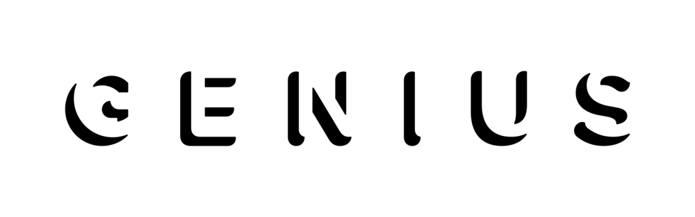
July 31, 2020

https://genius.com/videos/Saweetie-breaks-down-the-meaning-of-tap-in
YouTube: https://www.youtube.com/watch?v=Idh8bOI2QQo

