

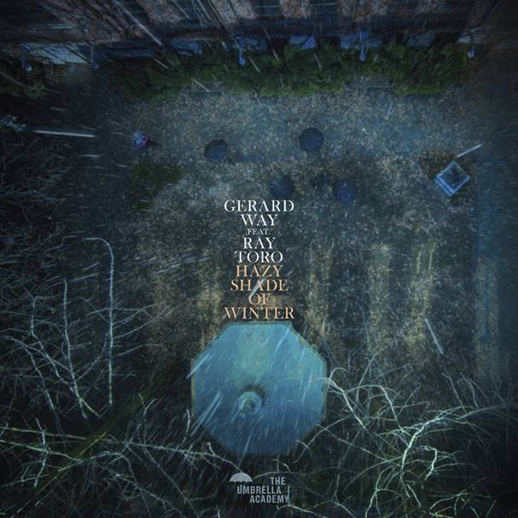

**January 24, 2019 (Los Angeles, CA)** – Gerard Way releases new track today via Reprise Records. You might recognize it simply from the title, “Hazy Shade of Winter.” Gerard covered the track in honor of the new upcoming Netflix show, “The Umbrella Academy,” which is being used in the show’s new trailer which just came out today. It features fan favorite guitarist, Ray Toro.

**Watch Trailer** [**HERE**](https://www.youtube.com/watch?v=0DAmWHxeoKw&feature=youtu.be)

**Click** [**HERE**](https://GerardWay.lnk.to/hazyshadeofwinter) **to Listen to Track**

The Umbrella Academy is based on the popular, Eisner award-winning comics and graphic novels created and written by Gerard Way (My Chemical Romance), illustrated by Gabriel Bá, and published by Dark Horse Comics. The live-action series stars Ellen Page, Tom Hopper, Emmy Raver-Lampman, Robert Sheehan, David Castañeda, Aidan Gallagher, Cameron Britton, and Mary J. Blige, and is produced by Universal Cable Productions for Netflix. Steve Blackman (Fargo, Altered Carbon) will serve as executive producer and showrunner, with additional executive producers Jeff F. King (Hand of God), Bluegrass Television, and Mike Richardson and Keith Goldberg from Dark Horse Entertainment. Gerard Way and Gabriel Bá will serve as co-executive producers. The show will premiere February 15, 2019.

###

**Press Contact:**

**Bobbie Gale** / Warner Bros. Records

(818) 953-3692 / [Bobbie.Gale@wbr.com](mailto:Bobbie.Gale@wbr.com)