GOO GOO DOLLS ANNOUNCE 2019 FALL HEADLINING TOUR

TICKETS ON SALE FRIDAY, JULY 26TH

NEW ALBUM MIRACLE PILL ARRIVING SEPTEMBER 13TH 2019
VIA WARNER RECORDS

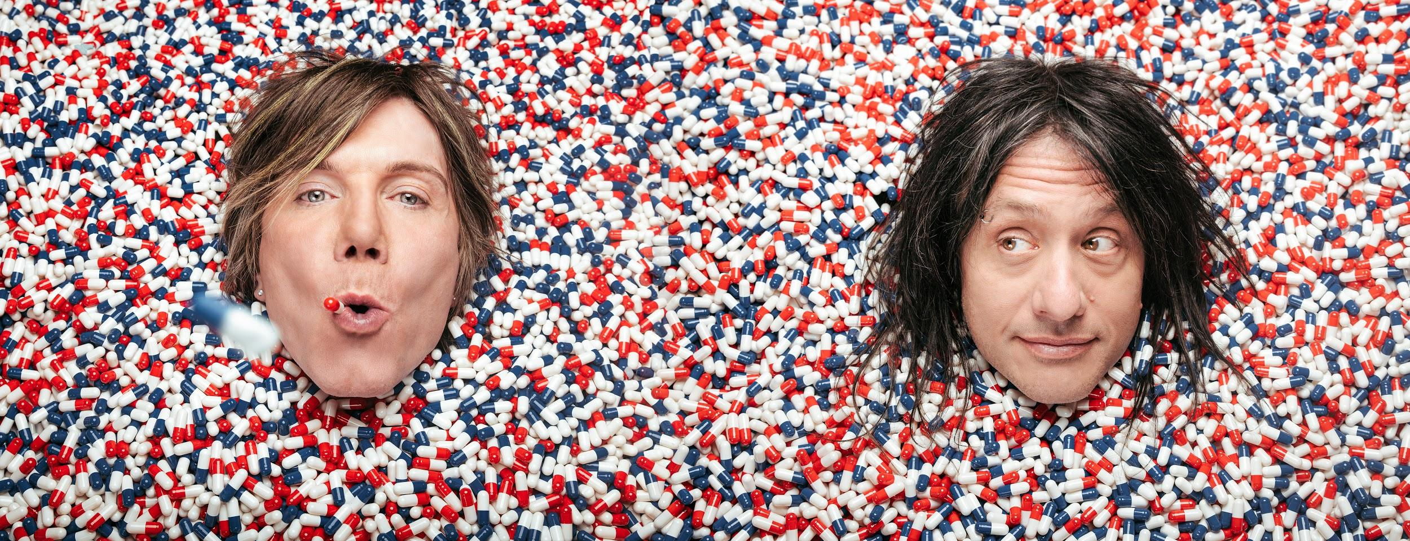
Goo Goo Dolls (Photo Credit: Ed Gregory & Dan Cooper)

July 23, 2019 (Los Angeles, CA) — Multi-platinum, four-time GRAMMY-nominated rock band Goo Goo Dolls have announced they will be embarking on a nationwide headlining tour in support of their forthcoming album, Miracle Pill (Warner Records). The tour kicks off in Austin, TX on October 25th and will visit over 20 cities across North America before wrapping in Toronto, ON on November 25th. Tickets will go on sale to the general public on Friday, July 26th at 10:00 AM local time. For more information on VIP Packages and tickets, visit GooGooDolls.com.

Goo Goo Dolls’ highly anticipated 12th studio album Miracle Pill will be out on September 13th, 2019 via Warner Records. Pre-orders for the album are live now HERE and limited edition merch bundles are also available through the band's online store HERE. Each pre-order purchase unlocks a brand new instant grat track entitled “Money, Fame and Fortune”, the second offering from Miracle Pill.

Last week, the band released their colorful new music video for the album’s first single “Miracle Pill”, which was directed by Ed Gregory & Dan Cooper. Billboard exclusively premiered the piece, stating that it’s “a vibrant pairing of lyrics and visual” that “illustrates their ability as a rock force”. As of last week, “Miracle Pill” ranks as Hot AC Radio’s most added song. Watch the video now HERE.

Goo Goo Dolls are currently in the midst of a massive co-headlining amphitheater tour alongside GRAMMY-winning band Train that has been met with widespread acclaim. The run will continue throughout the summer before concluding on August 17, 2019 in Mansfield, MA at Xfinity Center. Goo Goo Dolls will then embark on several South American tour dates before starting their North American headlining run, including a highly anticipated appearance at the iconic music festival Rock in Rio on September 29th, 2019 in Rio de Janeiro.

FALL DATES:
October 25th - Austin, TX - Bass Concert Hall
October 26th - Corpus Christi, TX - American Bank Center - Selena Auditorium
October 27th - San Antonio, TX - Majestic Theatre
October 29th - Tulsa, OK - Brady Theater
October 27th - San Antonio, TX - Majestic Theatre
October 29th - Tulsa, OK - Brady Theater
October 30th - Wichita, KS - Orpheum Theatre - Wichita

November 1st - Rapid City, SD - Rushmore Plaza Civic Center Arena
November 2nd - Sioux City, IA - Orpheum Theatre – Sioux City
November 3rd - Des Moines, IA - Hoyt Sherman Place
November 5th - Peoria, IL - Peoria Civic Center Theater
November 6th - Davenport, IA - Adler Theatre
November 8th - Kalamazoo, MI - Kalamazoo State Theater
November 9th - Appleton, WI - Fox Cities Performing Arts Center
November 10th - Madison, WI - Orpheum Theater
November 12th - Louisville, KY - Palace Theatre
November 13th - Huntsville, AL - Von Braun Center - Mark C. Smith Concert Hall
November 15th - Chattanooga, TN - Tivoli Theatre
November 16th - Knoxville, TN - Tennessee Theatre
November 17th - Charleston, SC - Charleston Gaillard Center
November 19th - Richmond, VA - The Carpenter Theatre
November 20th - Columbus, OH - Palace Theatre
November 25th - Toronto, ON - Queen Elizabeth Theatre

CURRENT TOUR DATES, ALREADY ANNOUNCED
July 23rd - Clarkston, MI @ DTE Energy Music Theatre*
July 24th - Cincinnati, OH @ Riverbend Music Center*
July 26th - Saratoga Springs, NY @ Saratoga Performing Arts Center*
July 27th - Bethel, NY @ Bethel Woods Center for the Arts*
July 28th - Gilford, NH @ Meadowbrook Music Pavilion*
July 30th - Bangor, ME @ Darling's Waterfront Park Pavilion*
August 1st - Scranton, PA @ Pavilion at Montage Mountain*
August 2nd - Canandaigua, NY @ Constellation Brands Marvin Sands Performing Arts Center*
August 3rd - Wantagh, NY @ Northwell Health at Jones Beach Theater*
August 5th - Lenox, MA @ Tanglewood Amphitheatre*
August 6th - Bethlehem, PA @ Musikfest*
August 7th - Burgettstown, PA @ KeyBank Pavilion*
August 9th - Columbia, MD @ Merriweather Post Pavilion*
August 10th - Camden, NJ @ BB&T Pavilion*
August 11th - Uncasville, CT @ Mohegan Sun Arena*
August 14th - Cuyahoga Falls, OH @ Blossom Music Center*
August 16th - Holmdel, NJ @ PNC Bank Arts Center*
August 17th - Mansfield, MA @ Xfinity Center*
September 22nd - Recife, Brazil @ Estádio do Arruda^
September 25th - Sao Paulo, Brazil @ Allianz Parque^
September 27th - Curitiba, Brazil @ Pedreira Paulo Leminski^
September 29th - Rio de Janeiro, Brazil @ Rock in Rio 2019^
October 2nd - Lima, Peru @ Estadio Monumental

*Co-headlining dates with Train
^Supporting Bon Jovi

ABOUT GOO GOO DOLLS:
Formed in Buffalo, NY during 1986 by John Rzeznik and Robby Takac, Goo Goo Dolls quietly broke records, contributed a string of staples to the American songbook, connected to millions of fans, and indelibly impacted popular music for three-plus decades. Beyond selling 12 million records worldwide, the group garnered four GRAMMY® Award nominations and seized a page in the history books by achieving 14 number one and Top 10 hits at Hot AC—"the most of any artist.” As a result, they hold the all-time radio record for “Most Top 10 Singles.” Among a string of hits, “Iris” clutched #1 on the Hot 100 for 18 straight weeks and would be named “#1 Top 40 Song of the Last 20 Years.” Thus far, A Boy Named Goo [1995] went double-platinum, Dizzy Up The Girl went quadruple-platinum, and Gutterflower [2002] and Let Love In [2006] both went gold as Something for the Rest of Us [2010] and Magnetic [2013] bowed in the Top 10 of the Billboard Top 200. 2016’s Boxes attracted the praise of People and Huffington Post as Noisey, Consequence of Sound, and more featured them. Their music has been covered by everyone from Taylor Swift to Leona Lewis. Among many accolades, John received the prestigious “Hal David Starlight Award” in 2008 as well.

Following a sold-out 2018 twentieth anniversary tour in celebration of Dizzy Up The Girl, Goo Goo Dolls wrote and recorded their twelfth full-length album, Miracle Pill [Warner Records]—ignited by the first single and title track “Miracle Pill” and kicking off a bold and bright new era in the process.

# # #

Contact:
Luke Burland / BB Gun Press
323.904.9094 / luke@bbgunpress.com

Peter Quinn / BB Gun Press
323.904.9094 / peter@bbgunpress.com

