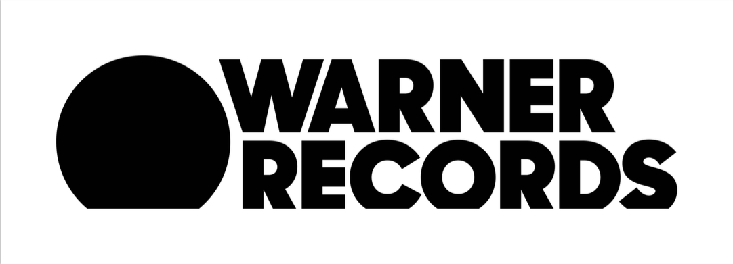
GOO GOO DOLLS TO PERFORM ON THE LATE SHOW WITH STEPHEN COLBERT ON CBS ON AUGUST 13TH

NEW INSTANT GRAT TRACK “INDESTRUCTIBLE” OUT NOW

BRAND NEW ALBUM MIRACLE PILL OUT SEPTEMBER 13TH VIA WARNER RECORDS

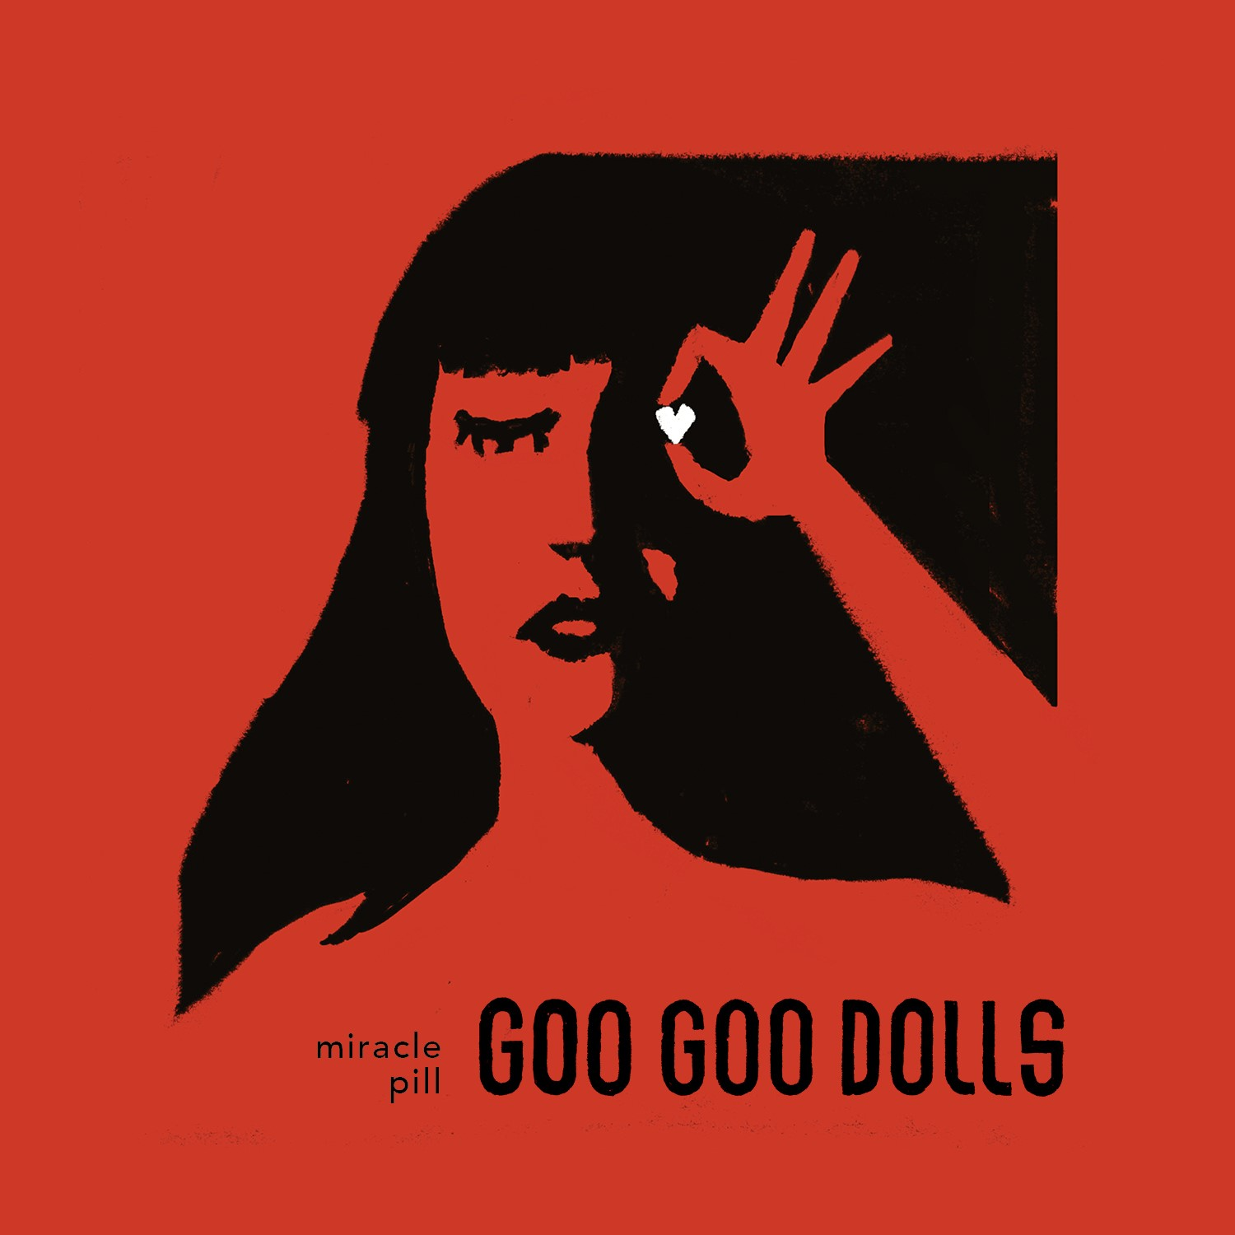
Goo Goo Dolls - Miracle Pill (Album Art Courtesy of Warner Records)

August 9, 2019 (Los Angeles, CA) — Multi-platinum, four-time GRAMMY-nominated rock band
Goo Goo Dolls will perform on The Late Show with Stephen Colbert on Tuesday, August 13th. Tune in to CBS that night at 11:35pm EST / 10:35pm CST (check local listings) to see the band deliver their first late-night TV performance of “Miracle Pill”, the title track from the band’s forthcoming album Miracle Pill (Warner Records). The song is currently at #34 on Billboard’s Adult Top 40 chart and rising.

Today, the band has also released a brand new instant grat track called “Indestructible” and an accompanying lyric video. The rock anthem marks the third offering from the band’s highly anticipated 12th studio record, Miracle Pill, out September 13th, 2019 via Warner Records. Pre-orders for the album are available now HERE, and each pre-order purchase unlocks “Indestructible” as an instant grat track along with the previously released songs “Money, Fame and Fortune” and “Miracle Pill”.

With over 30 years together as a band, over 12 million albums sold, and 14 number one and Top 10 hits at Hot AC, Miracle Pill finds Goo Goo Dolls at the top of their game. The entire collection of songs delivers musicianship that is as engaging as ever, emotion and intimate, relatable lyrics that reflect on the current landscape of instant gratification and relief that everyone seems to be seeking. For tracklisting information, limited edition merch bundle offers and more, visit the band's website HERE.

As Goo Goo Dolls wind down their acclaimed co-headlining summer tour with GRAMMY-winning band Train, the band will continue to rock audiences throughout the fall. Next month, they will perform several South American tour dates and appear at the iconic music festival Rock in Rio before returning stateside this October for a nationwide headlining tour in support of their forthcoming album Miracle Pill (Warner Records). The tour kicks off in Austin, TX on October 25th and will visit over 20 cities across North America before wrapping in Toronto, ON on November 25th. For ticket information and a complete list of tour dates, please visit GooGooDolls.com.

2019 Tour Dates
August 9th - Columbia, MD @ Merriweather Post Pavilion #
August 10th - Camden, NJ @ BB&T Pavilion #
August 11th - Uncasville, CT @ Mohegan Sun Arena #
August 14th - Cuyahoga Falls, OH @ Blossom Music Center #
August 16th - Holmdel, NJ @ PNC Bank Arts Center #
August 17th - Mansfield, MA @ Xfinity Center #
September 22nd - Recife, Brazil @ Estádio do Arruda~
September 25th - Sao Paulo, Brazil @ Allianz Parque~
September 27th - Curitiba, Brazil @ Pedreira Paulo Leminski~
September 29th - Rio de Janeiro, Brazil @ Rock in Rio 2019~
October 2nd - Lima, Peru @ Estadio Monumental
October 25th - Austin, TX - Bass Concert Hall^
October 26th - Corpus Christi, TX - American Bank Center - Selena Auditorium^
October 27th - San Antonio, TX - Majestic Theater +
October 29th - Tulsa, OK - Brady Theater^
October 30th - Wichita, KS - Orpheum Theatre - Wichita^
November 1st - Rapid City, SD - Rushmore Plaza Civic Center Arena^
November 2nd - Sioux City, IA - Orpheum Theatre – Sioux City^
November 3rd - Des Moines, IA - Hoyt Sherman Place^
November 5th - Peoria, IL - Peoria Civic Center Theater^
November 6th - Davenport, IA - Adler Theatre^
November 8th - Kalamazoo, MI - Kalamazoo State Theater*
November 9th - Appleton, WI - Fox Cities Performing Arts Center*
November 10th - Madison, WI - Orpheum Theater*
November 12th - Louisville, KY - Palace Theatre*
November 13th - Huntsville, AL - Von Braun Center - Mark C. Smith Concert Hall*
November 15th - Chattanooga, TN - Tivoli Theatre*
November 16th - Knoxville, TN - Tennessee Theatre*
November 17th - Charleston, SC - Charleston Gaillard Center*
November 19th - Richmond, VA - The Carpenter Theatre*
November 20th - Columbus, OH - Palace Theatre*
November 25th - Toronto, ON - Queen Elizabeth Theatre*

^With The Unlikely Candidates
*With Beach Slang
+Special Guest TBC
#Co-headlining dates with Train
~Supporting Bon Jovi

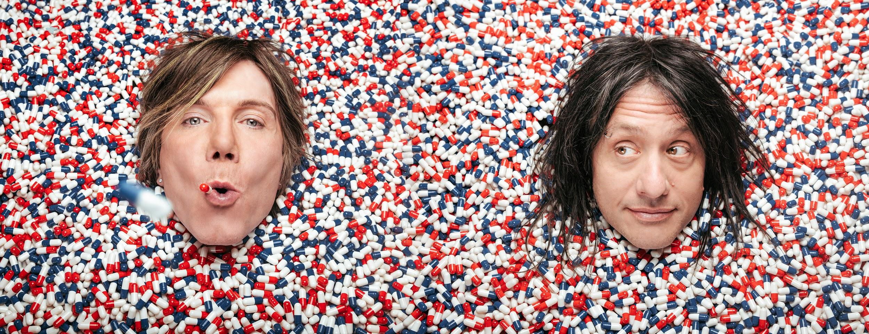
Goo Goo Dolls (Photo Credit: Ed Gregory & Dan Cooper)

ABOUT GOO GOO DOLLS:
Formed in Buffalo, NY during 1986 by John Rzeznik and Robby Takac, Goo Goo Dolls quietly broke records, contributed a string of staples to the American songbook, connected to millions of fans, and indelibly impacted popular music for three-plus decades. Beyond selling 12 million records worldwide, the group garnered four GRAMMY® Award nominations and seized a page in the history books by achieving 14 number one and Top 10 hits at Hot AC—"the most of any artist.” As a result, they hold the all-time radio record for “Most Top 10 Singles.” Among a string of hits, “Iris” clutched #1 on the Hot 100 for 18 straight weeks and would be named “#1 Top 40 Song of the Last 20 Years.” Thus far, A Boy Named Goo [1995] went double-platinum, Dizzy Up The Girl went quadruple-platinum, and Gutterflower [2002] and Let Love In [2006] both went gold as Something for the Rest of Us [2010] and Magnetic [2013] bowed in the Top 10 of the Billboard Top 200. 2016’s Boxes attracted the praise of People and Huffington Post as Noisey, Consequence of Sound, and more featured them. Their music has been covered by everyone from Taylor Swift to Leona Lewis. Among many accolades, John received the prestigious “Hal David Starlight Award” in 2008 as well.

Following a sold-out 2018 twentieth anniversary tour in celebration of Dizzy Up The Girl, Goo Goo Dolls wrote and recorded their twelfth full-length album, Miracle Pill [Warner Records]—ignited by the first single and title track “Miracle Pill” and kicking off a bold and bright new era in the process. Miracle Pill arrives on September 13th, 2019 via Warner Records.

# # #

Contact:
Luke Burland / BB Gun Press
323.904.9094 / luke@bbgunpress.com

Peter Quinn / BB Gun Press
323.904.9094 / peter@bbgunpress.com

